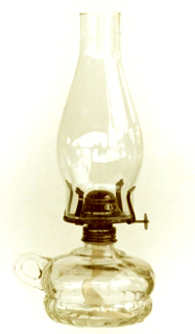
Vintage Table Lamp (Kerosene Lamp)
(picture courtesy: http://www.dore-kau.com/)

