AC 3φ Lap, Single layer, Full Pitch

Draw a developed diagram of stator winding of a motor with 36 slots, 4 poles. It is a full pitch lap, single layer winding

1. Calculations
Slots = 36
Poles = 4
Slot pitch = Slots/pole = 36/4 = 9
Slot angle = 180º/slot pitch = 180º/9 = 20º
Winding pitch = 180º – (slots shorted x slot angle) = 180º – (0x20) = 180º
Coil span = winding pitch/slot angle = 180º/20º = 9
Slots/pole/phase = 36/4/3 = 3

Note:
i. Slots shorted is 0, as it is Full Pitch
ii. Coil span can also be got from “slot pitch – slots shorted”, i.e., 9 - 0 = 9
iii. Slots/pole/phase gives the number of Red, Blue and Yellow conductors under each pole

Assume sequence as RYB
Starting conductor of:
- R is 1 (by default)
- Y is 1 + 120/slot angle = 1+120/20 = 7
- B is 1 + 240/slot angle = 1+240/20 = 13

2. Slot-pole table
 | Red | Blue | Yellow
Pole 1 | 1, 2, 3 | 4, 5, 6 | 7, 8, 9
Pole 2 | 10, 11, 12 | 13, 14, 15 | 16, 17, 18
Pole 3 | 19, 20, 21 | 22, 23, 24 | 25, 26, 27
Pole 4 | 28, 29, 30 | 31, 32, 33 | 34, 35, 36

This table does not give the connection status. It is only useful for finding which conductor is under which pole and what phase. For example, 12th line is a Yellow conductor under pole 2, i.e., first South Pole

3. Winding diagram
3.1 Slots/pole/phase is 3. Draw 36 lines with 3 red, 3 blue, 3 yellow, and number them

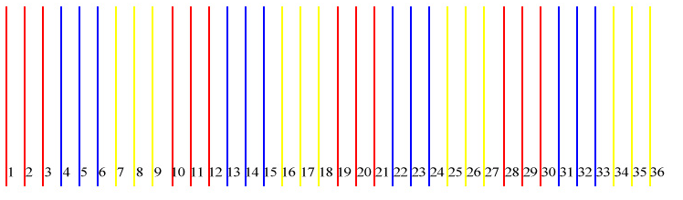

3.2 Make the top and bottom connections phase by phase.
First make the connections for Red
a. First red conductor in the first Red set is numbered 1. First red conductor in the next Red set is 10. Connect 1 and 10. This is also got from the equation, 1+coil span = 1+9=10
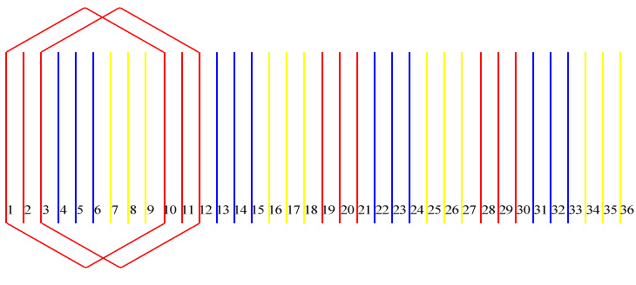

3.3 Make the same kind of connection at the bottom also, that is, from 10 to 1
Make a similar loop for the 3rd red conductor, from 3 to 12 at the top, and from 12 to 3 at the bottom

Note: When slots/pole/phase > 2, every alternate conductor in one phase must be in same direction, and the ones in between must be tilted in the opposite direction. As a thumb rule, odd numbered conductors in one phase tilt towards right, even numbered ones in that phase tilt towards left

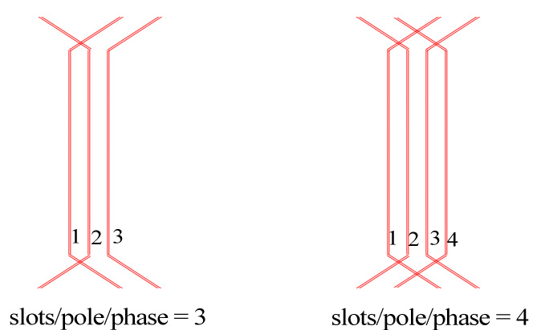

3.4 In the first and second Red sets, conductors 2 and 11 are free. Conductor 11 must tilt towards right. 11+9=20. Connect 11 and 20 on top and bottom. (This means connecting the second conductor in that red set (10,11,12) with the second conductor in the next set (19,20,21) of Red lines)

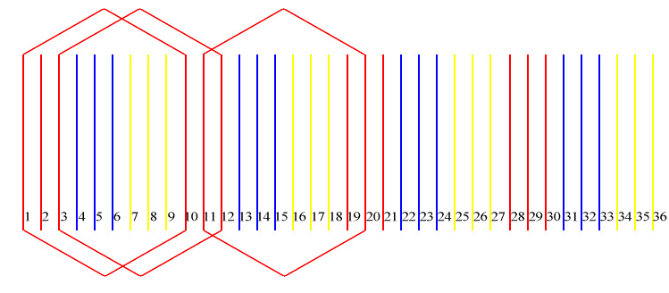

3.5 Similarly make the rest of connections for Red conductors
29+9 = 38 (2) Connect 29 to 2 at the top, and from 2 to 29 at the bottom, as below
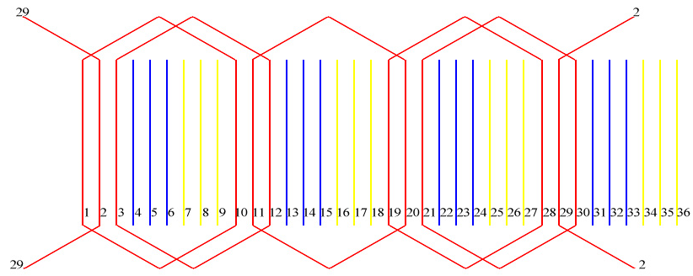

3.6 Draw the current directions
In AC, assume upward direction for conductors under North Pole, downward direction for conductors under South Pole
Slot pitch = 9. So first 9 conductors have current in one direction, next 9 in opposite direction
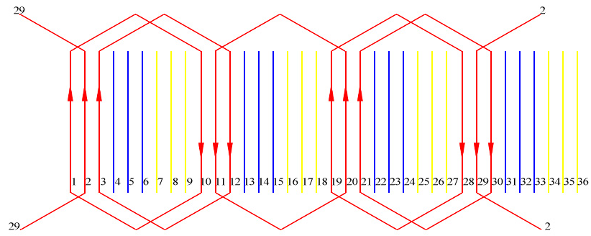

Note: In each loop (or hexagon), if current flows up in one side, it flows down in the other side of same loop. This makes it easy to draw the current direction in all AC winding diagrams irrespective whether it is Lap or Wave, Full pitch or Short Pitch, Single layer or Double layer

3.7 Similarly draw the current directions for Blue and Yellow phases also

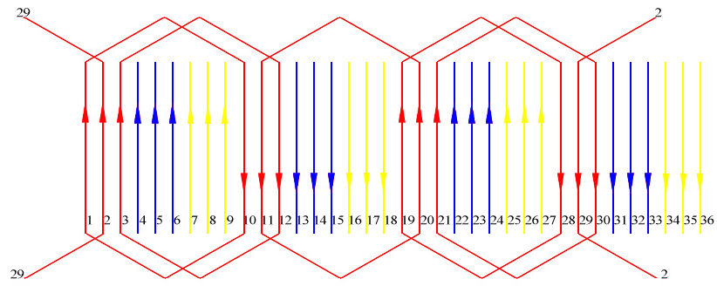

3.8 Draw the connections between the Red loops

a. Red starts from 1st conductor, R_{S}, by default. Draw a wire to the bottom overhang of the 1st conductor
b. The flow is from 1, goes up the overhang and comes down to 10. At the bottom overhang of 10, it makes a loop and goes up line 3, and down through 12
c. The connection wire comes out of the bottom overhang of 12 and must be connected to the bottom overhang of conductor 20 (as it is going up, and current in 20 is also going up)
d. The flow goes up 20 and comes down 11, and goes out of this loop
e. This connection out of 11 must be connected to bottom overhang of 19, as current in 19 is going up
f. The flow here is from 19 up, goes down 28. At the bottom overhang of 28, it makes a loop before going up 21, and coming down 30
g. The connection wire comes down out of the bottom overhang of 30, and is connected to the bottom overhang of 2, as current in 2 is going up
h. The flow goes up 2, and comes down 29. This is the last conductor in Red phase. The end wire of Red, R_{F} comes out of conductor 29
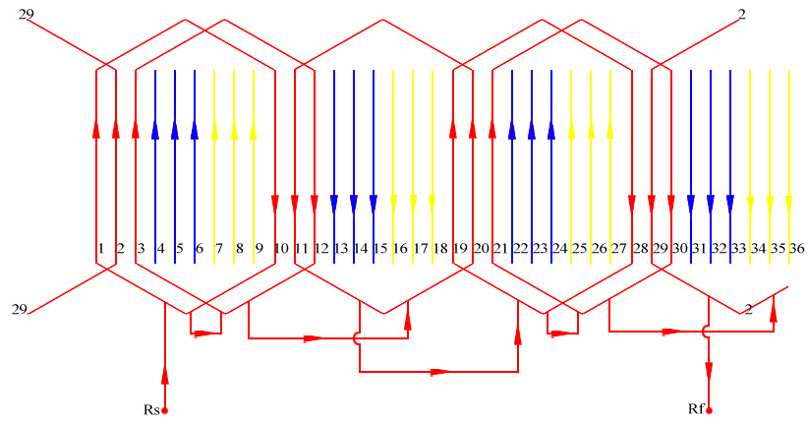

Note: The actual connection in a practical machine is as below
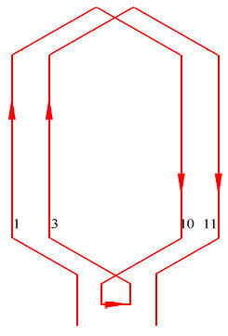 | In practical machines, conductors 10 and 1, or 3 and 11 are not shorted. The connection in fact, is as given in the diagram. But while drawing the winding diagram, loops are drawn as if two sides of a winding are connected to each other, i.e., shorted, forming a circular (hexagonal) loop.

3.9 Similarly, make connections for Yellow
Yellow starts from 7th conductor

a. Connection starts at 7th conductor, Y_{S}. It flows up 7, and down 16. It loops right and then goes up conductor 9, and down 18
b. The connection out of 18 connects to 26, as current is going up in 26
c. Connection flows up 26 and down 17, and comes out of 17
d. The connection out of 17 connects to 25, as current is going up in 25
e. It flows up in 25, and down 34, loops right, goes up 27 and down 36.
f. Connection out of 36 is connected to 8 as current is going up in 8
g. It flows up in 8 and down 35, and comes out of 35, which is the last conductor, Y_{F}

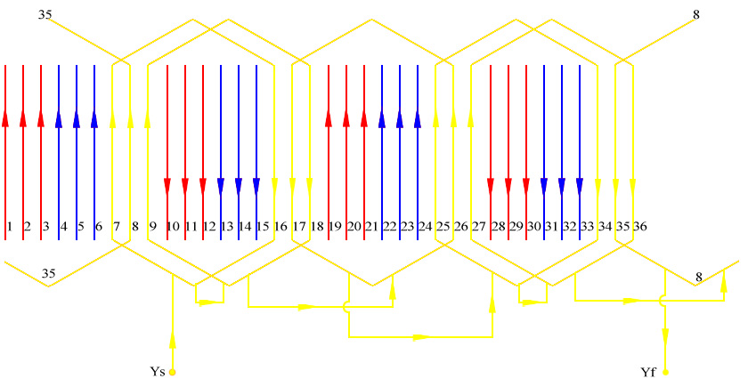

3.10 Make connections for Blue
Blue starts from 13th conductor

a. Connection starts at 13th conductor, B_{S}. It flows down 13, and up 22. It loops left and then goes down conductor 15, and up 24
b. The connection out of 24 connects to 32, as current is going down in 32
c. Connection flows down 32 and up 23, and comes out of 23
d. The connection out of 23 connects to 31, as current is going down in 31
e. It flows down in 31, and up 4, loops left, goes down 33 and up 6.
f. Connection out of 6 is connected to 14 as current is going down in 14
g. It flows down in 14 and up 5, and comes out of 5, which is the last conductor, B_{F}

Note: For Blue, direction of our movement is opposite to the arrow direction

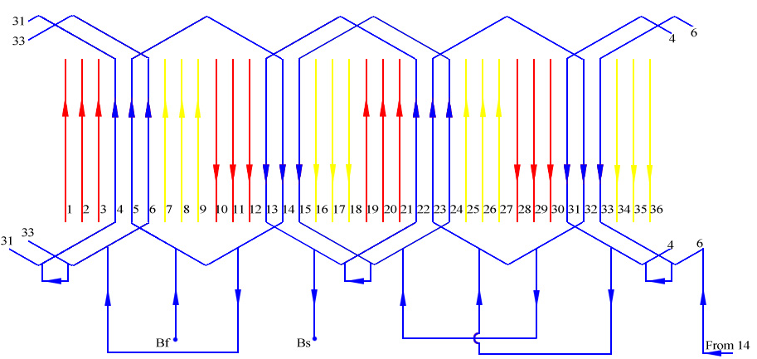

3.11 The above three diagrams are connections in Red, Yellow, Blue separately. Combining all in one diagram, the completed winding diagram as below

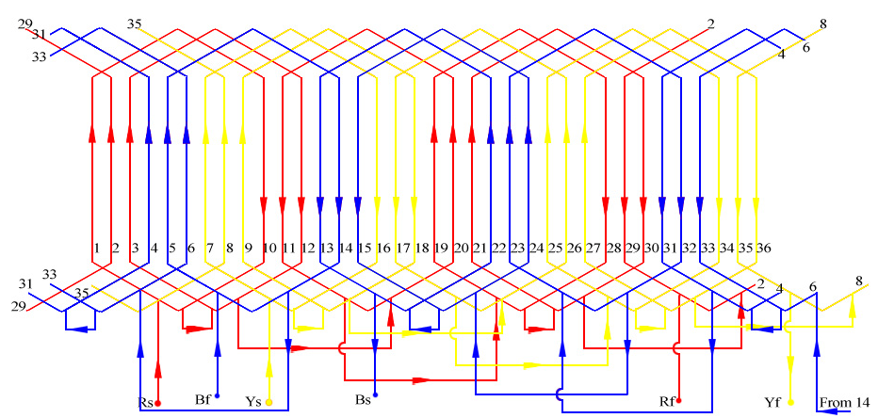

Note: In AC lap windings the current loops in –
- clockwise direction under North Pole
- anti-clockwise direction under South Pole

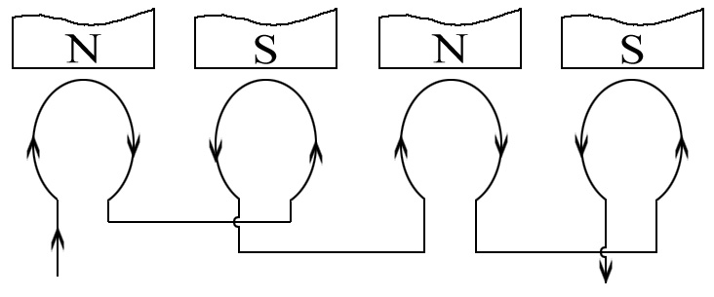

This is same for all Lap windings, full pitch and short pitch

kuldeeps10@yahoo.com (9845952486)

