A REMNANT OF ‘NILKUTHI’ IN BIRBHUM DISTRICT (WEST BENGAL)

Tapan Chatterjee
Indigo Revolt scattered all over then Bengal region in 1856. This lasted from 1859 to 1860. In the light of this revolt the great drama ''Neel Darpan'' was written by Dinabandhu Mitra from Dhaka. Indigo planting in Bengal dated back to 1777, Louis Bonnard was probably the first Indigo Planter in Bengal (from Wikipedia). In the village ‘Gunutia’ near Ramnagar at Birbhum district, there is a remnant of a ‘Nilkuthi’, which is going to be destroyed. In spite of its historical importance, it does not get any attention of the authorities. The property is now under private ownership and there is no maintenance of the diminishing structures including the old houses, Nil processing units, the tombs of the British owners, etc. In addition to that the garden contains many varieties of rare plants. The place is accessible from Sainthia at birbhum district by Ramnagar bound Private Buses.

Indigo Factory (from Wiki pedia). Indigo Planting in Bengal dated back to 1777. Louis Bonard was probably the first Indigo Planter in Bengal

Indigo Revolt scatterred all over then Bengal region in 1856. This lasted from 1859 to 1860. In the light of this revolt the great drama ''Neel Darpan'' was written by Dinabandhu Mitra from Dhaka. This picture is from a Neel Kuthi at Gunutia near Sainthia in Birbhum
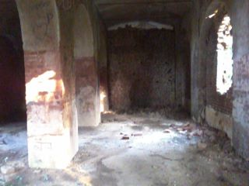
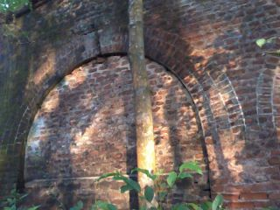

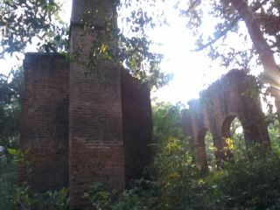

Indigo Revolt scattered all over then Bengal region in 1856. This lasted from 1859 to 1860. In the light of this revolt the great drama ''Neel Darpan'' was written by Dinabandhu Mitra from Dhaka. Indigo planting in Bengal dated back to 1777, Louis Bonnard was probably the first Indigo Planter in Bengal (from Wikipedia). In the village ‘Gunutia’ near Ramnagar at Birbhum district, there is a remnant of a ‘Nilkuthi’, which is going to be destroyed. In spite of its historical importance, it does not get any attention of the authorities. The property is now under private ownership and there is no maintenance of the diminishing structures including the old houses, Nil processing units, the tombs of the British owners, etc. In addition to that the garden contains many varieties of rare plants. The place is accessible from Sainthia at birbhum district by Ramnagar bound Private Buses.

My aim of writing this note is to attract the attention of readers interested in our history and also the authorities for conservation of this invaluable asset of historical importance.

