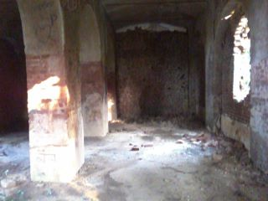

Fig. 1: Inside of the Neelkuthi

