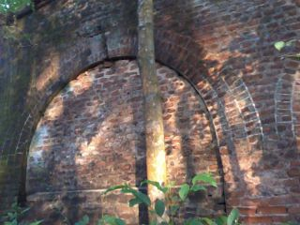

Fig.2: A tomb on a grave of the British owner

