[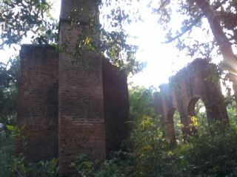](http://www.facebook.com/photo.php?fbid=242808622439353&set=a.143400662380150.35613.100001306508035&type=1&ref=nf)

## Remnant of Neel processing unit