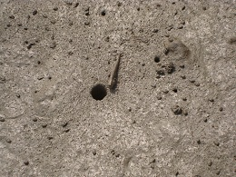

Fig.1: A mud skipper near its burrow

