SCHOLASTIC APTITUDE TEST 1995
CHEMISTRY
Time: 1 Hour | Max.Marks : 60

• Instructions:
(1) Answer must be written either in English or the medium of instruction of the candidate in high school.
(2) There will be no negative marking
(3) There are FIVE Sections. Answer all questions of a section at one place
(4) Use of calculators or graph papers is not permitted
(5) Marks allotted for individual sections are as follows. All questions in an individual section carry equal marks.

SECTION-I
Differentiate the following: (10x2=20 Marks)
1. Equilibrium constant - Rate constant
2. Ionic product - Solubility product
3. Activation energy - Threshold energy
4. Valency - Oxidation state
5. Allotropy - Enantiotropy
6. Lattice energy - Hydration energy
7. Specific heat - Atomic heat
8. Electrolysis - Hydrolysis
9. Gangue - Slag
10. Diffusion - Effusion
SECTION-II
Explain the following Facts: (10x1=10 Marks)
1. White phosphorus is highly reactive than all other allotropic forms forms of phosphorus.
2. The bond angle is ammonia is 107⁰ but in CH₄ is 109⁰ 28’.
3. Aluminium containers are used to carry conc. HNO₃.
4. The temperature of aqueous solution may increase or decrease when certain salts are dissolved.
5. Cl₂ is non-polar while ICI is polar.
6. Electron affinity of nitrogen is zero while carbon and oxygen have substantial electron affinities.
7. NH₃ is a base while NF₃ is not a base.
8. Mercury acts as a conductor in the liquid state as well as in the solid state, whereas NaCl acts as a conductor only in the molten state.
9. Oxidising strength of halogens decrease down the group.
10. p^{H} of the 10⁻⁸ M HCl is not equal to 8.
SECTION-III
Fill in the blanks: (15x1=15 Marks)
1. An element Z has two isotopes of atomic masses 16 and 18. Its overall atomic weight is 16.4. The proportion of the isotope 16 in Z is ______________________
2. The value of B is double that of `A’ and gas B is at double temperature and pressure. The number of moles B to A will be _______________________
3. 96.87% of a radio active substance disintegrated in 96.87 mints. The t1 of this is ___________
4. The total pressure of the mixture of two moles of oxygen and three moles of hydrogen is equal to 800 kpa. The partial pressure of oxygen in the mixture equals ______________ atm.
5. During the disintegration of radium, helium is produced. What volume of the helium produced at STP due to the disintegration of 2 grams of ²²⁴Ra after 3.65 days in a closed vessel. (t1 of ²²⁴Ra is 3.65 days) ______
6. The possible correct set of four quantum numbers for unpaired electron of chlorine atom _________
7. A gaseous oxide of nitrogen on strong heating gave a gaseous mixture not absorbed by water on cooling, the volume of gas found to be 1.5 times that of the oxide taken. Formula of oxide is _________
8. One mole of hydrogen iodide is heated in a closed container of capacity 2 litres. At equilibrium half a mole of hydrogen iodide has dissociated. The equilibrium constant is ___________
9. The number of sulphur atoms present in 100 ml of 0.1 M H₂SO₄ is _____________
10. A solution of sodium metal in liquid ammonia is strognly reducing due to the presence of __________.
11. When electron occupy orbitals of the same energy, each orbital is occupied by __________ with the spins of the electrons remaining ____________ before pairing takes place. This is principle is known as __________________
12. In the extraction of the copper from ore of copper, iron component is eliminated in the form of ________________ (formula)
13. Blue colour copper sulphate solution is stirred with Zn spoon, colour of the solution slowly fades away this is due to _________________________
14. The species M³⁺ has the electronic configuration 1s² 2s² 2p⁶ 3s² 3p⁶ 3d³. The atomic number of the element is _______________
15. Acid buffer solution of p^{H}=3 is prepared by mixing sodium acetate and acetic acid. If the resulted solution is 10 times diluted p^{H} of the solution is __________________.
SECTION-IV
Multiple Choice: (5x1=5 Marks)
1. The Khibini apatite contains 39.7% Ca, 38.1% O and 3.8% F the qualitative composition of the apatite can be represented by the formula
A) Ca₃(PO₄)₂F | B) Ca₅(PO₄)F | C) Ca₅(PO₄)₃F | D) Ca₂PO₄F
2. A solution with a mass percent of sodium hydroxide equal to 6% is prepared by adding the following mass of water (grm) to 200g of a solution with a mass percent of sodium hydroxide of 30%
A) 300 | B) 500 | C) 800 | D) 1000
3. KCl solution was left in a flask several weeks passed and a precipitate was formed in the flask. The solution over the precipitate is
A) Dilute | B) Super saturated | C) Saturated | D) Unsaturated
4. For a particular value of azimutal quantum number (l ) the total number of magnetic quantum number (m) is given by
A) 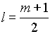 | B) 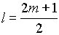 | C) 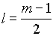 | D) 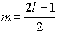
5. In the reaction between zinc and hydrochloric acid, a zinc cube of 1 gram mass was reduced into 1000 equal cubes. The volume of the evolving hydrogen per sec. will
A) remains unchanged | B) increases about 10 times
C) increases by about 100 | D) increases about 1000
SECTION-V
Solve the Problems: | (10 Marks)
1. What is the molecular weight of the substance, each molecule of which contains 8 carbon atoms, 13 hydrogen atoms and 3.33x10⁻²³g of other components.
2. Radium disintegrates by emitting α particles. Rate of disintegration of radium is 8.15x10¹² each second, during which 1.35x10⁻¹¹ moles of helium is formed. Calculate Avagadro’s number.
3. Nitrogen, phosphorus, and potassium are plant nutrients that are provided for most crops in large quantities. Often chemicals containing these three nutrients are mixed in varied proportions to make fertilisers of different compositions. The composition of a given mixture is usually indicated by three numbers printed on the fertiliser bag. The first number is the percentage of nitrogen in the mixture; the second gives the amount of phosphorus as if it were present as P₂O₅ (that is, as the percentage of P₂O₅ in the mixture); the third gives the amount of potassium as if it were present as K₂O in the mixture. For example, the numbers 15-10-5 indicate a composition of 15% total nitrogen, an amount of phosphorus equivalent to 10% P₂O₅, and an amount of potassium equivalent to 5% K₂O.
Calculate the weights (in grams) of nitrogen, phosphorus, and potassium in a 1.00 kg sample of a 15-10-5 fertiliser. (Atomic weight of N=14, K=39, P=31)
SCHOLATIC APTITUDE TEST 1996
SECTION-I
Fill in the Blanks (20 x 1 = 20 Marks)
1. The actual species exist in the aqueous solution of H₂SO₄ are ____________________________
2. He, Ne, Ar, Kr, Xe are called inert gases, but to create inert conditions during the chemical reactions nitrogen gas is used. The inert behaviour of nitrogen is due to ____________________
3. pH of the aqueous solution increases with dilution. pH of the solution increases by one unit on 10 fold dilution. One litre of solution of pH=6 is diluted to 100 litres pH of the resulted solution is nearly _______________
4. Four quantum numbers of the electron is useful in determining the spatial position of the electron in given atom. The four quantum numbers of the differentiating electron in scandium atom (Sc=21) is ______________
5. Radio activity is the property of instable nucleus. Atoms with instable nucleus emits α , β , γ radiations. The instability of the nucleus is due to __________________
6. Bond dissociation energy of the Cl₂ is greater than that of F₂ as well as Br₂.This is due to ________
7. Zinc decolourises the blue colour of aqueous blue vitriol, but silver does not do so. This is because ___________________
8. Every atom and ion contain three fundamental particles. The difference between the mercury () atom and mercurous ion is ______________ (in terms of number of fundamental particles)
9. Chemical formula of the compound which is commonly used to detect presence of Cl⁻ ion in drinking water is _____________________ and this compound can be detected by using ______________ aqueous solution
10. Most of the elements exist in the nature only in the form of compounds this is due to ___________
11. __________________________ is used to detect the presence of water.
12. When a compressed gas at a temperature is allowed to expand through a small porous plug or small orifice the temperature of gas ________________________
13. Self addition to form macro molecules is characteristic reaction exhibited by many unsaturated compounds. PVC obtained by ______________________
14. During chemical bonding BF₃ molecule always accepts pair of electrons to form a bond. This is due to __________________
15. Allotropy is the phenomenon of an element in which the element shows different physical properties and similar chemical properties. This is due to _______________________________
16. Be, Mg, Ca, Sr and Ba metals are called alkaline earth metals. This is due to _________________
17. A covalent bond is formed by the equal sharing of electrons from the bonded atoms. The actual forces responsible for holding the atoms together in the molecule are _______________________
18. According to collision theory rate of a reaction is directly proportional to the number of effective collisions per second. The meaning of the effective collisions is __________________________
19. _________________________ is used as a flux in blast furnace to remove _________________ in the extraction of iron
20. Theoretically the orbitals present in hydrogen atom are ________________________
SECTION-II
Explain the following: | (10 x 2¹/₂ = 25 Marks)
1. Some chemical reactions are reversible and some are irreversible.
2. The boiling points of hydrogen compounds of oxygen family can be represented graphically as follows:
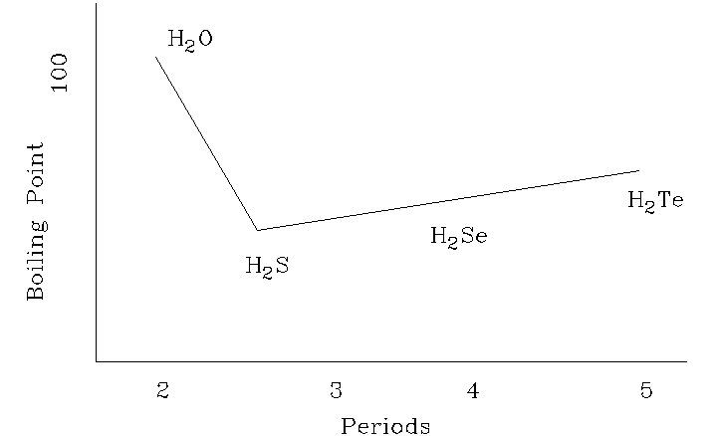
3. Solubility is generally defined as the number of grams of the solute present in 100 gm of the solvent at a given temperature. Generally as the temperature increases solubility increases but in few cases it decreases with increase of temperature.
4. Molality of the solution is independent of temperature where as molarity is dependent on temperature.
5. According to the equation 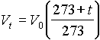, when t = -273⁰C V_{t} becomes zero. i.e. a gas would occupy no volume at all
6. What type of graphs are obtained for P vs V under isothermal conditions of T₁, T₂, and T₃ where T₃ > T₂ > T₁. To compare draw them in a single figure.
7. Only under certain conditions real gases obey the Boyle’s law.
8. Generally rate of the chemical reaction exponentially decreases with time.
9. pH of the 0.1 M HCl is 1, but 0.1 M acetic acid solution is greater than 1.
10. Glass is called as supercooled liquid.
SECTION-III
Solve the Problems: | (15 Marks)
1. 6.3 gm of oxalic acid crystals (C₂O₄H₂.2H₂O) in 250 ml flask is treated with excess of concentrated sulphuric acid. Heat the flask gently. The two gas components which are released passed through the caustic soda. Finally one gas is collected over water.
a) what is the function of concentrated H₂SO₄?
b) what are the gas components ?
c) what gas component is absorbed by caustic soda?
d) if the absorption is chemical process, write the chemical equation
e) how many grams of each component is released?
f) what is the pressure of the gas collected over water, if the volume of the gas is 2 litres and temperature of gas is 27⁰C (aqueous tension = 30 mm Hg at 27⁰C). ( 6 )
2. When salt `A’ is treated with concentrated H₂SO₄ , `B’ (solid) and `C’ (gas) are formed. `C’ forms white fumes with NH₃ . `B’ is treated with coke and lime stone and heated to 800⁰C, a solid `D’ is formed. `D’ is treated with water to obtain a solution E and a solid F. When excess CO₂ gas is passed through this solution precipitate `G’ is formed. `G’ on strong heating gives `E’. Write the sequence of chemical reactions and identify the substances from A to G. ( 3 )
3. 0.1525 gm of an unknown liquid on evaporation displaces 35.05 ml of air and collected in a graduated glass burette. The pressure of displaced air is 730 mm Hg and the temperature is 20⁰C. Calculate the molecular weight of the liquid. ( 3 )
4. In the chemical reaction 2X+3Y 4Z
1.0 mole of X, 1.25 mole of Y and 2.5 mole of Z are found at equilibrium in a 1.0 litre reaction mixture.
a) calculate the value for K
b) calculate the value for K if the same mixtrue had been found in a 2.0 litre vessel. ( 3 )
SCHOLASTIC APTITUDE TEST 1997
SECTION-A
Explain the following Facts (write the equations wherever necessary) (15 x 2 = 30 Marks)
1. For the detection of CO₂ lime water is used.
2. Electronegativity of N₂ is considerable but it is used as inert gas.
3. For the detection of Nitrates in the laboratory, to the Nitrate and Ferrousulphate aqueous solution sulphuric acid is slowly added through the walls of the test tube.
4. PV = nRT (Gras equation) is not applicable to real gases under all conditions.
5. Graphite as well as diamond both are the allotropes of carbon but Graphite is used as lubricant, where as diamond is used as abrasive.
6. White phosphorus is always stored in water but sodium metal is stored in kerosene.
7. Bohr’s atomic model is superior than the Ruthurford atomic model.
8. Cl₂ and SO₂ both are bleaching agents, but only Cl₂ is more frequently used as bleaching agent.
9. Across the period usually size of the atom decreases but size of the Inert gas in the given period is more than that of adjacent halogen.
10. Even though Zn is more reactive than Iron, surface of the Iron is converted with Zinc to protect from corrosion.
11. All minerals of a metal are not used for the extraction of metal.
12. Wooden shelf under the reagent bottle containing concentrated sulphuric acid blackens after some time.
13. Organic compounds don’t ionise when dissolved in water.
14. Electrolysis of Molten sodium chloride gives sodium and Cl₂, but aqueous. Solution of NaCl gives Hydrogen and Cl₂ gas.
15. Zinc displaces hydrogen from dilute acids but copper does not.
SECTION-B
Write the correct answers A,B,C,D,E: (5x1¹/₂ = 7¹/₂ Marks)
1. Three sets of quantum numbers are listed below pick the correct answer
a) n = 2 l = 2 ml = 2 m_{s} = ¹/₂
b) n = 4 l = 0 ml = 0 m_{s} = ¹/₂
c) n = 3 l = 2 ml = 3 m_{s} = ¹/₂
d) n = 3 l = 2 ml = 3 m_{s} = ¹/₂
A) a and b are allowed sets c is not |  | B) b and c are allowed sets a is not
C) all the 3 are allowed sets |  | D) only b is an allowed set
E) all 3 are not allowed sets
2. Given three statements below pick the correct answer
a) Cl has a higher electron affinity than P
b) the ionisation energy for Si is greater than p
c) the electron affinity for `O’ is greater than the S
A) a and c are true b is false | B) b and c are true a is false
C) a and b are true c is false | D) all the true are true
E) only b is true
3. Of the three which would be isoelectronic with oxygen atom
a) N⁺ | b) F⁻ |  | c) Ne²⁻
A) a and b are isoeletronic c is not |  | B) only a is isoelectronic
C) only b is isoelectronic |  |  |  | D) all are isoelectronic with oxygen
E) none are isoelectronic with O
4. In the natural radioactive decay chain U²³⁸ undergoes a series of radioactive decays finally producing the stable nuclide Pb²⁰⁶.
what are the values of a and b in this decay chain.
A) a = 10, b = 16 | B) a = 8, b = 6
C) a = 6, b = 8 | D) a = 16, b = 10
E) none of these
5. Which of these statements are true?
A) if two salts have equal solubility their solubility products are equal
B) BaSO₄ is more soluble in water than in dilute H₂SO₄
C) The solubility of a sparingly soluble salt is decreased by addition of a solute containing a common ion
D) If KI is added to a saturated solution of PbI₂ the concentration of Pb²⁺ ions in the solution decreases
E) In a solution containing AgCl the product of concentration of Ag⁺ and Cl⁻ is constant at constant temperature.
Match the Following (2 ¹/₂ Marks)
i). Aluminium hydroxide | a. fine extinguisher
ii). Ammonium sulphate | b. refrigerant
iii). Copper sulphate | c. Amphoteric
iv). Carbon dioxide | d. Fertiliser
v). Ammonia | e. fungicide
SECTION-C
Fill in the Blanks: (20x1=20 Marks)
1. A large quantity of red phosphorus is used in match industry. The Matches which we use are called safety Matches. The head of the stick consists of _____________ and ____________ together with gum. The striking surface is composed of ___________, ____________ and fine glass to produce rough surface.
2. Pyrolusite is fused with KOH in the presence of air ____________ is formed.
3. 500 ml of 0.1 M HCl is treated with 250 ml of 0.1 Mole of NaOH. The amount of the heat liberated is ______________ k.cal.
4. Pressure remaining constant at what temperature the volume of a gas will be double of its volume at OºC __________________
5. The energy indicated in the equation Cl_{g}  Cl + e⁻ - 1254 kJ is equal to ____________
6. Many thallous compounds are known but not thallic compounds because of _____________
7. The elements in which outer most shell incomplete are called _______________
8. As the temperature increases rate of reaction increases. This is due to ____________
9. Caffeine (Mol/wt = 194) contains 28.9% Nitrogen atoms in one Molecule of Caffeine is ___________
10. When 5p orbitals are filled completely, the differentiating electron enters into ______________
11. One mole of hydrogen iodide is heated in a closed container of capacity 2 lit. At equilibrium half a mole of hydrogen iodide has dissociated. The equilibrium constant is ______________
12. When zeolite which is hydrated sodium aluminium silicate is treated with hard water the sodium ions are exchanged with ________________ ions.
13. A Gaseous mixture contains oxygen and nitrogen in the ratio of 1:4 by weight. Therefore the ratio and their number of molecules is _____________
14. A mixture of sodium nitrate and ammonium chloride on strong heating gives rise to a colourless gas known as _______________
15. Radioactive isotope of hydrogen has ______________ neutrons.
16. Lithium is strongest reducing agent because of its ______________
17. A child has a temperature of 104⁰F . Body temperature of the boy in Celsius scale ___________
18. A supersaturated solution can form when temperature of a saturated solution is __________ and no crystals farm.
19. Major industrial source of hydrocarbons is ____________ which was formed from __________
20. Insufficient amounts of iodine in diet result in a condition called ___________, which is an __________ of the thyroid. This condition can be prevented by consuming Iodine containing foods such as _______________ and _______________

SCHOLASTIC APTITUDE TEST 1998
I. Multiple choice. Each question has one or more than one answer(s). Indicate the correct answer(s) by A,B,C,D. (5x1 = 5 Marks)
1. 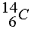is a beta-active nucleus. A sample ¹⁴CH₄ gas kept in a closed vessel shows increase in pressure with time. This is due to
A) formation of ¹⁴NH₃ and H₂ | B) formation of ¹¹BH₃ and He
C) formation of ¹⁴C₂H₄ and H₂ | D) formation of ¹²CH₃, ¹⁴NH₂ and H₂
2. For a particular value of azimuthal quantum number (l) the total number of magnetic quantum number (m) is given by
A) 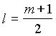 | B) 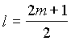 | C) 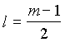 | D) 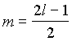
3. For a reaction 4A+B ® 2C+2D
which of the following statements is/are not correct
A) The rate of disappearance of B is one forth the rate of disappearance of A
B) Rate of appearance of C is one-half the rate of disappearance of B
C) The rate of formation of D is one-half the rate of consumption of A
D) Rate of formation of D is one-half the rate of consumption of A
4. Choose the correct statements
A) Under the similar conditions of pressure and temperature one mole of
all the gases have the same volumes
B) The average K.E. of gas molecules is proportional to absolute temperature
C) At absolute zero temperature the volume of a gas is expected to be zero
D) 273⁰C and 760 mm of Hg pressure are the standard temperature and pressure
5. Five valance electrons of ₁₅P are labelled as
If spin quantum of B and Z is +.
The group of electrons with three of the quantum number same are
A) XYZ, AZ | B) AB, XYZ, BY | C) AB | D) AB, XYZ

II. Write the balanced Chemical Equations for following chemical changes | (5x2=10 Marks)
1. Elemental phosphorus reacts with conc.HNO₃.
2. Carbondioxide is passed through a suspension of lime stone in water.
3. Conc.H₂SO₄ is drop wise added to the mixture of NaCl and MnO₂.
4. NaCl reacts with an aqueous solution of NH₃ saturated with CO₂ gas.
5. Aqueous solution containing potassium nitrate and ferrous sulphate is treated with conc.H₂SO₄.
III. Give reasons in one or two sentences for the following: (10x2 = 20 Marks)
(Write the chemical equations wherever necessary)
1. The hydroxides of aluminium and Iron are insoluble in water. However, NaOH is used to separate one from the other.
2. Helium is monatomic, while hydrogen is diatomic molecule.
3. Fluorine has less electron affinity than chlorine but electronegativity of fluorine is more than that of chlorine.
4. White precipitate is formed when AgNO₃ is treated with NaCl(aq) but no precipitate is formed when AgNO₃ is treated with CCl₄.
5. Dry SO₂ and Cl₂ does not bleach dry flowers.
6. Although aluminium is above hydrogen in the electrochemical series it is stable in air and water.
7. When hydrogen gas is bubbled through acidified potassium permanganate solution, pink colour is not discharged, but when few pieces of metal zinc are added to it, the pink colour disappears immediately.
8. When blue crystals of CuSO₄.5H₂O are added to conc.H₂SO₄ they turn white.
9. Ferric chloride solution used as a reagent in the laboratory is prepared by dissolving, Ferric chloride not in mere water, but in hydrochloric acid.
10. Sulphur melts to a clear mobile liquid at 119⁰C but on further heating above 160ºC it becomes viscous.
IV. Fill in the blanks | (15x1 = 15 Marks)
1. The weight of 1x10²² molecules of CuSO₄.5H₂O is ________________.
(atomic weight of Cu=63.5; S=32; O=16 amu)
2. The blue complex formed, on addition of conc.NH₄OH solution to a Cu²⁺ salt solution has the structure _________________.
3. The temperature at which the real gases obey the equation pV=nRT under all pressure conditions is known as ___________.
4. Molten sodium chloride conducts electric current due to the presence of __________.
5. The atomicity of a species is x and its atomic weight is y. The molecular weight of the species is ___________________.
6. An element has atomic weight 2Z+6 where Z is the number of extra nuclear electrons in the atom, then the number of neutrons in the nucleus is ____________.
7. A container holds an equimolar mixture of H₂ and O₂. If through small hole the mixture is allowed to diffuse, the mass ratio of H₂:O₂ in the initial diffusing gases is ___________.
8. Helium obtained at STP by the disintegration of 2 grams of ²²⁴Ra after 3.65 days in a closed vessel t_{1/2} of ²²⁴Ra is 3.65 days _____________.
9. The shift in the equilibrium 2CO + O₂ 2CO₂ + Heat
on increasing the temperature and decreasing the volume simultaneously, is __________.
10. Equal weights of hydrogen and methane are mixed in an empty container at 25⁰C. The fraction of total pressure exerted by hydrogen is ___________________.
11. An element which can exist as a positive in acidic solution and also as a negative ion in basic solution is said to be ____________.
12. A mixture of hydrogen and oxygen (45 ml) is sparked to form liquid water. The component not in excess reacts completely and 15 ml is leftover (all measurements are at the same temperature and pressure). The composition by volume in the original mixture of H₂ and O₂ is ____________.
13. The formula of deep red liquid formed on warming potassium dichromate with KCl in concentrated sulphuric acid is _______________.
14. The metal which reacts with dilute nitric acid but becomes passive with conc. Nitric acid is _______________.
15. Ship hull is protected against corrosion by attaching zinc blocks because __________.
V. Arrange the following as stated (5x1 = 5 Marks)
a) Increasing order of ionic size [N³⁻ , Na⁺ , F⁻, O²⁻, Mg²⁺ ]
b) Increasing the strength of hydrogen bonding (X ……… H - X ) [O, S, F, Cl, N]
c) Increasing order of basic character [MgO, SrO, K₂O, NiO, Cs₂O]
d) Increasing order of bond dissociation [N₂, O₂, F₂, Cl₂]
e) Increasing order of Ist I.P. [Na, Al, Mg, Si]
VI. Explain the following: (5x1 = 5 Marks)
(Give the Chemical equations wherever required)
1. What do you mean by Hardwater , heavy water, and distilled water.
2. Name the element whose atomic number is 17 and atomic mass is 35.5. Explain why it has fractional atomic mass.
3. State and explain the principle which restricts the number of electrons in an orbital to two.
4. HCl can be prepared by heating NaCl with conc.H₂SO₄while HBr cannot be prepared by heating NaBr with conc.H₂SO₄. Explain why?
5. Magnesium metal burns in air to give a white ash. When this ash is treated with water the odour of ammonia can be detected. What is the reason.
SCHOLASTIC APTITUDE TEST 1999
I. Multiple choice. Each question has only one correct answer. Indicate the correct answer by A,B,C,D. (5x1 = 5 Marks)
- The electronic configuration of elements A,B,C and D are (2,8,1) (2,8,2) (2,8,6) and (2,8,7) respectively which of them can make an ion with two negative charges.
A) A | B) B | C) C | D) D
- A neutral atom of an element has a nucleus with a nuclear charge 13 times and mass 27 times that of hydrogen nucleus. How many electrons would be in its stable positively charged ion.
A) 27 | B) 14 | C) 13 | D) 10
- At any moment before reversible reaction attains equilibrium it is found that
A) The velocity of the forward reaction is increasing and backward reaction is decreasing
B) The velocity of backward increasing and forward decreasing
C) The velocities of both forward and backward reaction are increasing
D) Velocities of both forward and backward reaction decreasing
- When the same amount of Zn is treated separately with excess of sulphuric acid and excess of sodium hydroxide the ratio of volumes of hydrogen evolved is
A) 1:1 | B) 1:2 | C) 2:1 | D) 9:4
- Which of the four conditions density of the nitrogen gas will be largest
A) STP | B) 273 K and 2 atm
C) 546 K and 1 atm | D) 546 K and 2 atm
II. Write the balanced Chemical Equations for following chemical changes: (5x1=5 Marks)
- Zn granules are dropped in to very dilute solution of nitric acid.
- Mixture containing CO₂ and CO is passed over the redhot coke.
- Ammonium nitrate is strongly heated.
- White phosphorus is treated with caustic soda solution.
- KI is treated with con.H₂SO₄ solution.
III. Explain the following Facts: (10x2 = 20 Marks)
(Write the chemical equations wherever necessary)
- NO₂ is reddish brown gas but on cooling it becomes colourless but on heating again it gains the colour.
- Potassium chromate in water forms yellow solution. On addition of acid this solution turns orange, on addition of NaOH to the orange solution again becomes yellow.
- Calcination is carried in the absence of air whereas roasting is carried in the presence of air.
- Gold is insoluble in either in con. HCl (or) HNO₃ separately while it is soluble in aqua-regia a mixture of both.
- Ist Ionisation energy of Nitrogen is greater than oxygen where as reverse the case for 2nd Ionisation value.
- To protect the Iron from corrosion it is covered with zinc (Galvanisation) even though zinc is more reactive than Iron.
- When Nitric acid is exposed to light slowly turns yellow.
- In the detection of 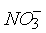through Brown ring test, concentration H₂SO₄ slowly added through the walls of Test tube.
- Ammonium chloride is a salt, but its aq.solution terns blue litmus red.
- Metallic zinc displaces Hydrogen gas from dilute H₂SO₄ but metallic copper doesnot.
IV. Fill in the blanks (5x1 = 5 Marks)
- Ratio of weights of O₂ and O₃ is 1:1 so the ratio of their moles is ___________________.
- 250 ml of 6M HCl, 650 ml of 3M HCl were mixed together. The volume of water should be added to make the solution 3M is _____________________ ml.
- If a hospital buys 8 grms of Co⁶⁰, the amount of same cobalt left after 20 years would be (t_{1/2} of Co⁶⁰ = 5 years) _________________.
- The central atom of a molecule of the type AX₃ has one lone pair in its valance shell. The shape of the molecule is _______________.
- An element which can exist as (+) ve ion in acidic solution but also as a negative ion in basic solution is said to be ______________________.
V. Differentiate the following: (10x2 =20 Marks)
- oils - fats
- ionisation - electrolysis
- thermoplastics - thermosetting plastics
- soap - detergent
- sublimation - liquification
- metallic conductor - electrolytic conductor
- hygroscopic solids - deliquescent solids
- cathode - anode
- bond energy - binding energy
- ionic product - solubility product
VI. Solve the following: (2x2½=5 Marks)
- Sodium bicarbonate (baking soda), NaHCO₃, can be purified by dissolving it in hot water (60⁰C), filtering to remove insoluble impurities, cooling to 0⁰C to precipitate solid NaHCO₃, and then filtering to remove the solid, leaving soluble impurities in solution. Any NaHCO₃ that remains in solution is not recovered. The solubility of NaHCO₃ in hot water at 60⁰C is 164 g/L. Its solubility in cold water at 0⁰C is 69 g/L. What is the percent yield of NaHCO₃ when it is purified by this method?
- Hash Chemical Company sells a test kit for determining the concentration of chloride ion in domestic water supplies. The kit contains a silver nitrate, AgNO₃, solution that is added drop by drop to a 23.0 mL water sample to which an indicator has been added. When sufficient silver nitrate has been added to convert the chloride ion completely to silver chloride, AgCl, the solid produced turns orange. The concentration of the silver nitrate solution is such that each drop used to reach the color change corresponds to 12.5 mg of Cl⁻ per litre of water tested.
(a) What mass of chloride ion (mg/L) is contained in a water sample that requires 12 drops of test solution to reach the color change?
(b) What is the molar concentration of Cl⁻ in the sample tested in part(a)?
(c) If the sample size used is 5.75 mL instead of 23.0 mL, to what chloride ion concentration (mg/L) does 1 drop of the test solution correspond?
(d) If 20 drops of the silver nitrate test solution equals 1.00 mL, what is its molar concentration of AgNO₃?
SCHOLASTIC APTITUDE TEST 2000
I. Differentiate the following: (10x2 =20 Marks)
- orbit - orbital
- rayon - nylon
- strong acid - concentrated acid
- polypeptides - polysaccharides
- periodicity - periodic properties
- acidity - basicity
- solution - colloid
- normal salt - acid salt
- vanderwaal’s forces - intermolecular forces
- hardening - annealing
II. Write the balanced Chemical Equations for following chemical changes: (5x1=5 Marks)
- Photographic film is exposed to sunlight.
- Lightening strucks the atmosphere.
- Burning magnesium ribbon is inserted into a jar of carbondioxide.
- Lime water is exposed to air.
- Red hot Iron interacts with steam.
III. Explain the following Facts: (10x2 = 20 Marks)
(Write the chemical equations wherever necessary)
- Formation of F⁻(g) from F(g) is exothermic where as formation of O²⁻(g) from O(g) is endothermic.
- Acetylene reacts with ammonical silver nitrate where as ethylene does not react with this reagent.
- HF is weaker than HCl is aqueous solution.
- In the electroplating of an article, the metal to be plated on the article is made as anode and article to be electroplated is placed at the cathode.
- Pure NaCl is precipitated when HCl is bubbled through concentrated solution of brine.
- MgSO₄ crystallises with greater number of molecules of water of crystallisation than CaSO₄.
- CO₂ is gas where as SiO₂ is solid at room temperature.
- Across a period from left to right atomic size should increase as the number of electrons is increasing. But atomic size decreases.
- K₂Cr₂O₇ is used as oxidising agent in H₂SO₄ medium. Can we use HCl as acidic medium?
- An aqueous solution of I₂ becomes colourless on adding little NaOH solution to it.
IV. Fill in the blanks: (5x1 = 5 Marks)
- The volume of steam produced when a mixture of 22.4 litres of Hydrogen and 22.4 litres of oxygen is ignited at 100⁰C ___________________.
- In nuclear reactions there is conservation of ______________ and ____________ for reactants and products.
- Half life periods of two bromine nuclei ⁸⁰Br and ⁸⁰Br are 4.4 hr and 18 minutes respectively. These two nuclei are called _____________.
- Aminoacids are water soluble and have high melting points due to ______________.
- Iron is independently converted into FeCl₂ and FeCl₃ by reacting with _________ and ____________ respectively.
V. Multiple choice. Each question has one or more answers. Indicate the correct answer by A,B,C,D. (5x1 = 5 Marks)
- Which of the following equilibria is (are) affected by pressure change
A) N₂+O₂ Â 2NO | B) N₂+3H₂ Â 2NH₃
C) 2O_{3 Â} 3O₂ | D) H₂+Cl₂ Â 2HCl
- Atom X (with 1 valence electron), Atom Y (with 3 valence electrons) Atom Z (with 7 valence electrons) belong to same period in the periodic table. The correct formula(e) of compounds formed from these atoms are.
A) YX₃ | B) ZX₇ | C) XZ | D) YZ₃
- If ₉₂U²³⁵ undergoes decay only by emitting  and  particles, the possible product(s) of decay
A) ₈₉Ac²²⁷ | B) ₉₀Th²²⁷ | C) ₈₉Ac³²¹ | D) ₉₁Pa²³¹
- Auxochrome
A) Is responsible for the colour of the dye
B) forms chemical bonds between dye and fibre
C) intensifies the colour of the dye
D) all the above
- When a perfect gas is made to expand into vacuum at constant temperature
A) its internal energy increases
B) internal energy decreases
C) decrease in internal energy is followed by its conversion is to liquid
D) no change in internal energy
VI. Solve the following: (5 Marks)
- An experiment to measure Avogadro’s number involves the collection of a beam of alpha particles to which electrons are added to give neutral helium. Suppose that for a particular run it takes a number of electrons equivalent to 6.40x10⁻⁵ coulomb/sec to neutralise the beam, and that after 24 hours of collection 1.14x10⁻⁴ g of neutral helium are collected. From this data, determine Avogadro’s number. The charge on one electron is 1.602x10⁻¹⁹ coulombs. (24 hours is equivalent to 86,400 sec) 3M
- An element of atomic weight X consists of two isotopes of Mass number (X-1) and (X+2) what is the percentage abundance of heavier isotope. 2M
SCHOLASTIC APTITUDE TEST 2001
- The questions below (1-10) consist of an `Assertion’ in column 1 and the `Reason’ in column 2. Use the following key to choose the appropriate answer.
[10x1½=15 Marks]
- If both assertion and reason are CORRECT, and reason is the CORRECT explanation of the assertion.
- If both assertion and reason are CORRECT, but reason is NOT the CORRECT explanation of the assertion.
- If assertion is CORRECT, but reason is INCORRECT.
- If assertion is INCORRECT, but reason is CORRECT.
Assertion (column 1) | Reason (column 2)

1 | The rate at which sugar dissolves in water increases with stirring | Stirring exposes the surface of solute crystal to a less concentrated layer of solution
2 | Diamond has a higher melting point | In a diamond crystal, the carbon atoms are held in place by ionic bonds
3 | Potassium has a lower Ist ionisation energy than lithium has | Potassium has more protons in its nucleus than lithium has
4 | Zinc metal will reduce Cu²⁺ in solution | Zinc is a more reactive metal than copper
5 | CH₃COOH+H₂O == CH₃CO+H₃O⁺  If some acetic acid is added to the equilibrium mixture represented by the equation above, the concentration of HO decreases. | The equilibrium constant of a reaction changes as the concentration of reactant changes
6 | Fluorine is the highest electronegative element | Electro-negativity is the inherent property of the free atom of an element
7 | Aromatic compounds give more soot than aliphatic compounds | Aromatic compounds are highly inflammable compounds
8 | have different chemical properties | They have the same number of electrons and also similar electronic configuration
9 | Heat of neutralisation for both HNO₃ and HCl with NaOH is 53.7kJ mole⁻¹ | The bond strength in O-H in HNO₃ and H-Cl in HCl are equal
10 | Bond angle in methane is 109⁰ 28’ | Mixing of the atomic orbitals prior to overlap which changes the special distribution of orbitals
II. Explain the following Facts: [10x2=20 Marks]
1. SO₂ has dipole moment but CO₂ has no dipole moment.
2. Amino acids are covalent compounds but exhibit properties like ionic salts.
3. N³⁻ and O²⁻ are isoelectronic but N³⁻ is larger in size than O²⁻.
4. Oxygen, Nitrogen and carbon have unpaired electrons 2,3,2 respectively. Their valencies are 2, 3 and 4 respectively.
5. All minerals are not used to extract the metal.
6. Melting point and Boiling point of Ionic compounds are higher than the covalent compound.
7. Glass is called as super cooled liquid.
8. p^{H} of aq.solution of NaCl is 7, but aq.solution of NaF is greater than 7.
9. KOH is much more soluble in liquid NH₃ containing water than in pure liquid Ammonia.
10. Iron is mostly used in the form of steel.
III. Differentiate the following: [10x2=20 Marks]
1. drugs - pharmaceuticals
2. magic numbers - quantum numbers
3. molecular formula - structural formula
4. amino acid - proteins
5. heat of reaction - activation energy
6. mixture - compound
7. emulsion - suspensions
8. displacement reaction - double decomposition reaction
9. mono saccharides - polysaccharides
10. barometer - manometer
VI. Solve the following: [5 Marks]
- A friend is trying to balance the following equation
N₂ + H₂  NH₃
He presents you with his version of the balanced equation N + H₃  NH₃ . You immediately recognize that he has committed a serious error; however, he argues that there is nothing wrong, since the equation is balanced. What reason can you give to convince him that his method of balancing the equation is flawed. 1M
2. Titanium dioxide is used as the base powder for a variety of cosmetics. Say you decide to manufacture TiO₂ in a furnace by the reaction Ti + O₂ ® TiO₂ . Your titanium supplier can supply titanium at Rs.2.00 per gram. In your process, the reaction has a 33% yield. Market forces demand that you sell your TiO₂ product at a cost no more than Rs.3.50 per gram.
  - Assuming that you can sell as much TiO₂ as you can make and the O₂ is freely available from the atmosphere, is it profitable for you to manufacture TiO₂?
  - If it is not profitable to make TiO₂, what do you need to charge, per gram, in order to break even, assuming no other costs than the Ti metal?
  - If you can’t increase the price of the TiO₂, yet you still want to make a profit, what specific thing do you need to do with your process?(Atomic Wt. Ti=48) 2M
3. Carborundum is silicon carbide, SiC, a very hard material used as an abrasive on sandpaper and in other applications. It is prepared by the reaction of pure sand, SiO₂, with carbon at high temperature. Carbon monoxide, CO, is the other product of this reaction. Write the balanced equation for the reaction, and calculate how much SiO₂ is required to produce 3.00 kg of SiC. (Atomic Wt. Si = 28) 2M
SCHOLASTIC APTITUDE TEST 2002
I. Multiple choice. Each question has more than one answer. Indicate the correct answer by A,B,C,D. (10x1½=15 Marks)
1. All the elements in a group in the periodic table have different
A) atomic weights B) number of electrons C) mass number D) atomic number
2. To understand the behaviour of molecules it is necessary to have a thorough understanding of which of the following properties of chemical bonding
A) bond types B) bond angles C) bond lengths D) bond energies
3. Choose the correct statements
A) the density of a gas varies with temperature
B) the density of a gas varies with pressure
C) the volume of a gas always increases when temperature increases
D) the volume of a gas may not increase when the temperature increases
4. The photosynthesis reaction is 6CO₂(g) + 6H₂O(l) C₆H₁₂O₆(s) + 6O₂(g) with  H=2802KJ consider the reaction to be at equilibrium. In order to increase the synthesis of
C₆H₁₂O₆
A) the amount of CO₂ should be increased
B) the amount of H₂O should be increased
C) the temperature should be increased
D) the partial pressure of CO₂ should be increased
5. Which of the following statements are correct for weak acid
A) only some of the ionisable hydrogen atoms are present as hydronium ions
B) the proton transfer equilibrium favours the ionised acid molecules
C) weakness refers to the number of moles of acid for litre
D) all simple carboxylic acids containing-COOH group are weak acids in water
6. Choose the correct alternatives
A) in all calculations involving solubility products the ion concentrations are expressed in units of solute per litre
B) in all calculations involving solubility products two ion concentrations are expressed in units of solute per litre of solution
C) molar solubility of a compound in a solution increases of the solution has common ion with the compound
D) molar solubility of a compound in a solution decreases if solution has a common ion with the compound
7. A zero order reaction is one in which
A) the rate of reaction is zero
B) the rate of the reaction is independent of concentrations
C) the power of the reactant in the rate law is zero
D) the rate of the reaction is equal to the rate constant k
8. According to the electro chemical series
A) metal above hydrogen are rarely found in free state
B) metals below hydrogen are often found in free state
C) highly electropositive metals occurs in association with non-metals
D) highly electro-negative metals occur in association with metalloids
9. Various metallurgical process employed for the extraction of metals depend on
A) the nature of the ore chosen for metal extraction
B) the type of the materials associated with ore
C) the percentage of the metal present in the ore
D) the degree of purity required in the extracted metal
10. Choose correct statements
A) the positive ions will be larger than their parent atoms
B) the positive ions will be smaller than their parent atoms
C) the negative ions will be larger than their parent
D) the negative ions will be smaller than their parent atoms
II. Fill in the blanks: (30x1 = 30 Marks)
1. NaCl on reaction with con H₂SO₄ produce HCl(g) similarly HBr(g) can be prepare by treating NaBr with ________ acid.
2. Physical state of the matter is function of temperature one state of the matter can be converted into another state. The favourable conditions for the conversions of a gas in to liquid, are _________ pressure __________ temperature.
3. Magnesium is extracted from molten MgCl₂ by electrolytic reduction method. During this process coal gas is passed through the cell. This role of the coal gas is ________.
4. 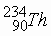is radioactive element with a half life of 24 days. This is much shorter than the age of the earth. This isotope is still existing in the nature. Reason for the existence of the isotope is _________.
5. In fertilizer industry hydrogen gas is prepared from catalytic reaction represented by the equation C_{n}H_{2n+2} + H₂O  CO₂ + H₂ for n=4. 429.12x10¹⁴ lit (STP) of H₂ is daily produced. Daily consumption of hydrocarbon and steam are ___________ , _________.
6. A student is placed a pellet of NaOH in a watch glass. After some time it becomes liquidous and superficially thin solid layer is formed. The composition of the layer is _______ chemical equation of the reaction is ________.
7. On heating colourless solid A, a gas B (liquid at room temperature) and gas "C" are formed. A is also decomposed by NaOH on heating to form gas D. This gas D gives white fumes with HCl. Gas C occupies 800 ml/gram at STP. Chemical formula of A is ______.
8. It is an oxide of nitrogen which reacts with NaOH solution to produce sodium nitrate and sodium nitrite. The electronic formula of gas is ________.
9. The equilibrium constant for the reaction H₂(g) + I₂(g) 2HI is K_{i} and K_{n} for the reaction nH₂(g) + nI₂(g) 2nHI(g) . The relation ship between K₁ and K_{n} is ________.
10. 0.76 grams of KOH completely neutralize 1 gram of a unknown acid the basicity of the acid is ________.
11. Equal weights of ethane and hydrogen are mixed in an empty container at 25⁰C. The fraction of the total pressure exerted by H₂ is ________.
12. Hydrogen halides HF, HCl, HBr, HI are used as the acids. The decreasing order of the strength of these acids is ________.
13. 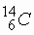is a beta active nucleus. A sample of 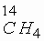gas kept in a closed vessel shows increase in pressure this is due to the ________.
14. Helium atom is two times heavier than hydrogen molecule. At 298 K the average kinetic energy of helium atom is ________ as that of hydrogen molecule.
15. Considerable part of the harmful UV rays of the sun does not reach the surface of the earth. This is because high above the earth’s atmosphere there is a layer of ________.
16. The composition of the reactants of a chemical reactions at equilibrium do not depend on the presence of the catalyst the reason for this is ________.
17. The compressed and liquefied cooking gas supplied in cylinders called LPG is a mixture of ________.
18. If a weak monobasic acid of 0.05 concentration undergoes 1% dissociation, the approximate ionisation constant is ________.
19. An acid is a substance which has a tendency to donate a proton to any other substance and base is a substance which has a tendency to accept a proton from any other substance. This theory was given by ________.
20. Solid NaCl is a insulator, but molten NaCl is a conductor, the electrolysis products of aq. Solution of NaCl are ________. (write the half reactions)
21. Ammonia can be dried by using quick lime, but HCl cannot be dried by quick lime this is due to ________.
22. Elements A and B form two compounds B₂A₃ and B₂A; 0.05 moles of B₂A₃ weight 9 gram and 0.1 mole of B₂A weighs 10 grams, atomic weights of A and B are ________ respectively.
23. The elements which are required to the body in very small qualities are called ________.
24. e/m ratio of the cathode rays of all gases are same but it is different for the anode rays the reason for this is ________.
25. The rate constant of one reaction K is found to be double that of the rate constant K of another reaction then the relationship between the corresponding activation energies of two reactions can be represented as ________.
26. In the preparation of chlorine from HCl, manganese dioxide serves as ________ agent.
27. When HCl gas is passed in to saturated solution of NaCl solution precipitation of NaCl occurs this is because ________.
28. There are two oxides of sulphur one of which contains 50% oxygen by weight. The other contains 60% oxygen by weight the weights of sulphur which combines with 1 gram of oxygen are in the ratio of ________.
29. Enthalpy of a chemical reaction which is difficulty to determine experimentally can be obtained by ________ law.
30. Solution of SO₂ in water is known as __________ acid and its salts are called ________.
III. Write the balanced Chemical Equations for following chemical changes: (5x2=10 Marks)
1. I₂ gas is passed through the hot and concentrated caustic soda solution
2. Copper is treated with dilute HNO₃.
3. Sodium thiosulphate is treated with iodine solution.
4. MnO₂ is fused with KOH in the presence of air and the resulted solution is treated with chlorine
5. Potassium chromate is treated with sulphuric acid.
IV. Solve the following: | (1x5=5 Marks)
1. A student gently drops an object weighing 15.8 g into an open vessel that is full of ethanol, so that a volume of ethanol spills out equal to the volume of the object. The experimenter now finds that the vessel and its contents weigh 10.5 g more than the vessel full of ethanol only. The density of ethanol is 0.789 g/cm³. What is the density of the object?
SCHOLASTIC APTITUDE TEST 2003

1. (a) What is ionic and solubility product, differentiate the two with suitable example.
(b) Derive a solubility product expression for the salt B_{x}A_{y}
(c) What is the significance of ionic and solubility product in chemistry. (1+2+2=5)
2. (a) For all practical purposes, chemical reactions are classified into reversible and irreversible reactions. What is the criterion for reverse and irreversibility of the reaction?
(b) What is equilibrium constant and what is the significance of equilibrium constant in chemistry.
(c) At a particular temperature the number of moles of different constituents for the reactions N₂ + 3H₂ 2NH₃ are (1- ) for N₂ ; 3(1- ) for H₂ ; 2 for NH₃
Derive the expression for equilibrium constant K_{p} in terms of  and total pressure P. Assume that  is less than one. (1+2+2=5)
3. (a) pH= -log[H⁺] ; pOH = -log[OH⁻] and pK_{w} = - logK_{w} from this information derive the relation among the term pH, pOH and pK_{w}.
(b) Nature of the solution depends on [H⁺], but pH notation is used to express the nature of the solution why?
(c) At 100⁰C pK_{w} of H₂O=13 and pH=6.5 but H₂O is neutral at this temperature, explain. (1+2+2=5)
4. (a) Give the preparatory procedure of white phosphorus through balanced chemical equation.
(b) How white phosphorus is converted into red phosphorus.
(c) Write one structural, one physical and one chemical difference between the white and red phosphorus.
(d) Explain reactions of white phosphorus with Ba(OH)₂ with balanced equation. (1+1+1+2=5)
5. (a) Why absolute temperature is used in discussing the behavior of gases.
(b) Draw the graph for volume of the gas versus absolute temperature T(k) for 5 moles of an ideal gas at one atmosphere pressure and
(c) at what point on Y-axis it intercepts.
(d) Show the volume of the gas in the graph at 473K. (2+1+1+1=5)
6. (a) What is oxidation and reduction according to modern theories?
(b) Why should oxidation and reduction occur together in a reaction?
(c) Give a displacement reaction, and identify the oxidant and reductant.
(d) What are the advantages in introducing the oxidation - reduction concept in chemical reactions. (1+1+1+2=5)
7. (a) What is meant by term rate of reaction. Why does rate of reaction normally change with time?
(b) When does rate of reaction equal to rate constant.
(c) What are the factors that affect the magnitude of rate constant and why? And which factors do not affect the magnitude of the rate constant.
(d) Alcohol is removed from blood stream by a series of metabolic reactions. The first reaction produces acetaldehyde and then other products are formed. The following data have been determined for the rate at which alcohol is removed from blood of an average male. Although individual rates can vary by 25% - 30% women metabolize alcohol little more slowly.
[C₂H₅OH] M 4.4x10⁻² 3.3x10⁻² 2.2x10⁻²
Rate moles/lit. 2.0x10⁻² 2.2x10⁻² 2.2x10⁻²
Determine the rate equation and overall order for this reaction. (1+1+1+2=5)
8. Potassium permanganate is most commonly used inorganic chemical in the industry. It is used as oxidizing agent in the most of the chemical reactions. Write the balanced chemical equations for its preparation and oxidizing properties given below.
(a) Pyrolusite is fused with solid KOH in the presence of air.
(b) Resulted mass is extracted with water and treated with Cl₂ gas.
(c) Through the acidified solution of potassium permanganate H₂S gas is passed.
(d) KMnO₄ is used as a disinfectant. (1+1+1+2=5)
9. (a) What is the basic difference between molarity and molality.
(b) What is affect of the temperature?
(c) For a given aqueous solution, which is the higher, molarity (or) molality.
(d) The molarity and molality of a solution are M and m respectively. If the molecular weight of the solute is Y derive the relation for density in terms of M, m and Y. (1+1+1+2=5)
10. (a) What is organic chemistry what makes the organic chemistry a systematic subject.
(b) What are the factors that are responsible for formation of more number of organic compounds?
(c) Why does silicon form catanated compounds of very low stability?
(d) Why does carbon compounds are called as organic compounds? (1+1+2+1=5)
11. (a) Modern periodic table is based on electronic configuration but not on atomic number (Z) why?
(b) Why do we call s and p block elements excluding zero group, are called as representative elements.
(c) What is the group and maximum combining capacity of the element with atomic number 53?
(d) A monatomic ion has a charge of +3. The nucleus of the ion has a mass number of 45. The number of neutrons in the nucleus is 1.14 times that of the number of protons. How many electrons are there in the ion. What is the name of the element? (1+2+1+1=5)
12. (a) Why cation is called as basic radical and anion is called as basic radical.
(b) What is acid - base neutralization? What happens during the neutralization?
(c) Every reaction has its own heat of reaction, but same amount of heat is liberated when one mole of caesium hydroxide is separately treated with one mole of HI and HClO₄.
(d) When acid solution is completely neutralized with base, the resulted solution is not always neutral, why? (1+1+1+2=5)
SCHOLASTIC APTITUDE TEST 2004
1. What is chemistry and what is the scope of this science?
2. What is the need to have different theories of acids and bases?
3. What is the molality and molarity of pure ethyl alcohol at 25⁰C, the density of ethyl alcohol is 0.92 g/cc?
4. What is the authentic test for detection of nitrate ion in the laboratory? Explain with proper equations.
5. Temporary hardness of water can be removed by heating. Explain?
6. Define the terms strong and weak electrolytes. How are they differentiated?
7. Why cannot all minerals of a metal be used for the extraction of metal?
8. What is the rate constant of reaction and how it is related to equilibrium constant?
9. What is the meaning of ionic product of water? Why and how does it depend on temperature?
10. What is a deliquescent substance and under what conditions does a hydrated salt show deliquescent property.
11. BF₃ acts as a Lewis acid whereas NF₃ does not. Explain?
12. Sodium has higher density than Lithium, but potassium has lower density than sodium. Why?
13. NH₄⁺ has a bond angle nearly equal to bond angle of CH₄ but ammonia has a different bond angle. Why?
14. How does elemental nitrogen present in the atmosphere is enter into soil in the form of nitrate?
15. Write the cathodic and anodic reactions when aqueous solution of Na₂SO₄ is electrolysed with platinum electrodes.
16. Why is strength of Hydrogen peroxide is expressed in volumes?. Calculate the strength of 5 volumes of hydrogen peroxide in molarity?
17. Rate of reaction depends on concentration of the reactants. At equilibrium rate of forward and backward reactions is same but concentration of reactants and products is not same. Explain?
18. Equilibria of all chemical reactions are not affected by change of pressure. Explain?
19. Write the principle involved in the froth floatation process?
20. Sodium chloride and sodium iodide on reaction with H₃PO₄ produce HCl and HI respectively, but sodium chloride produces HCl whereas sodium iodide produces iodine when treated with H₂SO₄. Explain?
21. A purple solution of aqueous potassium permanganate (KMnO₄) reacts with aqueous sodium sulphite (Na₂SO₃) in the basic solution to yield the green manganate ion (MnO) and sulphate ion (SO). The unbalanced equation is
MnO (aq) + SO (aq)  MnO(aq)+ SO(aq).
a. Identify the oxidant and reductant
b. Balance the chemical equation by oxidation number method
22. Aluminium cannot be extracted from Al₂O₃ by carbon reduction method. Why? And write the principle involved in the extraction of aluminium from Al₂O₃ through chemical equations.
23. Aluminium and Zinc hydroxides are insoluble in water but both are soluble in NaOH even though NaOH contains common ion. Why?
24. Why does nitrogen form stable diatomic N₂ whereas phosphorus gives P₄?
25. Heat of combustion of acetylene is less than that of ethane and ethylene but oxyacetylene flame is used for welding and cutting of metals. Why?
SCHOLASTIC APTITUDE TEST 2006 | Max.Marks : 60

1. Chromatography is used by the ‘Horse Racing Forensic Laboratory’ to test for the presence of illegal drugs in racehorses.  A concentrated sample of urine is spotted onto chromatography paper on the start line. Alongside this, known drugs are spotted. The chromatogram is run using methanol as the solvent. When finished , the paper is read by placing under ultra-violet light. A chromatogram of urine from four racehorses is shown. | 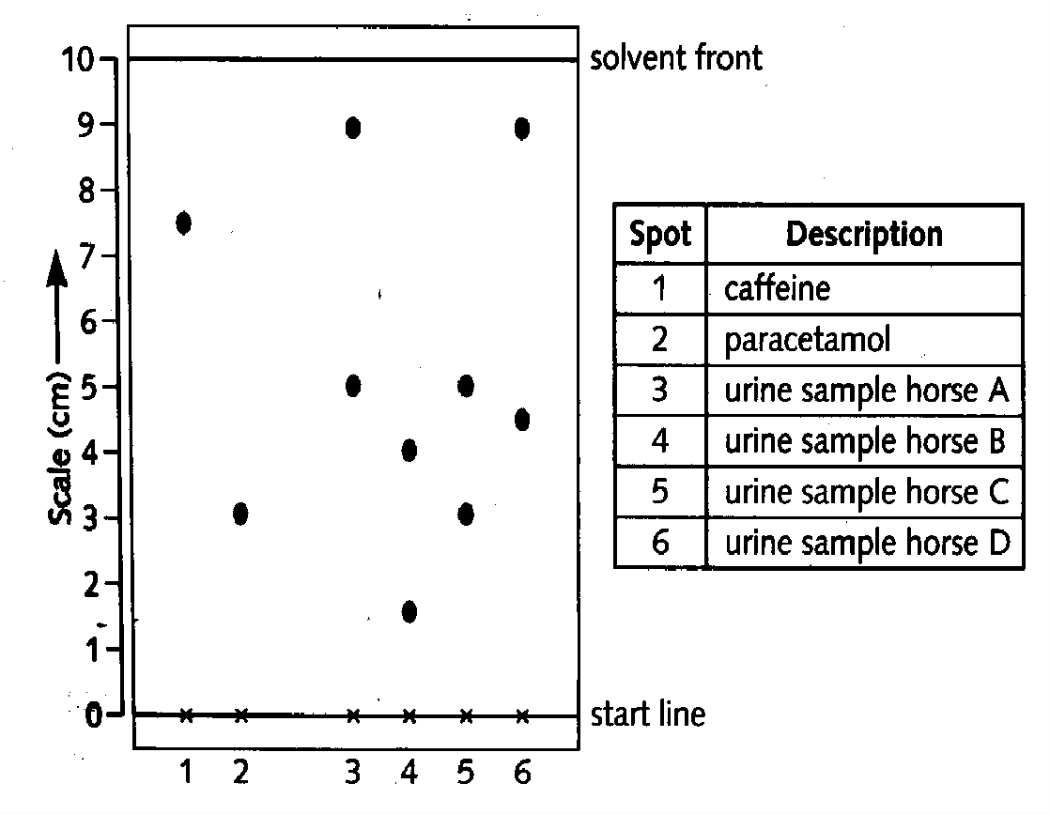
a) The results for known drugs are given as ‘R_{f} values’.; 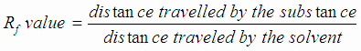calculate the R_{f} value for caffine ; 1M
b) Explain the meaning of the word ‘solvent’ ; 1M
c) State two factors which determine the distance a substance travels up the paper. 1M
d) From the results the sample from one horse contains an illegal substance.
i) State the horse, and the drug present.; 1M
ii) Give a reason for the use of this drug. ; 1M
2. Some solids dissolve easily, others do not
a) i) What is the name given to liquids which dissolve solids? ; 1M
ii) What is the name of the clear liquid formed when a solid dissolves in a liquid? 1M
b) Temperature change affects the solubility of substances in water.
i) How does the solubility of most solids change as the temperature of the water increases? 1M
ii) How does the solubility of a gas change as the temperature of the water increases? 1M
c) Describe how dry solid can be obtained from the liquid in which it is dissolved. 1M
d) The graph shows how the solubility fo ammonia sulphate in water changes with temperature.  100g of ammonium sulphate was heated in 100g of water until it all dissolved. Use the graph to answer the following.  i) What is the lowest temperature at which the water will dissolve all the ammonium sulphate? 1M  ii) What mass of solid will crystallizes from the liquid when it is cooled to room temperature? 1M  iii) This solid is filtered off at 20ºC. what will you see if the remaining liquid is then cooled to15ºC? 1M  iv) What word is used to describe a liquid which cannot dissolve any more solid at a given temperature? 1M | 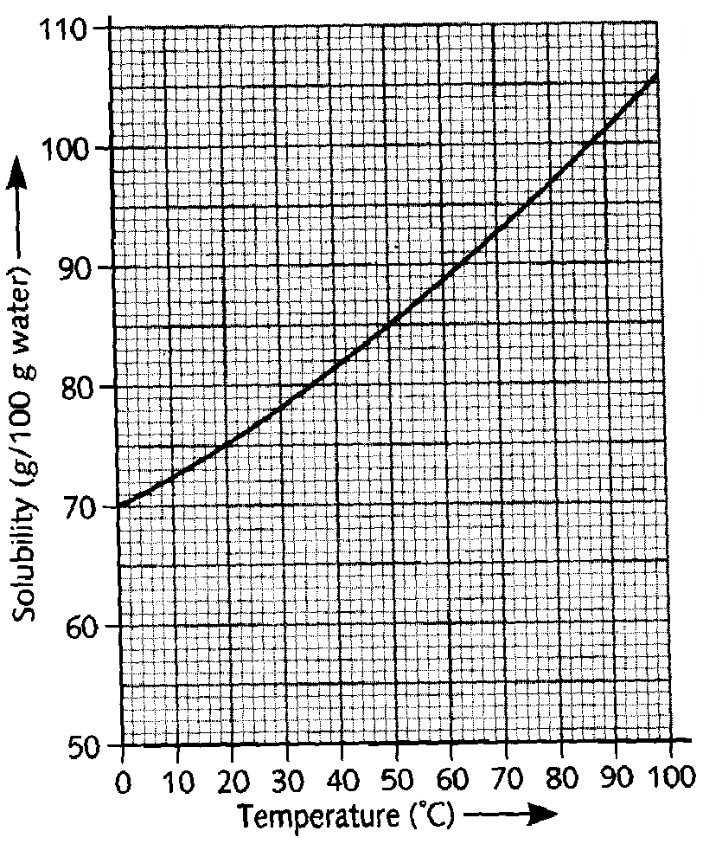
3. Write balanced chemical equations for the reactions between: ; 5M
i) Sodium thiosulphate and hydrochloric acid
ii) Magnesium and steam
iii) calcium and oxygen
iv) Bromine and potassium iodide solution
v) Zinc and copper sulphate solution.
4. Magnesium is obtained by the electrolysis of magnesium chloride in a cell similar to the one shown below.  a) i) What is cathode made from ? 1M  ii) What is the anode made from ? 1M  iii) Why is the chlorine gas kept separate from the magnesium metal? ; 1M | 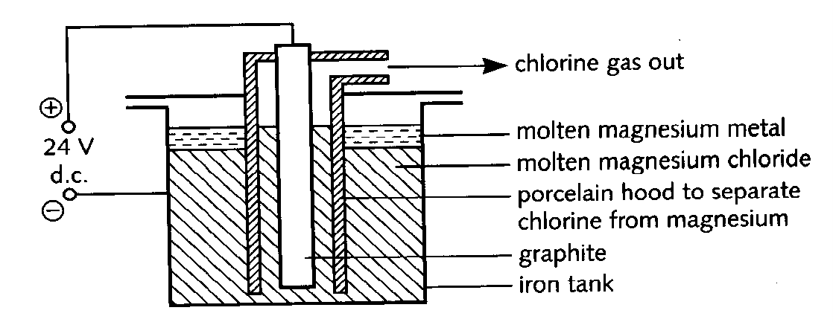
b) The magnesium chloride is made by the following reaction ; 1M
MgO + C+ Cl₂ MgCl₂ + CO
Rewrite the equation in words
c) Name two other metals that are obtained by electrolysis ; 1M
5. Reactions that give off carbon dioxide are used to raise dough when baking bread. On cooking, the bubbles of carbon dioxide become trapped in the dough and give the bread a pleasing texture.
The ingredients are made into a dough which is left in a warm place for about 30 minutes. The volume of the dough increases as carbon dioxide is produced from the sugar by the yeast.
a) There are two ionic compounds in the recipe. Name one of them. ; 1M The dough is then placed in a hot oven and the baking powder produces more carbon dixode as the naan bread cooks
Recipe card | NAAN INDIAN BREAD
Ingredients  75 cm³ of milk  1 teaspoon of sugar  1 teaspoon of yeast  200g of plain flour  ½ teaspoon of baking powder  (sodium hydrogencarbonate and tartaric acid) | 1 tablespoon of vegetable oil  75 cm³ of plain yogurt  1 egg  ¼ teaspoon of salt
Sodium hydrogen carbonate decomposes when heated.
2NaHCO₃ Na₂CO₃ + CO₂ + H₂O
Sodium carbonate has an unpleasant taste. It reacts with the tartaric acid to form sodium tartarate which has a pleasant flavour.
b) What type of compound is sodium tartarate? ; 1M
c) Suggest two reasons why baking powder is a mixture of tartaric acid and sodium hydrogen carbonate, and not just sodium hydrogen carbonate. ; 1M
6. A packet of washing soda crystals has been left open to the atmosphere for some time. The crystals have formed a white powder which may be represented by the formula Na₂CO₃. xH₂O. The value of ‘x’ may be found by dissolving a known quantity of the powder in water and titrating the solution with acid of known concentration.
In one experiment a student weighed out 1.59g of the powder and dissolved it in water. The volume of the solution was made up to exactly 250cm³. 25cm³ of this solution was titrated with hydrochloric acid of concentration 0.10 mol/dm³ (mol per litre). 25.6 cm³ of the acid was required for complete reaction. The equation for this reaction is:
Na₂CO₃ + 2HCl 2NaCl + H₂O + CO₂
a) Calculate the number of moles of hydrochloric acid used in the titration. ; 1M
b) Calculate the number of moles of sodium carbonate in the 25cm³ sample of solution which reacted with the hydrochloric acid. ; 2M
c) How many moles of sodium carbonate were in the 250cm³ of solution? ; 1M
d) Calculate the mass of sodium carbonate in the 250cm³ of solution. ; 1M
(Relative atomic masses C= 12, O = 16, Na = 23)
e) Using your answer to part (d), what mass of water was in the original powder? ; 1M
f) How many moles of water were present in the original powder ?
(Relative atomic masses H = 1, O = 16) ; 1M
g) Using your answers to parts (c) and (f), calculate the value of x. ; 2M
7. a) The Haber process is a reversible reaction. What does ‘reversible reaction’ mean? 1M  b) The graphs show the amount of ammonia produced at different temperatures and pressures.  i) What conditions favor the production of ammonia? 1M  ii) In industry the reaction is carried out at 450ºC and 200 atmospheres pressure. Use the graph to explain why these conditions are used. 2M  c) i) Some energy has to be put into the chemicals to start the reaction. Explain how this energy helps the reaction to start. 2M | 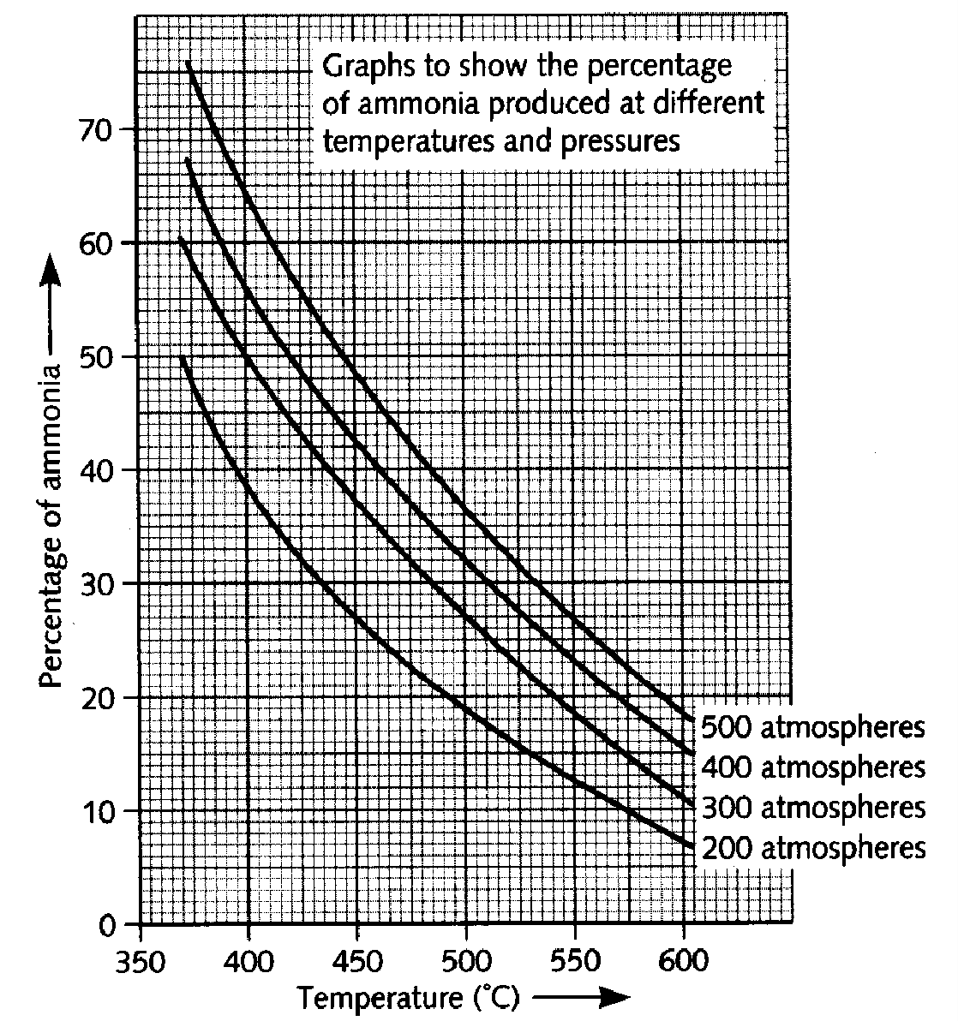
  ii) Here is an energy level diagram for this reaction. Is this reaction exothermic or endothermic? Explain your answer in detail 1M | 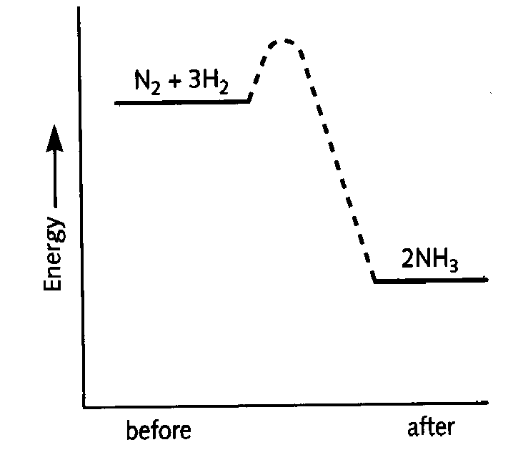
8. This question is about alcohols.
a) The alcohols are members of a homologous series.
i) Write down the general formula for this homologous series. ; 1M
ii) Write down the names and draw the structures of the two monohydric alcohols (alcohols that have only one –OH group) containing three carbon atoms per molecule ; 1M
b) On analysis, a 10.00g sample of an alcohol was found to contain 3.75g of carbon, 1.25g of hydrogen, and 5.00g of oxygen. Use this data to find the empirical formula of this alcohol. Suggest its molecular formula. ; 2M
c) The dissociation energy of ethanol is shown below
C₂H₅OH(g) 2C(g) + 6H(g) + O(g)  H = + 3234 kJ/mol of ethanol
Using bond energy values (given below) calculate the bond energy of C-O per mole. 1M
[Bond energies : H  H : 436 kJ/mol , C H : 435kJ/mol, O H : 464 kJ/mol, C C : 347 kJ/mol]
9. Red Lead, Pb₃O₄ is used in paints. It protects metal surfaces against corrosion. Red lead is made by heating lead (II) oxide, PbO, in air.
a) copy out and balance the following equation ; 1M
PbO + O₂Pb₃O₄
b) Red lead paint may be used to protect iron from rusting. Name two other ways of stopping iron or steel from rusting. ; 1M
c) On strong heating, red lead decomposes to form oxygen and lead (II) oxide.
i) How could you show that oxygen is given off in the decomposition? ; 1M
ii) Suggest how you could show when the decomposition was finished ; 1M
d) Red lead reacts with concentrated hydrochloric acid to form lead (II) chloride , chlorine and water. Pb₃O₄ + 8HCl 3PbCl₂ + Cl₂ + 4H₂O
i) Describe how you could show that chlorine was given off during the reaction. ; 1M
ii) Suggest how, using an electrical method, you could obtain lead from lead (II) chloride. 1M
10. The rate of reaction between a metal and bromine can be studied using the apparatus shown below.  A piece of metal, for example iron, was weighed and placed in the solution as shown above. The metal was removed at regular intervals and each time it was washed, dried and weighed. It was then replaced in the solution and the reaction continued.  From the results (mass of metal and time), the rate of the reaction can be calculated.  a) i) How would the rate change if more of the piece of metal was in the solution? Explain your answer ; 1M | 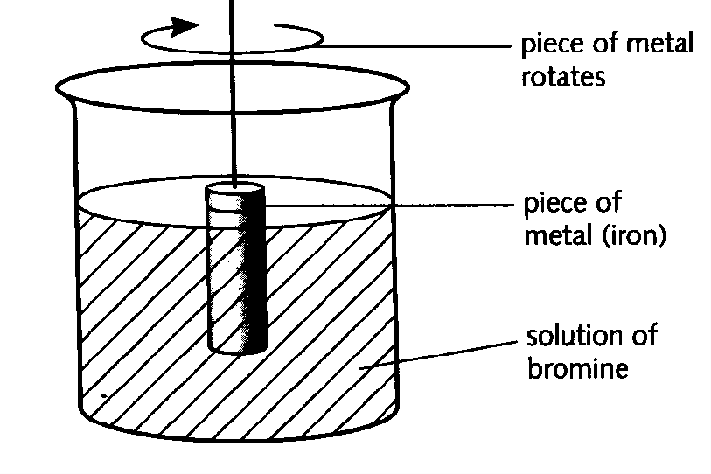

Concentration of bromine solutions | Rate
0.05 mol/dm³ | 10mg/minute
0.1 mol/dm³ | 20 mg/minute
Explain the change in rate. ; 1M
b) In a reaction between a solid and a solution, the rate may depend on the speed of stirring. Describe how you could find out if the rate of the reaction between solid iron and bromine solution depends on the speed of stirring. ; 1M
c) Iron has two oxidation states so it can form two ions: Fe²⁺ and Fe³⁺
How could you test a solution to find out which ion is present? Outline the test, and give the results for both ions. ; 1M
d) In the reaction between iron and bromine: iron atoms change into iron ions; Bromine molecules change into bromide ions.
i) Which of these changes is a reduction? Explain your choice. ; 1M
ii) If iodine was used instead of bromine, predict how the rate of the reaction would change: increase, decrease or stay the same. Give a reason for your answer. ; 1M

SCHOLASTIC APTITUDE TEST 2007 | Max.Marks : 60
SECTION – A Marks10x2=20
1. The reaction between dichromate ions and iron (II) ions can be carried in the presence of either dilute HCl (or) sulphuric acids. But the dilute HCl cannot be used to acidify the solution for titration between Iron (II) and permanganate ion system. The reason for this is ________.
2. Acetic acid is a weak acid and hydrochloric acid is a strong acid it follows that the
(A) pH of the 0.1M HCl will be 1
(B) Solution containing 0.1 mole acetic acid and 0.1 mole of sodium acetate will be a good buffer
(C) pH of the 0.1M HCl will be less than that of 0.1M acetic acid
(D) pH of a solution formed by mixing equimolar quantities of sodium hydroxide and HCl will be greater that of a similar solution formed from sodium hydroxide and acetic acid.
The correct statement(s) is/are ________________
3. A metal oxide has formula X2O3 it can be reduced by hydrogen to give free metal and water. 0.1596 g of metal oxide requires 6 mg of hydrogen for complete reduction. The atomic weight of the metal is __________.
4. Helium is mixed with the oxygen gas for deep sea divers. The percent by volume of oxygen gas in the mixture of the diver has to submerge to a depth where the total pressure is 4.2 atm and partial pressure of oxygen is maintained at 0.2 atm at this depth is ___________ .
5. In the reaction A + B ® products, if the concentration of B is kept constant and concentration of A is doubled, the rate becomes four times of initial rate and when A is kept constant and concentration of B is doubled rate remains the same. This indicates that reaction rate is proportional to the __________ of concentration of ___________ and rate equation is _____________.
6. One ________ of a substance is equal to its atomic or molecular mass expressed in __________ and contains 6.023x1023 chemical particles, which is known as ______________ of particles. Since 1 mole of any chemical substance contains same number __________ as 1 mole of any other chemical substance, we can calculate the weight of one chemical that will react with a given weight of other by using their _________ in other calculations.
7. 15 moles of H2 and 5.2 moles of I2 are mixed and allowed to attain equilibrium. Concentration of HI is found to be 10 moles the equilibrium constant for the formation of HI is ____________.
8. 600 ml of a mixture of O2 and O3 weighs 1 gram at NTP. The volume of ozone in the mixture _______.
9. At 27oC 4.6 grams of N2O4 undergoes decomposition and exerts an equilibrium pressure of 1.6 atmosphere when vapourised in a 1 lit flask. The fraction of N2O4 dissociated is ________. [N2O4(g) 2NO2(g)]
10. A compound contains 28% nitrogen and 72% metal by mass. 3 atoms of the metal combine with 2 atoms of the nitrogen. The atomic weight of the metal is __________
Marks 5x1=5
11. The V.D of Gas is 15. 15 g of this gas will occupy a volume of ______ cc at 273oC and 1 atm.
12. You are given 500 ml of 2N HCl and 500 ml of 5N HCl. The maximum volume of the 3 M that you can make from these two solutions is ___________.
13. The equilibrium constant for the reaction 2A + 2B 2C + 2D is 100. The equilibrium constant for the A + B C + D at same temperature is _________ .
14. The solubility product of sparingly soluble salt Ag2CrO4 is 4x10-12. The molar solubility of the salt is _____________
15. For the preparation of HBr in the lab the corresponding bromide salt should be treated with __________ acid.
SECTION – B Marks 10x2=20
16. Differentiate the following:
(a) Redox reaction – disproportionation reaction
(b) Primary standard substance – Secondary standard substance
(c) Electrolysis – Hydrolysis
(d) Gangue – Slag
(e) Lattice energy – Hydration energy
(f) Equilibrium constant – Rate constant
(g) Ionic product – Solubility product
(h) Activation energy – Threshold energy
(i) Valence – Oxidation number
(j) Allotropy – Enantiotropy
SECTION - C
17. A compound of oxygen and nitrogen has the composition 1.52 g N and 3.47 g of oxygen. The molar mass of this compound is known to be between 90 and 95 g. Determine the molecular formula and molecular mass of compound. 3M
18. A transition metal X forms an oxide of formula X2O3. It is found that only 50% of X atoms in this compound are in the +3 oxidation state. The only other stable oxidation states of X are +2 and +5. What percentage of X atoms are in the +2 oxidation state in this compound? 4M
19. Many diabetics must determine their blood sugar content daily. The measurements provided by the devices used for such purpose are in milligrams per deciliter. 3M
(a) What is the concentration of glucose [C6H12O6] in grams per liter when a reading of 95 is observed?
(b) What is the concentration in moles per litre?
20. A student was given a sample of colourless solution containing three cations and was asked to identify the cations. The student carried out a series of reactions as shown in the flow chart below. 5M
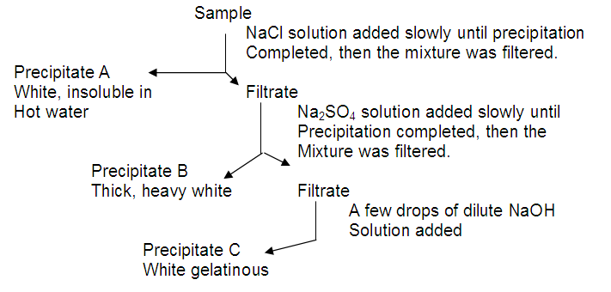
(i) From the information above, suggest three cations which could be in the sample and would form the precipitates A, B and C. Give the formula for each precipitate,
(ii) Give an additional test which would help to confirm the presence of each cation,
(iii) Name any other cations that would fit the requirements for precipitates A, B and C.

SCHOLASTIC APTITUDE TEST 2008

I. Explain the following | 5x3=15M
1. The value of K (equilibrium constant, rate constant, solubility constant) changes with temperature. But radioactive decay constant is independent of temperature.
2. On expose to air, caustic soda becomes liquid and after some time it changes to white powder.
3. Aqueous solution of AlCl3 behaves acidic towards litmus while that of NaCl not.
4. Both coke and flux are used in smelting process of metallurgy.
5. Bottle containing NaOH solution should not be closed by glass lid.
II. Differentiate the following: | 5x3=15M
1. An equivalent in acid-base reaction and an equivalent in oxidation–reduction reaction
2. Acid strength and concentration
3. Mixed salt and Double salt
4. Complex salt and Simple salt
5. Contrast the action of heat on the following (with equations)
(a) Na2CO3 and CaCO3
(b) MgCl2.6H2O and CaCl2.6H2O
(c) Ca(NO3)2 and NaNO3
III. Answer the following: | 10x3=30M
1. A fuel gas contains carbon and hydrogen only. Burning a small sample of it in oxygen gives 3.38 gm carbon dioxide, 0.69 gm of water and no other products. A volume of 10 lit (measured at STP) of this gas is found to weigh 11.6 gm.
(a) Calculate
(i) empirical formula
(ii) molecular mass of the gas
(iii) molecular formula
(b) Write one single step preparation of the gas
(c) Does it react with bromine? If so what colour change do you expect?
(d) What do you expect the calorific value of the gas with reference to marsh gas?
2. At a given temperature, the degree of ionization (fraction dissociated) of water is found to be 1.8x10-9. Calculate the ionization constant and the ionic product of water at this temperature.
3. Suppose the gas-phase isomerisation reactions
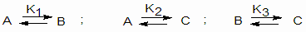
reach equilibrium at a fixed temperature. Express the equilibrium mole fractions of A,B and C in terms of equilibrium constants, K1, K2 and K3.
4. A sample of P2O5 contains some impurity. 0.405 gm sample is reacted with water and the resulting solution requires 42.5 ml of 0.25 M NaOH solution. The salt resulted is monobasic acid salt. Calculate the percent impurity.
5. What will be the resultant pH when 200 ml of an aqueous solution of HCl (pH=2) is mixed with 300 ml of an aqueous solution of NaOH (pH=12).
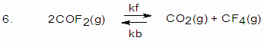
K=2 for the reaction at 10000C.
If a 5L mixture contains 0.105 mole COF2, 0.22 mol CO2 and 0.055 mol CF4 at 10000C.
(a) Will the mixture be at equilibrium?
(b) If the gases are not at equilibrium, in which direction will a net reaction occur?
(c) What is the amount of each gas present when equilibrium is established.
(d) What are the rate equations for the forward and backward reactions?
(e) Compare the rate constants at (i) initial stage and (ii) equilibrium stage
7. For the reaction
(i) A B ; Kc = 2
(ii) B C ; Kc = 4
(iii) C D ; Kc = 6
For the reaction A D what is the Kc?
8. Four elements coded A,B,C and D form a series of substances e.g. AB, B2, CB3, DB2 and DB3. If the atomic number of these elements are not necessarily in the order are 13, 19, 26 and 35. Write down extra nuclear electronic structures of these elements. From this information and the formula of the compounds, allocate A,B,C and D with appropriate atomic numbers. Mention the nature of bonding in each of them.
9. Calculate the molecular weight of hydrogen fluoride if density of this gas is 3.17 g/L at 300K and 1.0 atm pressure. What information can you deduce from the result?
10. Anhydrous copper sulphate turns to blue from colourless on expose to atomosphere and again make it colourless by some substance (X). When copper sulphate is added to water a blue colour solution is resulted with some turbidity. The turbidity disappears by the addition of a drop of HCl solution. On placing Iron rod in it, a greenish solution is resulted. A chocolate like precipitate is resulted when a drop of potassium ferrocyanide solution is added to the blue colour solution of copper sulphate. Black precipitate is resulted by passing H2S gas through copper sulphate solution but the precipitate is soluble in conc.HNO3.
(a) What is X ?
(b) Write the chemical reactions to explain the observations.

