Symbol | Party
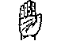 | INC
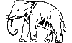 | BSP
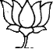 | BJP
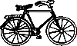 | SP
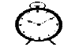 | NCP
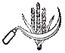 | CPI
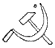 | CPM
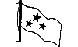 | CPI(ML)(L)
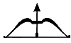 | SHS
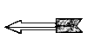 | JD(U)
 | TDP
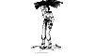 | JD(S)
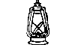 | RJD
 | AGP
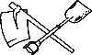 | RSP
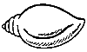 | BJD
 | JMM
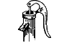 | RLD
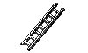 | MUL
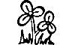 | AITC
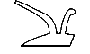 | JKN
 | JKNPP
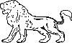 | FBL
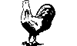 | NPC
 | MAG
 | FPM
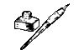 | JKPDP
 | MNF
 | MPP
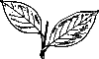 | UGDP
 | AD
 | TRS
 | KNDP
 | LJNSP
 | SAP
 | JP
 | BBM
 | ABHM
 | GGP
 | NLP
 | SBSP
 | RSPS
 | PPOI
 | RPI
 | RSD
 | LRP
 | ARP
 | JKP
 | PRCP
 | IJP
 | ABJS
 | PMSP
 | AJSU
 | SJP(R)
 | ASP
 | BKRP
 | BNP
 | HJP
 | SVRP
 | MCPI(S)
 | AMB
 | USYP
 | BRPP
 | CSP
 | PPI
 | RSMD
 | PWPI
 | KKJHS
 | BMSM
 | AIMIM
 | VJP
 | UMFA
 | SSD
 | SPVD
 | PRP
 | PRBP
 | LSWP
 | BMVP
 | BEP
 | ABDBM
 | AIMF
 | ABLTASJM
 | BKD
 | BPSGKD
 | BRP
 | RCPI(R)
 | PTSS
 | PSP
 | PSJP
 | JMP
 | JKPP
 | JKM
 | JKAL
 | JDP
 | HEAP
 | EU
 | BVP
 | BSP(A)
 | PP
 | PDP
 | NTRTDP(LP)
 | NSTP
 | NMNP
 | NBNP
 | MRS
 | MRRC
 | MP
 | YGP
 | VRP
 | VP
 | VJC
 | TNGP
 | SWD
 | SPI
 | SLP(L)
 | SHSP
 | SDP
 | SBS
 | RSNP
 | RPI(KH)
 | RPI(D)
 | RPI(A)
 | RLSM
 | RKSP
 | MNVP
 | MCO
 | MBT
 | LPSP
 | LP(S)
 | LJSP
 | KSVP
 | JVP
 | BPSP
 | BLP
 | BLKD
 | ASDC
 | ANP
 | AIFB(S)
 | ABHS
 | IND

