HUMAN RESOURCE TOPIC PAPER PRESENTATION
“STRESS MANAGEMENT-AN OVERVIEW”
BY- Swetha Shenoy (07951E0051)
Institute of Aeronautical Engineering, Dundigal

ABSTRACT
Stress is seen in every corner of the world and which occurs to everyone. People use the term stress to describe the feeling they have when it all seems too much, when they are overloaded and don't feel that they are able to meet all the demands placed upon them.A child burdened with heavy bag right from School to the Manager of Corporate world, stress has become a new lifestyle disease. It has become predominant and people have come up with balanced monitored concepts to minimise stress. This paper proceeds to explain stress, the causes and the ways to minimise stress.

1.WHAT IS STRESS?
Researchers define stress as a physical, mental, or emotional response to events that causes bodily or mental tension. Simply put, stress is any outside force or event that has an effect on our body or mind

The term "stress", as it is currently used was coined by Hans Selye in 1936, who defined it as "the non-specific response of the body to any demand for change” In attempting to extrapolate his animal studies to humans so that people would understand what he meant, he redefined stress as "The rate of wear and tear on the body"
According to Richard S Lazarus,
“Stress is a condition or feeling experienced when a person perceives that demands exceed the personal and social resources the individual is able to mobilize.”

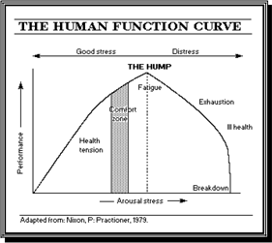

Hens Selye developed a model called the General Adaptive Syndrome Model to explain the stress phenomenon and the stress level. This model has four stages. The first stage is the alarm reaction stage, which involves the body's response to or familiarizing itself with the new situation or stressor. The second stage is the resistance stage, which involves resisting and reacting to the situation, and the third stage is the exhaustion stage, which is the aftermath of resistance. If the resistance stage goes on for a long period, then the person becomes distressed. Fourth stage is Termination-if there is no relief from arousal, then the stress on the physiological system can lead to death.

2. SIGNS OF STRESS
Emotional  Being in a bad mood  Feeling upset  Feeling angry  Feeling impatient  Feeling hopeless | Thoughts  I can't do this  I'll never finish  I can't cope  Mind racing | Behaviour  Rushing around  Starting tasks and not finishing them  Not being able to concentrate  Shouting  Waking up too early in the morning | Physical  Feeling hot  Heart beating fast  Sweating  Stomach ache  Headache

3. CAUSES OF STRESS
"Situations, circumstances or any stimulus that is perceived to be a threat is referred to as a stressor, or that which causes or promotes stress."(Brian Luke Seaward)

The causes of stress are known as stressors and there are literally hundreds of different types of stressors. Any event in life that a person finds threatening, difficult to cope with or causes excess pressure can be a potential cause of stress. It is important to bear in mind that stress is an individualistic, subjective experience and therefore what one person finds stressful another may not. Stressors can be broken down roughly into either external or internal (or a mixture of both.)

3.1. External Stressors
a) Major Life Events
b) Daily Hassles-

- Misplacing keys
- Arguments
- Traffic jams
- Time pressures
- Lack of sleep
- Fear of Crime
- Shopping
- Bureaucracy
- Waiting
- Loneliness
- Queuing
- Pollution

- Gossip
- Relatives
- Excess noise
- Inconsiderate people
- Difficult neighbours
- Car breakdown
- Meal Preparation
- Job dissatisfaction
- Office Politics
- Problems with children

3.2. Internal Stressors

"Stress resides neither in the situation nor in the person; does it depend on a transaction between the two." (Dr Richard Lazarus PhD)

Physical Stressors

- Sleep debt

- Excess/to little exercise

- Poor diet

- Drug misuse

- Alcohol misuse

- Excess heat

- Excess caffeine

- Chronic hyperventilation

- Excess cold

- Illness

- Smoking

- Hypoglycaemia

- Lack of relaxation

- Surgery

- Chronic pain

Psychological Stressors

· Excess anger

· Unrealistic beliefs

· Excess pessimism

· Health worries

· Unrealistic expectations

· Excessive worrying

· Unhappy childhood

· Unemployment

· Financial problems

· Perfectionism

· Loneliness

· Low self esteem

· Low levels of assertion

· People pleasing

· Boredom

· Negative self talk

· Personality

· Rigid thinking style

· Excessive self criticism

· Exams

· Giving talks/presentations

Environmental Stressors

· Pollution

· Excess noise

· Poor housing

· Damp conditions

· Traffic jams

Work Stressors

· Commuting

· Time pressures

· Job insecurity

· Excess working hours

· Workplace bullying

· Company takeovers

· Understaffing

· Conflicts with colleagues

· Low pay

· Role ambiguity

· Delegation problems

· Lack of work recognition

· Poor support/supervision

· Workaholic

Family Stressors

· Caring for a chronically ill relative

· Partner with health problems

· Partner with alcohol/drug problems

· Relationship difficulties

· Arguments with children

· Bereavement

· Children leaving home

Social Stressors

· Fear of crime

· Living in an urban area

· Poverty

· Low social support

· Bureaucracy/red tape

· Rude, aggressive, unhelpful people

· Victim of crime

· Problem neighbours

· Racial harassment

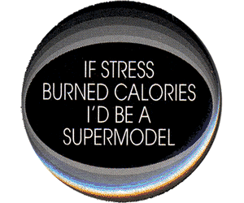
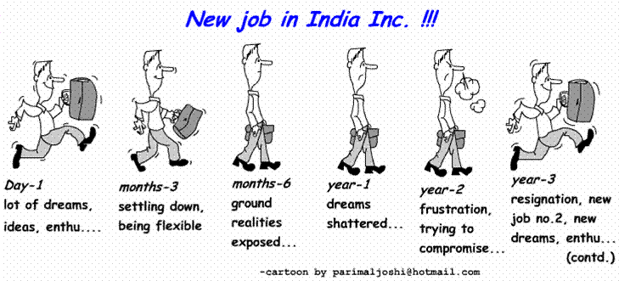
4. EFFECTS OF STRESS
Physically The heart pumps faster, making the heart pound and blood pressure rise; some people experience palpitations. Muscle tension increases, leading to headaches, dizziness, jaw ache and even insomnia. The mouth goes dry, digestion slows causing "butterflies" in the stomach. Breathing is faster and less efficient which can lead to over breathing (hyperventilation) and breathlessness. Changes in the flow of blood to the skin can cause sweating, blushing or clammy hands and feet.
Mentally A certain amount of stress can be mentally stimulating but too much can affect our thinking ability. Thoughts may become jumbled and confused. Thinking becomes focused on worrying. We may become preoccupied with problems. It becomes much harder to make decisions or find solutions to problems.Thinking negatively and fearing the worst increases worry and stress.
Emotionally People respond to stress in many different ways. Common emotional effects are irritability, impatience, anger, frustration, fear, anxiety, self-doubt, panic, despondency, feelings of inadequacy, insecurity, hopelessness, unhappiness, emotional withdrawal and depression. Behaviourally: Stress can change people's behaviour towards one another. We may become less sociable, less caring, more hostile and insensitive towards others. When stress is accompanied by anger we may become less tolerant, fly off the handle easily and provoke rows. Many people respond to stress by eating, drinking or smoking much more than is usual: some engage in risk taking behaviour. Students often complain that when they feel stressed they find it hard to concentrate, feel tired all the time, perhaps start to miss lectures and deadlines and feel they can't cope.
5. HOW TO MANAGE STRESS?
There is a tremendous need for a Holistic approach or min-body intervention to combat the menace of negative stress.
Every individual should learn how to deal a stressful situation in a positive way and not to react negatively. Stress Management should be practiced from childhood, through out your life and the only method to remain healthy, physically, mentally, socially, emotionally, psychologically, physiologically, environmentally and spiritually.
There are 3 types of responses when there is stress.
1. Response of reaction: You hit the roof.
2. Response of indifference: You are not bothered about the problem.
3. Response of Action: You sit comfortably, analysis the problem and come up with positive solutions----always try to be this.
Milton says the mind is in its own place and in itself can make a heaven of hell and a hell of heaven

Martin Luther King has said:
“The ultimate measure of a man is not where he stands in the moments of comfort and convenience but where he stands at times of challenge and controversy.”
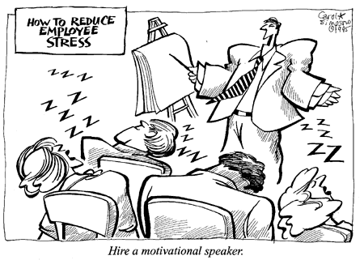

6. WHAT PEOPLE DO?
The key to success is to think positively; take control of your stress and anxiety by learning effective techniques to combat it. Relaxing bodily tension in order to reduce the physical sensations of stress is a good place to start. If your body is free of tension your mind tends to be relaxed.This helps you concentrate and study, take decisions and solve problems. When you are relaxed, you can view each task as a positive challenge, and use stress as a stimulus to help you to carry it out giving you a relaxing glow of achievement afterwards.
Things that help reduce stress:

- Jogging
- Aerobics
- Change of diet
- Vitamins
- Vacation
- Sport
- Time Management
- New hobby
- New relationships
- Sleep
- Tranquilizers
- Meditation
- Join Laughter club

7. REFERENCES

- http://www.brookes.ac.uk/student/services/health/stress.html#manage
- http://www.samaritans.org/your_emotional_health/managing_stress/what_is_stress.aspx
- http://stresscourse.tripod.com/id14.html
- http://managing-stress-strain.blogspot.com/
- http://controlling-anger.blogspot.com
- http://www.citehr.com/143077-stress-mgmt.html
- http://www.coolavenues.com/forums/search.php?do=process
- http://www.managementparadise.com/forums/achive/index.php/t-10490.html
- http://www.ivf.com/stress.html
- Aswathappa, Human Resource Management-Text and Cases, Third edition, pg 496-503

THANKYOU!

