I. EVOLUTION OF BANKING IN INDIA
Modern banking in India could be traced back to the establishment of Bank of Bengal (Jan 2, 1809), the first joint-stock bank sponsored by Government of Bengal and governed by the royal charter of the British India Government. It was followed by establishment of Bank of Bombay (Apr 15, 1840) and Bank of Madras (Jul 1, 1843). These three banks, known as the presidency banks, marked the beginning of the limited liability and joint stock banking in India and were also vested with the right of note issue.
In 1921, the three presidency banks were merged to form the Imperial Bank of India, which had multiple roles and responsibilities and that functioned as a commercial bank, a banker to the government and a banker’s bank. Following the establishment of the Reserve Bank of India (RBI) in 1935, the central banking responsibilities that the Imperial Bank of India was carrying out came to an end, leading it to become more of a commercial bank. At the time of independence of India, the capital and reserves of the Imperial Bank stood at Rs 118 mn, deposits at Rs 2751 mn and advances at Rs 723 mn and a network of 172 branches and 200 sub offices spread all over the country.
In 1951, in the backdrop of central planning and the need to extend bank credit to the rural areas, the Government constituted All India Rural Credit Survey Committee, which recommended the creation of a state sponsored institution that will extend banking services to the rural areas. Following this, by an act of parliament passed in May 1955, State Bank of India was established in Jul, 1955. In 1959, State Bank of India took over the eight former state-associated banks as its subsidiaries. To further accelerate the credit to fl ow to the rural areas and the vital sections of the economy such as agriculture, small scale industry etc., that are of national importance, Social Control over banks was announced in 1967 and a National Credit Council was set up in 1968 to assess the demand for credit by these sectors and determine resource allocations. The decade of 1960s also witnessed significant consolidation in the Indian banking industry with more than 500 banks functioning in the 1950s reduced to 89 by 1969.
For the Indian banking industry, Jul 19, 1969, was a landmark day, on which nationalization of 14 major banks was announced that each had a minimum of Rs 500 mn and above of aggregate deposits. In 1980, eight more banks were nationalised. In 1976, the Regional Rural Banks Act came into being, that allowed the opening of specialized regional rural banks to exclusively cater to the credit requirements in the rural areas. These banks were set up jointly by the central government, commercial banks and the respective local governments of the states in which these are located.
The period following nationalisation was characterized by rapid rise in banks business and helped in increasing national savings. Savings rate in the country leapfrogged from 10-12% in the two decades of 1950-70 to about 25 % post nationalisation period. Aggregate deposits which registered annual growth in the range of 10% to 12% in the 1960s rose to over 20% in the 1980s. Growth of bank credit increased from an average annual growth of 13% in the 1960s to about 19% in the 1970s and 1980s. Branch network expanded significantly leading to increase in the banking coverage.
Indian banking, which experienced rapid growth following the nationalization, began to face pressures on asset quality by the 1980s. Simultaneously, the banking world everywhere was gearing up towards new prudential norms and operational standards pertaining to capital adequacy, accounting and risk management, transparency and disclosure etc. In the early 1990s, India embarked on an ambitious economic reform programme in which the banking sector reforms formed a major part. The Committee on Financial System (1991) more popularly known as the Narasimham Committee prepared the blue print of the reforms. A few of the major aspects of reform included (a) moving towards international norms in income recognition and provisioning and other related aspects of accounting (b) liberalization of entry and exit norms leading to the establishment of several New Private Sector Banks and entry of a number of new Foreign Banks (c) freeing of deposit and lending rates (except the saving deposit rate), (d) allowing Public Sector Banks access to public equity markets for raising capital and diluting the government stake,(e) greater transparency and disclosure standards in financial reporting (f) suitable adoption of Basel Accord on capital adequacy (g) introduction of technology in banking operations etc. The reforms led to major changes in the approach of the banks towards aspects such as competition, profitability and productivity and the need and scope for harmonization of global operational standards and adoption of best practices. Greater focus was given to deriving efficiencies by improvement in performance and rationalization of resources and greater reliance on technology including promoting in a big way computerization of banking operations and introduction of electronic banking.
The reforms led to significant changes in the strength and sustainability of Indian banking. In addition to significant growth in business, Indian banks experienced sharp growth in profitability, greater emphasis on prudential norms with higher provisioning levels, reduction in the non performing assets and surge in capital adequacy. All bank groups witnessed sharp growth in performance and profitability. Indian banking industry is preparing for smooth transition towards more intense competition arising from further liberalization of banking sector that was envisaged in the year 2009 as a part of the adherence to liberalization of the financial services industry.
II. STRUCTURE OF THE BANKING INDUSTRY
According to the RBI definition, commercial banks which conduct the business of banking in India and which (a) have paid up capital and reserves of an aggregate real and exchangeable value of not less than Rs 0.5 mn and (b) satisfy the RBI that their affairs are not being conducted in a manner detrimental to the interest of their depositors, are eligible for inclusion in the Second Schedule to the Reserve Bank of India Act, 1934, and when included are known as ‘Scheduled Commercial Banks’. Scheduled Commercial Banks in India are categorized in five different groups according to their ownership and/or nature of operation. These bank groups are (i) State Bank of India and its associates, (ii) Nationalised Banks, (iii) Regional Rural Banks, (iv) Foreign Banks and (v) Other Indian Scheduled Commercial Banks (in the private sector). All Scheduled Banks comprise Schedule Commercial and Scheduled Co-operative Banks. Scheduled Cooperative banks consist of Scheduled State Co-operative Banks and Scheduled Urban Cooperative Banks
.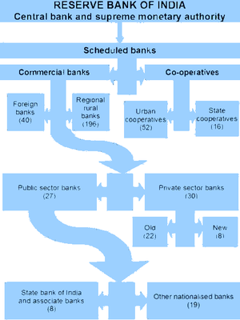
Banking Industry at a Glance
In the reference period of this publication (FY06), the number of scheduled commercial banks functioning in India was 222, of which 133 were regional rural banks. There are 71,177 bank XIV offices spread across the country, of which 43 % are located in rural areas, 22% in semi-urban areas, 18% in urban areas and the rest (17 %) in the metropolitan areas. The major bank groups (as defined by RBI) functioning during the reference period of the report are State Bank of India and its seven associate banks, 19 nationalised banks and the IDBI Ltd, 19 Old Private Sector Banks, 8 New Private Sector Banks and 29 Foreign Banks.
Table 1: Indian Banking at a Glance
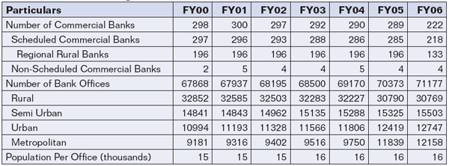
Source: Reserve Bank of India
Table 2: Number of Banks, Group Wise
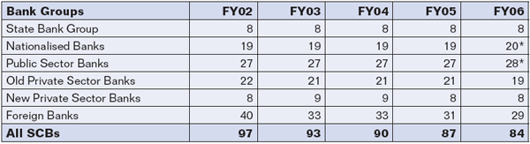
Source: Indian Banks’ Association/ Reserve Bank of India.
* Includes Industrial Development Bank of India Ltd.
Table 3: Group Wise: Comparative Average
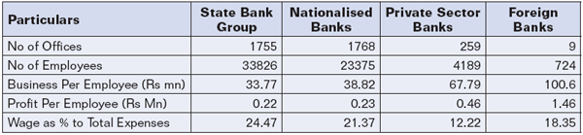
Source: Reserve Bank of India.
Table 4: Bank Groups: Key Indicators
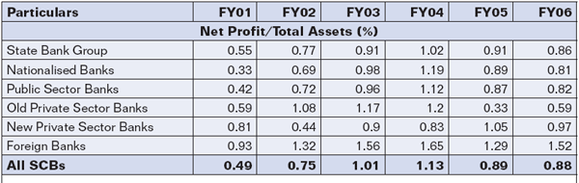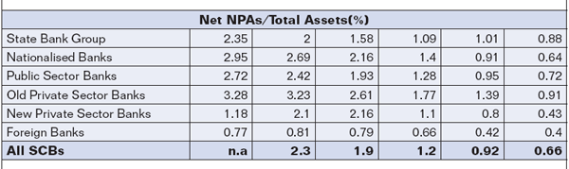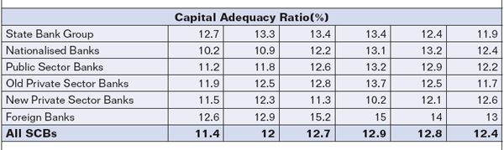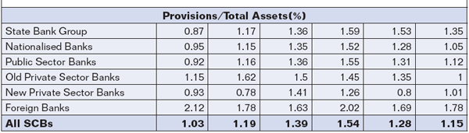
Source: Reserve Bank of India.
Mergers & Acquisitions
During FY06, two domestic banks were amalgamated - Ganesh Bank of Kurundwad with Federal Bank Ltd and Bank of Punjab Ltd with Centurion Bank Ltd to become Centurion Bank of Punjab Ltd, while one Foreign bank UFJ Bank Ltd merged with Bank of Tokyo-Mitsubishi Ltd. ING Bank NV closed its business in India. In Sept, 2006, The United Western Bank Ltd was placed under moratorium leading to its amalgamation with Industrial Development Bank of India Ltd. in Oct, 2006. On Apr 1, 2007, Bharat Overseas Bank an old private sector bank was taken over by Indian Overseas Bank and on Apr 19, 2007, Sangli Bank, another old private sector bank was merged with ICICI Bank, a new private sector bank.
Shareholding Pattern
As of Mar 2006, only four Nationalised Bank had 100% ownership of the Government. These are Central Bank of India, Indian Bank, Punjab and Sind Bank and United Bank of India. As of Mar 2006, the government shareholding in the State Bank of India stood at 59.7% and in between 51-77% in other nationalised banks. In Feb 2007, Indian Bank came out with a public issue thus leaving only three nationalised banks having 100% government ownership. Foreign institutional holding up to 20% of the paid up is allowed in respect of Public Sector Banks including State Bank of India and many of the banks have reached the threshold level for FII investment. In respect of Private Sector Banks where higher FII holding is allowed, threshold limit has been reached in the leading banks.
111. BUSINESS OF COMMERCIAL BANKS
- Balance Sheet Growth
In FY06, the aggregate balance sheet of the scheduled commercial banks increased by 18.4%, over a 19.3 % growth registered in FY05. The ratio of bank assets to GDP rose to 86.9% as compared to 82.8% in FY05. Banking industry gained from the by rapid rise in the real economy, leading to surge in several areas of business.
- Capital and Reserves
The capital of the scheduled commercial banks as on Mar 31, 2006 stood at Rs 252040 mn. During FY06, reserves and surplus of all scheduled commercial banks rose by 27.6%. Revenue and other reserves nearly doubled for the banks as a whole, with SBI reporting four fold increase in this regard.
- Deposits and Advances
Deposits of SCBs grew by 17.8 % in FY06 as against 16.6% in FY05, but the advances growth outstripped this pace with a rise of 31.8% in FY06, over a 33.2% growth in FY05. As per a recent RBI report, FY06 was the second consecutive year, when increase in credit in absolute terms was more than the absolute increase in aggregate deposits.
Table 5: Deposits/Advances/Investments of Bank Groups in India (In Rs mn)
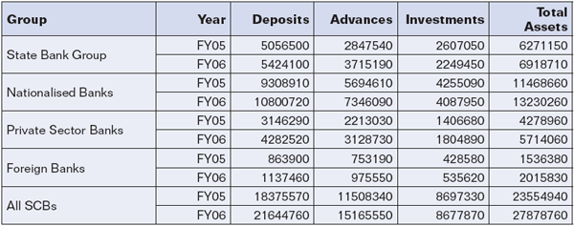
Source: Reserve Bank of India
- Group-wise Performance
The growth in deposits across the different bank groups showed substantial variation. Public Sector Banks with a deposit growth of 12.9% and Old Private Sector Banks with 11.4% showed a relatively subdued growth in deposits where as the New Private Sector Banks with 50.7% and Foreign Banks with 31.7% showed a sharp rise. Borrowings of the Public Sector Banks grew at 24%, but that of the Foreign Banks was much higher (30%). Due to redemption of the India Millennium Deposits in Dec 2005, banks’ non-resident foreign currency deposits showed a sizeable decline. Loans and advances growth too was on similar trends. For Public Sector Banks, loan growth was 29.5% as compared to 34.9% in FY05, for Old Private Sector Banks, it was 21.5% as against 22.7% in the previous year, for New Private Sector Banks it was 50.2 % as against 33% in FY05, and for Foreign Banks it was 29.5% as against 24 % in FY05. In the non-food credit, apart from retail credit which grew at 40.9%; infrastructure (24%), basic metals (14.1%) and textiles (11.2%) were the other major sectors that received higher levels of incremental credit.
- Growth in Retail Lending
While total credit of the SCBs grew at 31% in FY06, credit to the new segments in the retail banking showed still higher growth rates. In FY06, loans to housing rose by 33.4%, credit card receivables by 47.9%, auto loans by 75%, and other personal loans by 39.1% taking the growth of retail loans during the FY06 to 40.9%. Retail loans in FY06 constituted 25.5% of the total loans and advances of scheduled commercial banks. Lending to sensitive sectors also rose significantly. Loans to capital market rose by 39.2%, to real estate markets by 81.78% and to commodities by 85.56% with the growth in these three segments reaching to 77.65% in FY06.
Table 6: Advances to Sensitive Sectors as a percentage to Total Loans
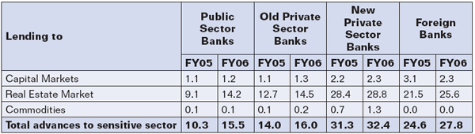
Source: Reserve Bank of India
- Priority Sector Advances
Credit to priority sector increased at a robust rate of 33.7% in FY06 on the top of 40.3% in the previous year. A major portion of the credit growth in the priority sector is accounted by agriculture and housing. Credit to SSI also grew sizeably.
Table 7: Priority Sector Lending
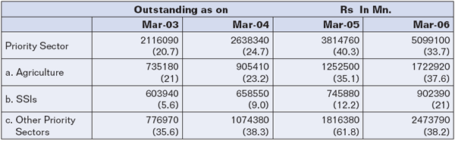
Source: Reserve Bank of India.
Figures in brackets are annual growth rate in %
- Market Share
The share of Public Sector Banks showed deceleration in respect of major areas of business, where as that of the new private sector and Foreign Banks earned higher share of business. The market share of the Old Private Sector Banks too came under pressure. Public Sector Banks hold 75% market share in major areas of business.
Table 8: Major Components of Business, Bank GroupWise (in %)
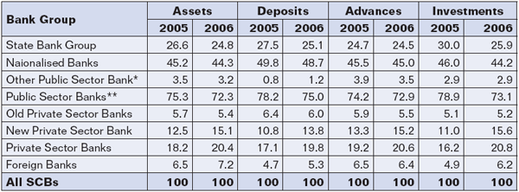
Source: Reserve Bank of India
* Industrial Development Bank of India Ltd
** Includes Industrial Development Bank of India Ltd
- Access to Equity Markets
Banks have been increasingly accessing primary equity capital markets for raising resources. In FY06, resource mobilization of banks through public equity markets rose by 24%. Resources raised by banks from public equity markets showed continuous increase, from Rs 24560 mn in FY04 to Rs 89220 mn in FY05 to Rs 110670 mn in FY06. Encouraged by the response to banks stocks, eleven banks, six in the public sector and five in the private sector, raised Rs 110670 mn from the equity markets. The Public Sector Banks which raised equity from the capital markets included Allahabad Bank, Oriental Bank of Commerce, Syndicate Bank, Andhra Bank, Bank of Baroda and Union Bank of India. The five Private Sector Banks were Lakshmi Vilas Bank Ltd, Yes Bank Ltd, ICICI Bank Ltd., The South Indian Bank Ltd and The United Western Bank Ltd. The size of the share issue of these banks was Rs 6270 mn where as the premium was at Rs 104400 mn. Banks also tapped private placement market for resource mobilization in a big way by raising Rs 301510 mn of which Public Sector Banks accounted for 74%.Bank stocks also emerged as an important portfolio for investment giving significant returns. Returns from bank stocks as measured through BSE Bankex rose from 28.6% in FY05 to 36.8 % in FY06 as compared to the benchmark index. Bank stocks still have scope for further growth with lower valuation prevailing at present in many banks.
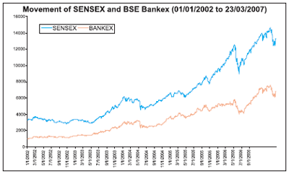
Source : Bombay Stock Exchange.

- Asset Quality
There is a perceptible increase in the quality of bank assets. Standard assets as percent of all assets for scheduled commercial banks moved from 94.9% in FY05 to 96.7% in FY 06, with decline in reported sub standard, doubtful and loss assets. The proportion of standard assets rose across all the bank groups in FY06, showing improved management of assets by banks. According to a report of the Reserve Bank of India, the gross non performing assets of the scheduled commercial banks declined by Rs 73090 mn over and above the decline of Rs 65610 mn in FY05.
As on 31 Mar 2006, gross NPAs of scheduled commercial banks stood at Rs 518150 mn of which 26.4% are with State Bank group, 53% with the nationalised banks, 7.1% with the Old Private Sector Banks, 7.3% with the New Private Sector Banks and 3.7% with the Foreign Banks.
Scheduled commercial banks stepped up recovery efforts through numerous methods. In addition to their own internal recovery processes, banks recovered to the tune of Rs 6080 mn through one-time settlement and compromise schemes, Rs 2230 mn though Lok Adalats, Rs 47100 mn through Debt Recovery Tribunals and Rs 34230 mn through SARFAESI Act. Asset Reconstruction Company of India Ltd (ARCIL) acquired 559 cases amounting to Rs 211260 mn from banks.
Table 9: Asset Classification in Banks (as % of Total Assets)
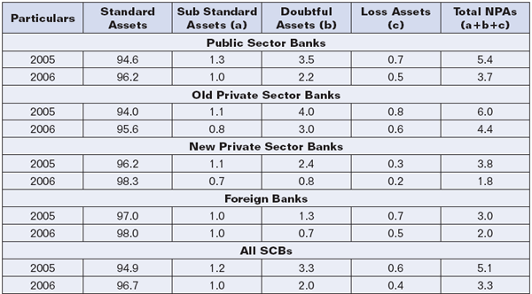
Source: Reserve Bank of India
- Distribution of Network
The expansion in the distribution network of the banks is increasingly evident from the growth of the automated teller machines. There is a surge in the growth of off-site ATMs with their share in the total ATMs rising to 32% in respect of Public Sector Banks, 67% in State Bank group, 32% in Old Private Sector Banks, 63% in New Private Sector Banks and 73% in Foreign Banks. Computerisation of public sector bank branches is also moving at rapid pace. In 2007 the pace of computerization progressed much further. Public Sector Banks have 93 branches operating abroad in 26 countries. All scheduled commercial banks together have 106 branches abroad.
Table 10: Branches/ATMs/Staff in Banks (Number)
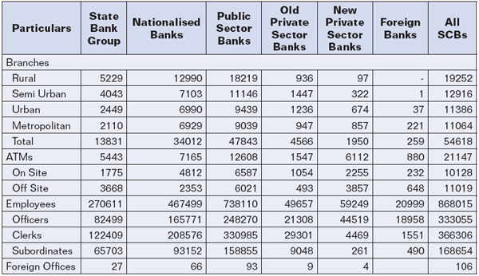
Source: Reserve Bank of India
IV.Total Assets
Total assets for the 82 scheduled commercial banks combined stood at Rs 27,785,739 mn in FY06, of which Public Sector Banks had the largest share of 72.5%, followed by Private Sector Banks of 20.2% and Foreign Banks at 7.3%.The asset base of SBI & Associates in FY06 stood at 24.9% of the total assets for the 82 banks profiled. In other words, excluding SBI & Associates, the asset base of Public Sector Banks was 47.6% of total assets of scheduled commercial banks.
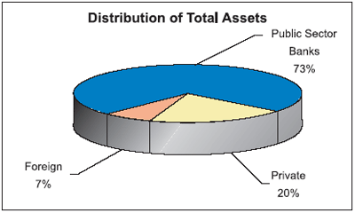
* During the year FY06, two domestic banks were amalgamated - Ganesh Bank of Kurundwad with Federal Bank Ltd and Bank of Punjab Ltd with Centurion Bank Ltd to become Centurion Bank of Punjab Ltd, while one foreign bank, UFJ Bank Ltd merged with Bank of Tokyo-Mitsubishi Ltd. ING Bank NV closed its business in India. In Sept, 06, The United Western Bank Ltd was placed under moratorium, leading to its amalgamation with Industrial Development Bank of India Ltd. in Oct, 2006, Sangli Bank, another Private Sector Bank was merged with ICICI Bank. Ganesh Bank of Kurundwad, Sangli Bank and The United Western Bank have therefore been excluded of the publication.
The assets for all the profiled banks have grown at a rate of 22.6% over the previous year. It was observed that the asset base of Private Sector Banks was growing more rapidly compared to the other bank groups. Total assets of private banks grew by 16% in FY05 and 33% in FY06, over the previous year. The asset base of Foreign Banks grew by 13% in FY05 and by 30% in FY06 mainly driven by the growth in advances of four banks in this group. The Public Sector Banks maintained a decent year-on-year growth of 15% and 19% in the respective years. However, it should be noted that the growth of Public Sector Banks is on a very high base.
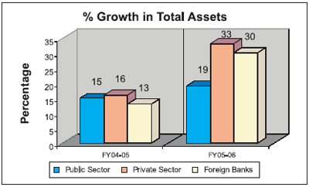
V.Total Income
The total income for the 82 banks stood at Rs 2,215,280 mn in FY06, of which the Public Sector Banks held the highest share of 72.7%, Private Sector Banks at 19.5% followed by 7.8% for the Foreign Banks. The SBI & Associates accounted for 36.6% of the total income for Public Sector Banks; having a combined income of Rs 589, 096.6 mn which is slightly higher than one fourth of the total income of the 82 banks profiled.
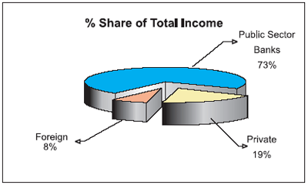
The top ten banks classified on the basis of their respective total income accounted for nearly 56% of the total income of the 82 banks. Of these top ten banks, 8 banks were Public Sector Banks while the remaining two were Private Sector Banks.
Non-Interest Income/Total Income
The non-interest income for all the 82 banks profiled in this publication on an average stood at 22.1% of the total income. Among the bank groups, non-interest income was the highest for Foreign Banks at 31%, followed by Private Sector Banks at 19.8%; indicative of the value-added services these banks offer. For Public Sector Banks, non-interest income was just 15.3% while interest income was a high 84.7%. Non-interest income includes fee income components such as commission, brokerage and exchange transactions, sale of investments, corporate finance transactions, M&A deals; and any other income other than the interest income generated by the bank.
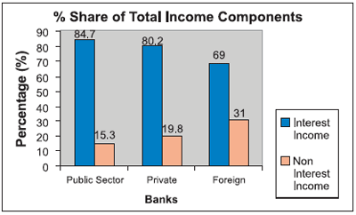
Net Profit
The net profit for the profiled banks together stood at Rs 248,281.5 mn for FY06. The top ten banks, based on the net profit classification, accounted for nearly 58.5% of the total net profit of all the 82 banks. These top ten banks included 6 Public Sector Banks, two Private Sector Banks and two Foreign Banks. Interestingly, of these top 10 banks, four banks that managed to make it to the top ten on the basis of net profit do not feature among the top ten on the basis of total income.
Bank group-wise, Public Sector Banks continued to dominate with a 66.6% share in the net profit. The share of Private Sector Banks in the total net profit stood at 21%, followed by Foreign Banks having a 12.4% share in the total net profit. Within the Public Sector Banks, SBI & Associates accounted for 36% of the total Public Sector Banks’ net profit, or nearly one-fourth of the total net profit of the 82 banks profiled. There are 5 banks, 4 foreign and one private, out of the profiled 82 banks, which made losses in FY06.
Infrastructure
Banks across all three groups have been rapidly increasing their infrastructure to tap the under served markets, though Public Sector Banks are dominant all across in all regions. As of Mar 06, the total number of branches of the profiled banks operating in the country was 54,346, of which 88% of the branches belonged to the Public Sector Banks (PSBs), indicative of the extent of penetration these banks have in the country. Another 11% of the branches belonged to Private Sector Banks and the rest were of Foreign Banks.Region-wise, the concentration of branches was highest in the rural areas, accounting for almost 35% of the total. The rural segment is entirely dominated by Public Sector Banks with 95% of the total rural branches belonging to PSBs. 23% of the branches of PSBs are located in semi urban area, while 19% branches are in the metropolitan regions. The immense reach of PSBs can be seen by the fact that almost 62% of total PSB branches are in rural & semi-urban areas.Group-wise, the presence of Private Sector Banks was largely in urban areas with almost 30% of their branches in this region.
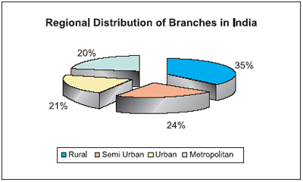
As of Mar 06, the total numbers of ATMs installed by profiled banks were 21,047. Public sector banks once again accounted for the largest share of installed ATMs with 12,608 machines, followed by the Private Sector Banks with 7,584 ATM’s. Foreign Banks have installed 855 ATMs around the country.
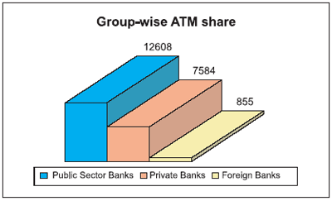
VI. Growth in Deposits, Advances & Retail Credit
Deposits
The overall deposit growth for the profiled banks was at 18.2% for FY06. Group-wise, deposits of Private Sector Banks witnessed a robust growth of 39.2%, closely followed by Foreign Banks at 31.7%. For Public Sector Banks the deposits grew at about 13% for the same time period. The share of Private Sector Banks in total deposits has been rising gradually, while that of Public Sector Banks has been declining over the years.
Growth in Deposits, Advances & Retail Credit
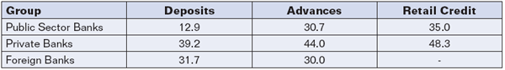
* The above figures are represented as an average % growth over FY05

Advances
Advances for all the profiled banks have grown at about 32% YoY and that made by Private Sector Banks grew at the highest rate of 44% for FY06 followed by a growth of 30.7% for Public Sector Banks and 30% for Foreign Banks. Among the major components of total advances, there was no relative change in the percentage share of Bills Purchased and Discounted, over the last three years. Cash Credits, Overdrafts and Loans have shown a yearly decline of 4% in FY05 as a part of total advances. Correspondingly, Term Loans have been growing and constitute a large component of advances. In FY04, Term Loans constituted 49.4% of Total Advances, which increased to 54.2% in FY05, and further to 55.7% in FY06.
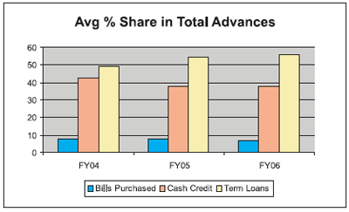

Group-wise Average Growth in Term Loans
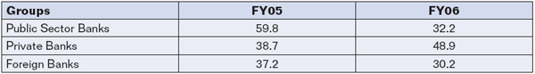
*All figures in %age
In FY06, Term Loans across the profiled banks grew on an average of 35.9%. Term Loans provided by the public sector banks showed robust growth of 59.8% in FY05 which almost reduced to half and stood at 32.2% in FY06. The growth shown by Private Sector Banks has varied too, with 38.7% growth in FY05 and 48.9% in FY06. Foreign Banks, however, have shown a lower growth in term loans in FY06 as compared to FY05, which grew by 30.2% in FY06 as against a growth of 37.2% in FY05. This growth in all three bank-groups can largely be attributed to the growth in retail credit and the overall economy, among other factors.
Retail Credit
Retail credit for the Public Sector scheduled commercial banks increased by 35%, which was significantly higher than the profiled banks’ overall credit growth of 32%. The retail advances by the Private Banks grew by 48.3%, which too was well above the overall growth.
Credit Deposit Ratio
The Credit-Deposit ratio (C-D ratio) is the proportion of loan-assets created by the bank from the deposits received. Among the 82 banks profiled, the aggregate C-D ratio stood at 70.1% in FY06 as compared to 62.7% in FY05. Among the profiled bank-groups, foreign banks had the highest C-D ratio of 85.8% in FY06, which was slightly lower than that of FY05. An opposite trend was seen with private banks, where in their C-D ratio stood at 73.4% in FY06, higher than 70.9% for FY05. Public sector banks too showed a growth in their C-D ratio at 68.2% as compared to 59.5% in FY05. As seen earlier, the high rate of bank credit growth during the last two years has resulted in this unique behaviour of credit-deposit (C-D) ratio.
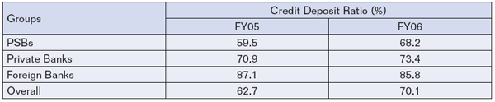
Priority Sector Advances / Total Advances
As instructed by the RBI, a target of 40% of net bank credit was stipulated for priority sector lending by domestic scheduled commercial banks, both in the public and private sectors. Within this, sub-targets of 18% and 10% of net bank credit had been stipulated for lending to agriculture and weaker sections, respectively.
In FY06, the average credit to the priority sector by the profiled Public Sector Banks accounted for 41.6% of their total credit, a little above the stipulated target level of 40%. In FY05, the profiled private banks lending to the priority sector constituted 39.6% of their total advances. The Public Sector Banks contributed 15.6% of their total credit to the agriculture sector and private banks contributed 11.9% for the same, both falling short of the stipulated sub-targets of 18%.
VII Operating Efficiency
Net NPAs to Net Advances (Net NPAs/Net Advances)
On an average, the net NPA/Net Advances ratio for the 82 banks was 1.4% in FY06. Of this, the net NPAs to net advances ratio for the Public Sector Banks was estimated to be 1.4%, closely followed by Private Sector Banks at 1.8%. For Foreign Banks, the ratio was much lower at 0.9%.
The graph below depicts that the asset quality of all the banks has been improving for the past couple of years. It is evident that there has been a sharp decline in non-performing loans of Public Sector Banks and Private Sector Banks.
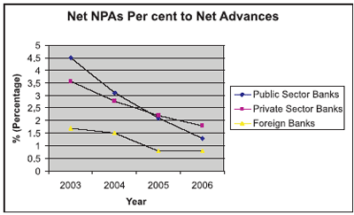
Operating Expenses
The operating expenses are those expenses that cover the day-to-day functioning of the bank like employee costs and charges for normal running of business. Among the profiled 82 banks, the ratio of operating expense to total expense for the Public Sector Banks was 26.5%, Private Sector Banks was 28.4%, while for Foreign Banks the ratio was nearly one-third of their total expenses and stands a little higher compared to their peers.
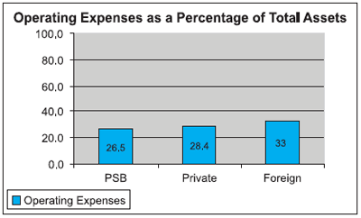
Intermediation cost is the ratio of operating expense to total assets, and when seen in conjunction with non-interest income explains how much is the non-interest income able to cover up the operating expenses of the banks. This gap (the excess of operating expenditure over non-interest income as a percentage to total assets) has been narrowing considerably over the past few years. Among the profiled banks, for Public Sector Banks this gap was 0.9%, for private banks 0.4% and for Foreign Banks it stood at 0.2% for the year ending Mar 06.
Capital Adequacy Ratio
The Capital Adequacy Ratio is a measure of the amount of a bank’s capital expressed as a percentage of its risk weighted credit exposures. The RBI guidelines require a capital adequacy ratio of 9%. All the banks profiled in this publication have a capital adequacy ratio of above 9%; with most of the banks placed well above the 9% mark.
Return on Assets
In the list of 82 banks profiled, the return on assets for Foreign Banks was highest at 1.5%, followed by Private Sector Banks at 0.9%; and Public Sector Banks at 0.6%. The graph depicts that the return on assets bounced back smartly for Foreign Banks after the slight decline it witnessed in FY05. The return on assets for the Private Sector Banks has more or less remained the same with just a slight decline in it. While the return on assets for Public Sector Banks shows a very sharp decline.
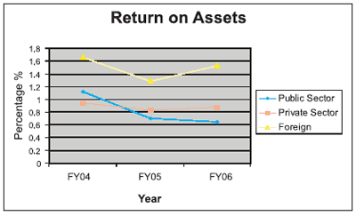
Return on Equity
Of the 82 banks profiled in the publication, the Return on Equity for Public Sector Banks was estimated to be the highest amongst its peers at 16%, closely followed by Private Sector Banks at 11.1% and 9.2% for Foreign Banks.
As shown in the graph depicting the trend in Return on Equity over the last four years, it is observed that the Return on Equity for Private Sector Banks fell drastically from 21.1% in the year 2003 to 11.1% in the year 2006. The Return on Equity for Public Sector Banks too showed a sharp decline from 21.8% in 2003 to 16% in 2006. As for Foreign Banks, the return on equity showed a marginal decline from 11% in 2003 to 9.2% in 2006.
One of the reasons for the declining RoE could be the large amount of resources raised from primary capital market to strengthen the capital base. As per RBI data ,the equity capital for public sector banks jumped close to five times from Rs 11040 mn in 2003-04 to a whopping Rs. 54130 mn in the year 2005-06. The private sector banks which had a low capital base in 2003- 04, also witnessed a huge jump in equity capital and ended the year with an equity capital of Rs. 56540 mn in 2005-06.
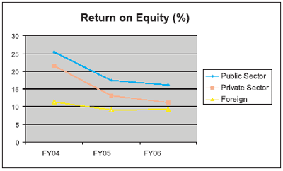
Net Interest Margin
It is defined as the excess of interest income over interest expense, as an percentage to total bank assets. Broadly speaking, this ratio reflects the allocative efficiency of financial intermediation, a lower ratio being indicative of upper efficiency. The net interest margin in FY06 stood at 3.5% for Foreign Banks its due to the fact that tradionally, the Foreign Banks can mobilise low-cost deposits. ; followed by 3.4% for Private Sector Banks and 3.13% for Public Sector Banks.
VIII Financial services

Real Time Gross Settlement
The Reserve Bank of India (India's Central Bank) maintains this payment network, which is available on weekdays only from 10 am to 1:30 pm. Fees for RTGS vary from bank to bank. Both the remitting and receiving must have Core banking in place to enter into RTGS transactions. Core Banking enabled banks and branches have assigned RTGS 11-character alphanumeric codes, which are required for transactions along with recipient's account number.

RTGS is a large value (minimum value of transaction should be Rs. 1,00,000 funds transfer system whereby financial intermediaries can settle interbank transfers for their own account as well as for their customers. The system effects final settlement of interbank funds transfers on a continuous, transaction-by-transaction basis throughout the processing day. Customers can access the RTGS facility between 9 am to 4:30 pm on week days and 9 am to 12 noon on Saturday)

The statistics of transactions for the month of March 2004 shows that in the interbank market transactions involving 45,000 instruments and aggregating Rs. 1,79,000 crore (1,790 billion) were settled. High value instruments (3,17,000) settlement aggregated Rs. 2,74,000 crore (2,740 billion). However, settlement of MICR instruments (145 lakhs) accounted for only Rs. 54,000 crore (540 billion). RTGS will eliminate settlement risk in the case of interbank and high value transactions.

The system went ‘live’ on 26 March with State Bank of India, HDFC Bank, Standard Chartered Bank, and Saraswat Co-operative bank. The Reserve Bank of India expected 120 scheduled commercial banks and primary dealers to become part of the real time gross settlement system (RTGS) by June 2004. ICICI Bank, IndusInd Bank, BNP Paribas, Bank of Baroda, Bank of India, Canara Bank, Central Bank of India, Corporation Bank and Union Bank of India were among those likely to join shortly.

Banks could use balances maintained under the cash reserve ratio (CRR) instead of the intra-day liquidity (IDL) to be supplied by the central bank for meeting any eventuality arising out of the real time gross settlement (RTGS). The RBI fixed the IDL limit for banks to three times their net owned fund (NOF).

The IDL will be charged at Rs 25 per transaction entered into by the bank on the RTGS platform. The marketable securities and treasury bills will have to be placed as collateral with a margin of five per cent. However, the apex bank will also impose severe penalties if the IDL is not paid back at the end of the day.

On 11 May 2004, 19 more banks joined RBI's RTGS bringing the total to 23. This include Bank of Baroda, Punjab National Bank, Canara Bank, Union Bank of India, Indian Overseas Bank, Central Bank of India, Dena Bank, BNP Baripas, IndusInd Bank, ING Vysya Bank. Out of the total 23 banks, the early batch of four banks State Bank of India, HDFC Bank, Standard Chartered Bank and Saraswat Bank have already embarked upon customer transactions.

National Electronic Fund Transfer
National Electronic Fund Transfer (NEFT) is an online system for transferring funds of Indian financial institution (especially banks). This facility is used mainly to transfer funds below Rs. 1,00,000.

The Reserve Bank of India has instructed banks that they should not use RTGS for amounts below Rs 1 lakh (100 thousand). The new rule came into effect on 1 January 2007. For small transactions, RBI has asked banks to offer National Electronic Fund Transfer (NEFT) which provided T+0 and T+1 settlement system (depending on the time a customer gives instruction to the bank for transferring the fund).

IX Challenges facing Banking industry in India
The banking industry in India is undergoing a major transformation due to changes in economic conditions and continuous deregulation. These multiple changes happening one after other has a ripple effect on a bank (Refer fig. ) trying to graduate from completely regulated sellers market to completed deregulated customers market.
• Deregulation: This continuous deregulation has made the Banking market extremely competitive with greater autonomy, operational flexibility, and decontrolled interest rate and liberalized norms for foreign exchange. The deregulation of the industry coupled with decontrol in interest rates has led to entry of a number of players in the banking industry. At the same time
reduced corporate credit off take thanks to sluggish economy has resulted in large number of competitors battling for the same pie.
• New rules: As a result, the market place has been redefined with new rules
of the game. Banks are transforming to universal banking, adding new
channels with lucrative pricing and freebees to offer. Natural fall out of this has led to a series of innovative product offerings catering to various
customer segments, specifically retail credit.
• Efficiency: This in turn has made it necessary to look for efficiencies in the business. Banks need to access low cost funds and simultaneously improve the efficiency. The banks are facing pricing pressure, squeeze on spread and have to give thrust on retail assets
• Diffused Customer loyalty: This will definitely impact Customer preferences, as they are bound to react to the value added offerings. Customers have become demanding and the loyalties are diffused. There are multiple choices, the wallet share is reduced per bank with demand on flexibility and customization. Given the relatively low switching costs; customer retention calls for customized service and hassle free, flawless service delivery.
• Misaligned mindset: These changes are creating challenges, as employees
are made to adapt to changing conditions. There is resistance to change from employees and the Seller market mindset is yet to be changed coupled with Fear of uncertainty and Control orientation. Acceptance of technology is slowly creeping in but the utilization is not maximised.
• Competency Gap: Placing the right skill at the right place will determine success. The competency gap needs to be addressed simultaneously otherwise there will be missed opportunities. The focus of people will be on doing work but not providing solutions, on escalating problems rather than solving them and on disposing customers instead of using the opportunity to cross sell.

Strategic options with banks to cope with the challenges
Leading players in the industry have embarked on a series of strategic and
tactical initiatives to sustain leadership. The major initiatives include:
• Investing in state of the art technology as the back bone of to ensure reliable
service delivery
• Leveraging the branch network and sales structure to mobilize low cost
current and savings deposits
• Making aggressive forays in the retail advances segment of home and
personal loans
• Implementing organization wide initiatives involving people, process and
technology to reduce the fixed costs and the cost per transaction
• Focusing on fee based income to compensate for squeezed spread, (e.g.
CMS, trade services)
• Innovating Products to capture customer ‘mind share’ to begin with and later
the wallet share
• Improving the asset quality as per Basel II norms

Transformation initiatives needed for banks

X Trends in Indian Banking Sector
The banking sector is the most dominant sector of the financial system in India, and with good valuations and increasing profits, the sector has been among the top performers in the markets. According to a FICCI survey, the chief strong point of the Indian banking industry is the regulatory system, which has enabled India to carve a place for itself in the global banking scene. The regulatory systems of Indian banks are rated above China and Russia; and at par with Japan and Singapore.
The public sector banks (PSBs) maintained its dominance in the banking system. As on March 31, 2008, PSBs accounted for 69.9 per cent of the aggregate assets and 72.7 per cent of the aggregate advances of the Scheduled Commercial Banking (SCB) system. An exceptional feature of the reform of the public sector banks was the course of their financial restructuring.
Furthermore, a report "Opportunities in Indian Banking Sector", by market research company, RNCOS, forecasts that the Indian banking sector will grow at a healthy compound annual growth rate (CAGR) of around 23.3 per cent till 2011.
Banking, financial services and insurance (BFSI), together account for 38 per cent of India's outsourcing industry (worth US$ 47.8 billion in 2007). According to a report by McKinsey and NASSCOM, India has the potential to process 30 per cent of the banking transactions in the US by the year 2010. Outsourcing by the BFSI to India is expected to grow at an annual rate of 30–35 per cent.
According to a study by Dun & Bradstreet (an international research body)—"India's Top Banks 2008"—there has been a significant growth in the banking infrastructure. Taking into account all banks in India, there are overall 56,640 branches or offices, 893,356 employees and 27,088 ATMs. Public sector banks made up a large chunk of the infrastructure, with 87.7 per cent of all offices, 82 per cent of staff and 60.3 per cent of all ATMs.
On the growth curve
According to the Reserve Bank of India's (RBI), August bulletin, the Indian banking sector's Reserve Money stood at US$ 214.53 billion and credit was estimated at US$ 543.87 billion, till July 4, 2008.
Aggregate bank deposits as on November 5, 2008 stand at US$ 716.76 billion. On a financial year basis, aggregate deposits went up by US$ 23.67 billion (3.5 per cent) during 2008-09, till July 4, 2008. The incremental non-food credit-deposit ratio increased to 82.4 per cent till July 2008, from 68.8 per cent a year ago. Earlier, aggregate demand deposits had increased to US$ 112.10 billion from US$ 97.75 billion till July 4, 2007.
Commercial banks' investment in statutory liquidity ratio (SLR) eligible securities increased by US$ 9.31 billion up to July 4, 2008 as against an increase of US$ 12.26 billion in the corresponding period of 2007–08. Aggregate deposits of the scheduled commercial banks (SCBs) reached US$ 132.74 billion till July 2008, as against US$ 120.78 billion in July 2007, and the year-on-year increase in aggregate deposits of SCBs stood at US$ 132.71 billion. Simultaneously, loans and advances of SCBs touched US$ 1.23 billion.
Banks had disbursed US$ 3.36 billion of advances between April 1 and May 23 2008, compared to a decline of US$ 10.03 billion in the corresponding period last year. The credit extended by Indian banking sector rose 25.3 per cent at end of May 2008, with the outstanding credit estimated at US$ 499.61 billion. As on March 2008, while the interest income of the 18 public sector banks and seven private banks rose by 28.4 per cent, the net profit rose at much higher rate of 33.61 per cent.
In fact, Indian banks bettered their foreign competitors during the first five months of 2008. According to the league tables for Indian markets compiled by Thomson Reuters, in June 2008, three domestic banks—States Bank of India (SBI), ICICI Bank Ltd and Kotak Mahindra Bank Ltd—were the top three banks in 2008. While the foreign banks' fee decreased by 61 per cent, the three domestic banks saw a 110 per cent growth in average fee income from investment banking operations. SBI's total investment banking fee income increased by 264.2 per cent to US$ 28.2 million during the first five months of 2008, against US$ 7.7 million during the corresponding period in 2007. ICICI Bank, witnessed a rise of 54.5 per cent at US$ 14.2 million, while Kotak Mahindra Bank, received US$ 11 million from investment banking.
Education loan portfolio of banks is expected to grow by 40 per cent in 2008–09, against 30–40 per cent in 2007–08. Online cash transactions are increasing rapidly in numbers, with people preferring to send and receive money electronically. With more bank branches getting interconnected through core banking systems, settlements through the electronic systems have nearly grown three times since April 2007. According to latest RBI data, the number of transactions done through electronic funds transfer systems (EFT) and national electronics funds transfer system (NEFT) went up to 1.92 million a month in June 2008 from 675,000 in April 2007. The total amount settled electronically was US$ 2.54 billion in April 2007 and it went up to US$ 4.20 billion by May 2008.
Global players
The Reserve Bank of India (RBI), has allowed foreign players to set up branches in rural India and take over weak banks with an investment of up to 74 per cent, and further relaxations are on the anvil by 2010, with the second phase of opening expected to commence in April 2009.
Some of the biggest names in global financial services and banks like Credit Suisse, Rabo Group and ANZ are seeking a banking licence in India. The RBI has, in recent months, given fresh banking licences to UBS - Switzerland's largest bank, Dresdner Bank and United Overseas Bank.
ANZ and Rabobank Group, the Dutch Group, is now in the process acquiring a banking licence. The Rabobank Group already holds 18.2 per cent stake in another local private bank YES Bank. Some of the existing players such as StanChart, Citi and HSBC, hold India as one of their top markets.
Overseas expansions
Some of India major banks are planning to increase their foreign operations, with an eye on the rapidly expanding NRI and corporate financing business in foreign markets. The State Bank of India (SBI) is in the concluding stages of introducing its overseas offices and is targeting a three-fold increase in its international business, by the next five years. SBI had been given the consent by the Singapore monetary authority to begin 25 branches in the country.
India's biggest private sector lender ICICI Bank will start four new offices in US - in New Jersey, Texas, California and Illinois. HDFC Bank also plans to increase its foreign operations. Presently, it has representative offices in Dubai and Toronto.
ICICI Venture-controlled Ranbaxy Fine Chemicals (RFCL) has acquired the US-based speciality chemicals major Mallinckrodt Baker. The deal was estimated at US$ 340 million.
Private Sector
Ever since the banking operations had been opened to the private sector in 1990s, the new private banks have been increasing its role in the Indian banking industry.
Private banks such as HDFC Bank and ICICI Bank are posting a rapid increase in their asset base every year as compared to public sector banks. A comparison between all profit-making 21 public sector banks and 18 private banks operating in the country revealed that private banks' price earning (P/E) ratio was more than public sector banks on June 12, 2008 and in June 12, 2007. The aggregate market capital of 21 public sector banks had increased by 0.66 per cent from US$ 38.57 billion on June 12, 2007 to US$ 38.75 billion on June 12, 2008.
The Dun & Bradstreet study revealed that new private sector banks dominated the banking industry in terms of growth with an average year-on-year growth in assets, with 38.7 per cent for deposits, advances at 39.9 per cent and operating profit at 46.7 per cent. Old private sector banks registered an annual growth rate of 7.1 per cent in assets, 6 per cent in deposits and 12 per cent in advances for FY 07. They fared better in net profit, which increased by 30 per cent. All bank groups recorded a capital adequacy ratio of more than 12 per cent.
Rural banking
Rural India's current credit requirement for 2008-09 is estimated to be US$ 826.73 million, and recognising the huge potential it holds, corporate sectors and banks are now increasingly moving towards rural India.
Mobile banking has already taken off in rural areas and thousands of people from rural areas across 12 Indian states are likely to get their social security pension and wages through mobile banking. As per the suggestions of a working group set up by the RBI, all the regional rural banks (RRBs) should move to the core banking platform (CBS) by September 2011. This can enable them to undertake 90 per cent of their business on the platform. The expected expenditure of this move is estimated at US$ 153 million. All RRBs are likely to get financial help but sponsor banks may have to provide 25 per cent of the cost. By the middle of 2009, the RRBs would be performing 25 per cent of their businesses through CBS, and by September 2010, this would be 50 per cent. All new branches opened after September 2009 need to be CBS-compliant.
Retail banking
Indian retail banking is likely to grow at a CAGR of 28 per cent till 2010 and touch US$ 203.7 billion. It has provided need of the hour services like around-the-clock accessibility through automated teller machines (ATMs), mobile and internet banking. It has also offered services like D-MAT, plastic money (credit and debit cards), and online transfers.
- ATMs
Banks have increased their ATM network over the past three years. According to the RBI, by June 2008, the number of ATMs in the country had gone up to 36,314 against 27,088 and 20,267 at end-March 2007 and 2006, respectively.
- Loan disbursement
Retail loan disbursements have become simpler and faster. The sector has been growing at around 30 per cent per year over the past 4–5 years. According to the RBI data, the growth of retail portfolio of banks (29.9 per cent) was higher than the overall credit portfolio of the banking sector (28.5 per cent), during 2006–07.
- Plastic Money
With the use of credit cards increasing significantly over the last few years, it has played an important role in promoting retail banking. The number of credit cards (outstanding) in June 2008 stood at 27.02 million, against 24.39 million in June 2007, posting a 10.73 per cent growth.
- Core Banking Solutions (CBS)
The concept of CBS enables a customer to fulfil numerous banking operations online, has grown since the past four years. The number of bank branches providing CBS increased to 44 per cent in March 2007, against 28.9 per cent in March 2006. Electronic fund transfer facilities and mobile banking is expected to further strengthen the retail banking segment in the future.
Investment Banking
With numerous mergers and acquisition deals by Indian corporates, investment banking revenues have gone up to a record high. According to Dealogic, an international firm that tracks global M &A transactions, investment banking revenues from India crossed the US$ 1 billion-mark for the first time in 2007 to US$ 1.06 billion. This is significantly higher than the US$ 400 million-investment banking revenues recorded in 2006. Also, this surge in revenues has propelled India to become the third largest market for investment banking in Asia-Pacific in 2007.
ICICI Bank, Kotak Mahindra Bank are already into this space and now, HDFC and the Union Bank of India are now also planning to expand into investment banking at a time when aggressive Indian companies are buying foreign rivals.

XI CONCLUSION:
Road Ahead
The Indian consumer holds the biggest opportunity for the Indian banking system and retail banking has immense opportunities in India. Though there are 334 million bank accounts in India, only 60 million Indian households are actively involved with regular banking activities. If these 30 million additional households are targetted over the next three years, it would expand the revenue pool by around US$ 2.24 billion for banks. Around 91 million households, with incomes of varying between US$ 899– US$ 4,052 per annum, are yet to be tapped by the banking sector.
Fiscal year 2008–09 is likely to set off the reform process in the banking sector with most banks complying with Basel II guidelines by 2009. The Indian banking system is expected to undergo an enormous transformation after 2009 with the opening of the financial services sector under the World Trade Organisation (WTO). Under WTO, the Indian banking sector will be open to foreign banks. Bigger capital reserves, cutting edge technology, best practices in audit, accounting and transparency and skilled personnel of foreign banks will pose major challenges to Indian banks.
According to a report by Boston Consultancy Group, the profit pool of the Indian banking industry is estimated to increase from US$ 4.8 billion in 2005 to US$ 20 billion in 2010 and further to US$ 40 billion by 2015. The domestic credit market of India is estimated to grow from US$ 0.4 trillion in 2004 to US$ 23 trillion by 2050. To sustain an average capital adequacy ratio of 12.0 per cent by March 2010, the public sector banks would require an additional capital of approximately US$ 67.50 billion. Under such favourable conditions, India is expected to become the third largest banking hub in the world by 2040, says a Pricewaterhouse Coopers report

XII References and Sources

1 www.dnb.co.in
2. http://en.wikipedia.org/wiki/Indian_banking
3. www.ibef.org
4. www.busniess.mapsofindia.com
5. www.ecs-limited.com/download/Challenges
6. www.rediff.com/money
7. www.ficci.com

