DISCLOSURE OF CORPORATE SOCIAL PERFORMANCE: PRESENT SCENARIO IN WEST BENGAL

Name of the Author: Rathin Kumar Bardhan

DISCLOSURE OF CORPORATE SOCIAL PERFORMANCE: PRESENT SCENARIO IN WEST BENGAL

Abstract: With the accelerating pace of globalization and increasing competition, it becomes inevitable for companies to have clearly defined business practices with a sound focus on public interest. In recent years, the concept of corporate social responsibility has gained prominence from all avenues. The present societal marketing concept of companies is constantly evolving and has given rise to a new concept — Corporate Social Responsibility. Many of the leading corporations across the world had realized the importance of being associated with socially relevant causes as a means of promoting their brands. Cause-related marketing and corporate social responsibility has provided companies with a new tool to compete in the market. With this background, an attempt is made in this paper to comprehend and gain insight into behavior or attitude of companies in West Bengal towards various aspects of social contribution. Analysis indicates that, around 50% companies in West Bengal do not disclose their corporate social performance.

Key words: Corporate social performance, Corporate social responsibility, Community welfare, environment, Health, Donation

- Introduction: Corporate social performance has been introduced in the academic literature, allowing us to be more precise in thinking about corporate social responsibility. Corporate social performance (CSP) is defined (D. J. Wood, 1991), as “a business organization’s configuration of principles of social responsibility, processes of social responsiveness, and policies, programs, and observable outcomes as they relate to the firm’s societal relationships.” Measurement and reporting of the social performance of profit oriented firms forms the core of corporate social performance. The National Association of Accountants (NAA, 1976) committee on Accounting for Corporate Social Performance described the term ‘Corporate Social Performance’ as “The term corporate social performance reflects the impact of a corporation’s activities on society. This embodies the performance of its economic functions and other actions taken to contribute to the quality of life. These activities may extend beyond meeting the letter of the law, the pressures of competition or the requirements of contracts.”
The corporate needs the society to carry on business. Social support is essential for development of a business. No business can grow with out society’s support. As an important part of the society, corporate has to carry some social activities. The NAA Committee on Accounting for Corporate Social Performance identified four major areas of social performance.
- Community Development: It includes social activities that are basically beneficial to the general public. For example, activities of housing construction, food programme, community planning and improvement etc. by a corporate would be treated as community development.
- Human resources: It includes social performance directed towards the well-being of employees. Training programme, up gradation of employees, improvement of working condition, promotion policies and provision of job enrichment etc would be treated as corporate social performance towards human resource.
- Physical Resources and Environmental Contributions: Activities by the corporate to prevent environmental deterioration or pollution would be under this heading. Corporate activities towards prevention of air, water or noise pollution, conservation of scarce resources and the disposal of solid waste are included in this area.
- Product or Service Contributions: This area includes consumerism, product quality, packing, advertising, warranty provisions etc.
With performing for social welfare, it is also very much important to disclose performance in their annual report. Disclosure of Social performance by a corporate has multiple effects. Corporate performance discloser is being evaluated as a culture of ‘doing the right thing’. It helps corporate in building up brand name based on distinctive ethical values and in getting loyalty of the customers at the market place. It also contributes the corporate in recruitment and retention of staff which are of critical importance for surviving in the highly competitive markets. Firms with a comprehensive corporate social performance and reporting policy attracts committed persons, which give them a distinct advantage over others. It also helps in improving the perception about the company among its existing staff, particularly when the staffs get involved in CSR activities.
Nature of Corporate social performance in India has been changed and is being changed over the years. Before independence, the corporate sector was dominated by British firms with very few corporate of Indian origin. The companies had hardly any social relevance. (Panda S, 2008). After independence, social performance was only the part of government organizations. Mainly Public Sector units were looking after social activities. But since 1990-91, due to new economic policy adopted by Govt. of India, many foreign and global business units has entered in India. Competition among the corporate bodies has also been increased. It leads the corporates to undertake some sort of social activities to get loyalty of the customers. However, due to global affect, awareness about social responsibility has also been increased among the corporate bodies. The objective of a business as ‘to sale goods or product’ has been changed ‘to ‘satisfy customers’. So, the view of corporate to words society is also has been changed. Now in India, many of the big corporate houses contribute lots of money towards society. But, the contributions towards society by the corporate houses are very nominal if we compare it with their sales volume or profit. Most of the cases it is even less than .01% sales or .5% of their net profit (Karmayog Survey report, 2007 and 2008). Keeping in view the pragmatic importance of corporate social responsibility and disclosure of it, an attempt has been made in this study to look into the nature of corporate social responsibility and disclosure of corporate social performance of the corporate world of West Bengal.
The rest of this paper is organized as follows:
In Part –II, some literature on corporate social performance has been reviewed. In Part –III covers the database and methodology adopted in the study. Empirical analysis of the data processed is presented in Part – IV. Conclusions are included in Part –VI.
- Literature Review: Most of studies in this area are made in micro level. Performance of corporate social responsibility has been analyzed for individual firm. Study about nature of corporate social performance is very limited. Again, most of the study has been done outside India. In India this type of study is very less. Most of the studies in this field are descriptive in nature. Quantitative study on corporate social performance is very few.
American Accounting Association (1975), had undertaken a study on corporate social reporting standard in America. They had considered social reports of 14 firms and analyzed statistically. A score of 1 (lowest ranking) through 5 (highest ranking) was assigned under each element of corporate social standard determinants. Analysis of ranks revealed that, around 50% of the firms got more than 3 or more score. They concluded that, about half the number of firms who present social reports maintain good standards of reporting. Around 38% of large firms in USA are conscious of reporting the social performance in a meaningful way.
National Association of Accountant (1977) conducted a survey of the current state of accounting for the social contributions of product/service in America. A sample of 800 of the largest corporation was made. This group included large corporations from banking, insurance, retailing, transportation, financial institutes etc. Objective of the survey was to identify the type of measures normally used to account for social performance. Main finding of the study was, while the corporates perceive the need to fulfill their social responsibilities, they do not in most cases, account for the costs and benefits of these activities.
A study was made by Consultancy and Research for Environmental Management (2004), on Policy and practices of Dutch companies regarding Corporate Social Responsibility in India. Objective of the study was to analyze to what extent Dutch companies with direct activities, a supply chain or investments in India, have developed a policy on Corporate Social Responsibility (CSR), to identify good practices and potential bottlenecks in the implementation of such policy and to support companies in finding practical solutions. They evaluated the companies by different parameters like Human rights, National sovereignty and local communities, labors, consumer protection, environmental aspect, economic aspect etc. After detailed analysis, they found, the companies keep distance with political matters of India. Their performance towards society is average and mainly for short term purpose. Long term contributions of the companies are limited.
A study on Indian corporate social responsibility was undertaken in 2001 (Kumar R, Murphy D.F and Balsary V). A poll had been conducted under the study and observed that, role of companies in different areas like supporting community development initiatives, empowering women and other groups, providing lowest possible prices etc are mostly higher towards general public compared to workers and company executives. As far as the study of the most important factors in forming opinion of a company is concerned, 58% of the respondents gave primary weighted to brand quality, 32% has reiterated the environmental, labour and social issues as most important. Only 9% of the respondents consider labour practices and business ethics as most important in forming an opinion of a company.
The key conclusions that have emerged from the poll are: high expectations from companies are not yet matched by judgments about corporate responsibility and more trust is placed in the media and non-government organizations than in industry.
Most of the study in this sector has been done at micro level. Like, in 2006 a study on ‘the corporate social responsibility initiatives of Tesco and its impact on the internal and external environment of the company’ have been made by ICMR. . It analyzed in details the activities undertaken by Tosco’s management and employees to contribute to the benefit of the society and the community in which the company operates. The case also discussed the active role played by Tesco in protecting and regenerating the environment and in extending the CSR initiatives to its suppliers.
It also highlighted a few criticisms against Tesco including polluting the environment in some countries and not adhering to its CSR standards.
Similarly, a study on Corporate social responsibility of Singareni Collieries Company Limited has been made by Prajna Paramita Mishra and Harish Pranav Jagannath in 2008. The study observed, the firm ignored employees’ interest every year of their study period. But the firm is very aggressive in case of customers as well as shareholders interest. Initially, the firm was not involved in environmental and community development aspects. But, they changed their view latter on. The analysis shows that mission statements emphasizes customer interests and the maximization of returns for shareholders, while annual reports give more attention to financial than social issues. This indicates that CSR is still a peripheral concern in the agenda of SCCL. In the absence of a legal framework mandating social responsibility, social issues will continue to achieve a peripheral attention in their policies and strategies.
- Database and Methodology: For the study, descriptive data has been collected from individual company’s annual report 2007-08. At first, top 100 companies has been chosen from SEBI website, whose head office is in West Bengal and sales volume is more than 200 crores of rupees in the year 2007-08. Then, detailed information regarding corporate social performance disclosure has been collected from companies’ annual reports.
The study is based on the method called ‘descriptive research’. But for some extent, quantitative measurement is also taken to quantify and to find abstract result. Social activities of the companies during the year 2007-08 has been categorized under different groups as Community Welfare, Environment, Education, Disaster relief, Sports, Health care, rural development, women’s empowerment, energy conservation, water, donation, activities related to girl child, adult literacy.
- Empirical analysis: In West Bengal, around 47% companies do not disclose social performance in their annual report. Banking and Financial sector institutes, Hotels, Diversified companies, Automobile, Polymer, Petroleum are the sectors where disclosure of corporate social performance is more or less zero. Whereas, iron and steel industries, cement, FMCG, paper industries etc has been found better in case of disclosure of corporate social performance.
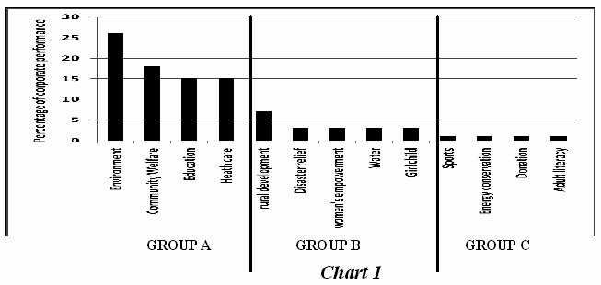
Areas of corporate social performance in West Bengal can be categorized in three groups [Chart 1]. Group A-where most of the companies concentrate. Environment, community welfare, education and health care are under this group. 26% of the sample companies were found to be worked in environmental issues.
Similarly, 18% of the companies’ area of social work was community welfare. In educational activities and health care activities, 15% of the companies were involved (in each activity). Group B- where moderate interest of corporate has been found. Rural development, Disaster relief, Women’s empowerment, Water purification & supply and social development of girl child are the areas under this group. 3% to 7% of the companies in the study have been found to be involved in these types of activities. Group C is most neglected area. Adult literacy, Sports, energy conservation and donation to social activities are under this group. Only 1% of companies have been found to be involved in each of the activities.
Community welfare activities: In community welfare activities, companies from Iron and steel industries and FMCG have been found more active [Chart 2]. 50% of the companies involved in community welfare activities are from these two industries. Other industries in this area are cement, Auto ancillaries, Metal, engineeringand Miscillaneous (8% each).

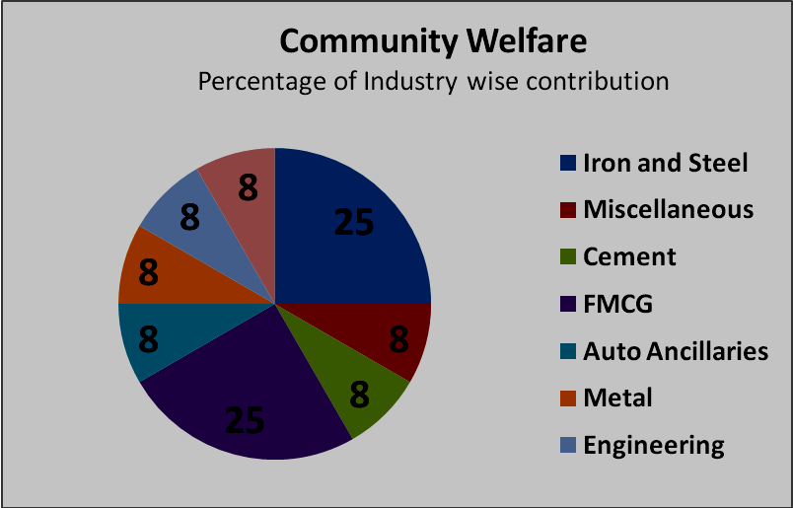
Chart -2

Under community welfare activities, following activities were found to be included.
  - Irrigation scheme to supply free irrigation water to local farmers.
  - Arrangement of free doctor visits to the surrounding villages frequently.
  - Organising different training programmes like embroidery training for women
  - Development of community hall
  - Building of roads and bridges
  - Construction of play grounds for surrounding villages
  - Free blanket distribution
  - Installing solar lights besides the roads.
  - The self-employment programme focuses to train people to become employed. It includes training of drivers, pot making training for women etc.
  - Social and Farm Forestry initiative for greening the environment.
To increase awareness among the public about social, political, economical matters as well as health, longevity, safety ness etc, different awareness programme is being conducted by individual companies. For example, Iron deficiency among Indian children is a key cause of school dropouts as well as decreased productivity. In keeping with its core essence of “Swasth Khao Tan Man Jagao”, Britannia Company constantly strives to find sustainable opportunities to drive home the message of nutrition and good food habits among children at the right age.
Environment: In environment issues, more than 60% contribution is observed from four industries [Chart 3]. Iron and Steel industries and industries under miscillaneous items contributed 20% each of total contribution. Metal and Chemicals industries contributed 13% each towards environmental issues. Other industries contributed in environmental issues are paper, Mining, Textile, power and Auto ancillaries.
Under environmental issue, many companies have made substantial investments in various pollution control equipment. The equipment installed includes ETP incinerators, electrostatic precipitators, dust collectors, scrubbers, fume hoods and oil separators. These measures are mainly to maintain emission and pollution control levels well within the prescribed limits.
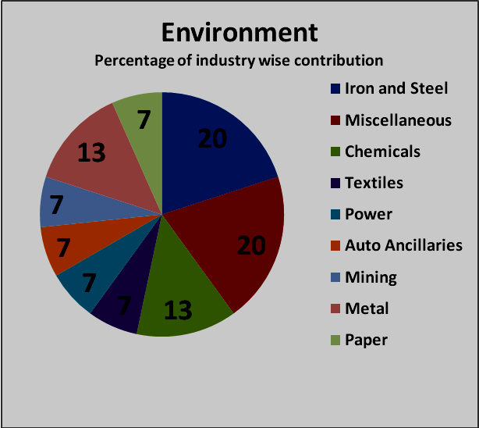
Chart -3

Many companies has undertaken project to control of pollution. Like, Bata India Limited has taken a project ‘Saving the Ganga’, a project that has made a significant contribution in this direction. Bata at a considerable cost has ensured that the effluents from the tanneries are treated in a state-of-the-art effluent treatment plant, so that they do not pollute the river at Batanagar and Mokamehghat. Not only is that, Bata was one of the first companies to come forward to preserve nature, when it joined hands with World Wide Fund (WWF) to protect the natural environment and its wildlife. Through an arrangement with the apex body of WWF, a part of the sale proceeds from "Power WWF" collection T-shirts were donated to the WWF.
Education: Out of total contribution in education, total 60% is covered by iron and steel industry, Chemicals and FMCG sector [Chart 4]. Other sectors in this area are Cement industry (10%), Auto ancillaries (10%), Metal (10%), construction (10%).
Contribution towards education can be classified at two categories: long term contribution and short term contribution. Some firms contribute towards operation of schools. Tata Metaliks Ltd has adopted a school at Gokulpur. This school has strength of about 2000 students and is the only Higher Secondary School in the immediate vicinity. It has built class rooms for the school, for the Shishu Shiksha Kendra and a space for kitchen, has helped replenish library, built laboratories for higher classes, donated computers and run free computer classes. The Satna Unit of Birla Corporation Ltd has constructed school building and provided furniture in nearby villages namely Baraj, Bari, Naina, Bathia, Sagmania and Ghurdang. At Chanderia, the Company made substantial contribution for construction/renovation of school building for Government Higher Secondary School. Shalimar Paints Ltd runs a high School at Howrah where it imparts free education to boys and girls from Class 1 to Class X.
Short term contributions towards education are:
- Donation of computers to rural school
- Sponsoring the education of brilliant students
- Computer training
- Scholarships to the students for higher studies
- Providing free primary education for employees children
- Adult education and adult literacy programme
- Providing books and materials to handicapped children for education
- Distribution of school uniforms
- Providing vocational training in various skills to local youths or groups to start small business units for achieving self dependence.
- Training of villagers in multi-farming, horticulture, fish breeding, agro tourism, organic farming and achieving self-sufficiency through supplementary income – generation activities.

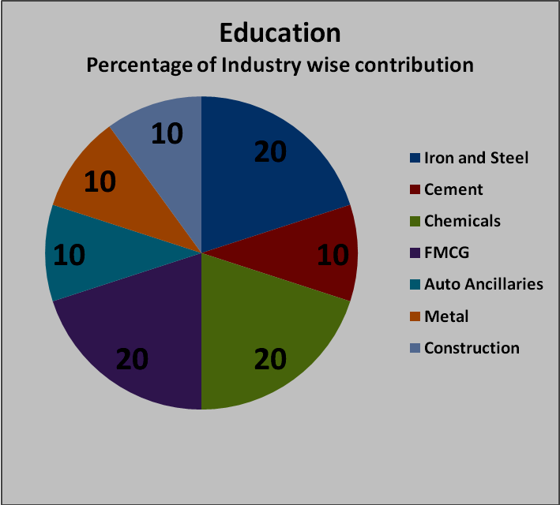
Chart 4
Not only is that, Considering every child is an asset for the nation, Tantia Constructions Ltd has undertaken a movement by promoting greeting cards made by students to meet their school fees for personal and corporate use. It has donated its old computers for spreading training and awareness in villages of West Bengal.
Health Care: FMCG, in health care has been found to be more active. 30% of total contribution in this area is made by FMCG industry only [Chart 5]. Remaining portion is shared by iron and steel industry, cement, chemicals, oils and gas, textile, auto ancillaries and metals industry equally.
Contribution towards health care also can be classified under two categories: long term and short term contribution. Under long term contribution, many firms established hospitals and health centers, donated ambulance for public utility. Birla Corporation Ltd established Priyamvada Birla Aravind Eye Hospital at Kolkata. In a short time this Institution has built an outstanding reputation for Quality and Care. The State-of-the-Art facilities are now catering to approximately 1,000 surgeries every month out of which 75% is almost free. In addition, it has to-date treated more than 50,000 OPD patients, other than camp patients.
In short run contributions, following areas have been observed:
- Organizing Eye Check-up Camp
- Organizing General Health Check-up Camp
- Organizing HIV/AIDS Awareness Camp
- Blood Donation Camp
- Nutritional camps for children
- Personal Accident Policy for workers
- Mediclaim and Personal Accident Policy
Emami Ltd sponsors subsidized treatment of the needy in best-in-class hospitals like AMRI and Shree Vishudhanand Hospital and Research Institute in Kolkata. Donations are made in the form of free supplies of medicines, assistance for surgeries and hospital charges for the poor through trust.

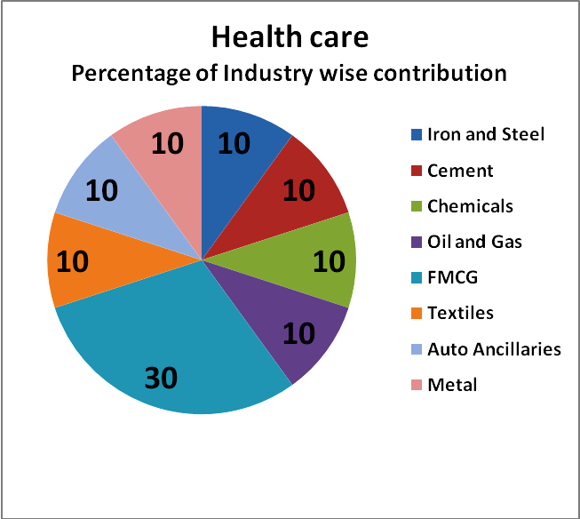

Chart 5
Rural development, Disaster relief, Women’s empowerment, Water purifying and supply and helping Girl child: Agriculture is one of the most prominent sectors in Indian economy. Agriculture and allied sectors accounted for 18.6% of the Gross Domestic Products (GDP). About 60% of the total population are engaged in agricultural activities. Some companies contribute towards the development of the farmers’ by providing training and education besides seeds, fertilizer, etc. Some provide direct employment to several thousands people.
Star Paper Mills Ltd initiated "Social Forestry Programme” with following objectives:
- Plantations for green coverage and mitigation of environmental pollution.
- Employment generation in rural areas and additional income to Farmers apart from their normal agricultural income.
- Availability of good quality wood for the industry.
Women’s empowerment includes the work for self employment of women, organizing and helping to operate self help group by women etc.
Sports, energy conservation, donation and adult literacy: These are the most neglected area. Only 1% of companies have been found to be involved in each of the activities.
In sports following contribution from corporate has been found.
- Organizing World Run Day to spread consciousness among the common people to keep fit & healthy.
- Scholarship for athletes in the age group of 12 years to 16 years.
- Athlete Search Programme for spotting young budding athletes.
- Residential Coaching Camp to asses the performance of the scholarship recipients and other budding athletes.
- Football tournament.
In case of energy conservation, following contribution by the company has been observed.
- "Genentech Environment Excellence Award” by Birla Corporation Ltd.
- Consumption of fly ash
In case of donation contributed for social activities, following activities has been observed.
- Relief to flood victims
- Donation for Tsunami
- Donation for beautification of city/town
- Donation to charitable institutes
In the area of adult literacy, following contribution has been found.
- Adult literacy programme conducted by company
- Special training programme to the illiterate employee
- Night school for adult illiterates.
- Findings: From the empirical analysis, main findings are:
- 47% of corps did not disclose their social performance.
- In annual report, companies disclose only the performance area and activities, but they don’t disclose their actual expenses. Only one firm in the study is found to disclose expenses.
- Whereas, environment, community welfare, education and health care are the prominent areas of corporate social performance and disclosure, sports, energy conservation, adult literacy etc are the neglected sector.
- Most of the company’s area of operation is whole India and abroad. So, in some case it is very difficult to segregate activities state wise.
- In most of the cases, corporate social activities have been found for local areas around the factory of head office.
- Though the companies do not state actual expenses for social activities, but analyzing their activities and areas, it can be taken for granted they spend less than .5% for corporate social activities.
- Suggestive measures: Following measures can be suggested to improve the situation.
- A state level committee should be created. The committee would look after the matter of corporate social performance.
- There should be a common objective and common platform. All the company should work under the same master guidelines.
- Government should order all the corporate to spend a particular percentage of their profit in favor of corporate social activities and to disclose in Annual report.
- Conclusion: In present globalized economy, corporate social performance and its disclosure is a must. All the global firms started to spend a part of their profit for social welfare. But, in West Bengal, the situation is not so good. Even more than 47% of the companies having head offices in West Bengal don’t contribute towards social activities or disclose their activities in their annual report. Again, social activities are found to be clustered in particular areas and some important sectors are neglected. Therefore, Government should have master plan to control over this. Further research on this area can disclose more in this aspect.
- References:
- D. J. Wood (1991), corporate social performance revisited, Academy of Management Review, 16, p. 693.
- NAA Committee Report, Part I, 1976, p-39.
- Marc Orlitzky, (June 2000) Corporate Social Performance: Developing Effective Strategies, Research Brief, Centre for Corporate Change, Australian Graduate School of Management
- Sanjay Kumar Panda, 2008, CSR in India: The Past, Corporate social responsibility in India, The ICFAI University Press.
- Sanjay Kumar Panda, 2008, CSR in India: The Present, Corporate social responsibility in India, The ICFAI University Press.
- Sanjay Kumar Panda, 2008, CSR in India: The Future, Corporate social responsibility in India, The ICFAI University Press,
- Survey report, Karmayog social network, http://www.karmayog.org/csr/
- AAA Committee Report, 1975, p 48-49
- NAA Committee Report, 1977, p 13-16 and p 83-86
- Consultancy and Research for Environmental Management, Corporate Social Responsibility in India, Policy and practices of Dutch companies, Amsterdam, the Netherlands, February 2004, CREM-report nr. 03.650
- Rity Kumar, David Murphy and Viraal Balsari, 2001, Altered Images-The 2001 state of corporate responsibility in India poll, Source: Tata Energy Research Institute, TERI-Europe,
- Tesco's Corporate Social Responsibility Initiatives, 2006, Case Code BECG059,Center for management Research,
- Prajna Paramita Mishra and Harish Pranav Jagannath, 2008, Corporate Social Responsibility in Coal Mining: A Case of Singareni Collieries company limited, www.ecoinsee.org/fbconf/Sub%20Theme%20C/Prajana.pdf

