Introduction of the Microcontroller Kits by the Pictures
1)Microcontroller Kits:  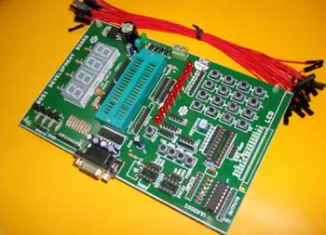 | Features:  1)ZIF socket  2)8051 microcontroller  3)on board keypad  4)on board Seven Segment  5)Serial communication with PC  6)good experiment sets in the user manual
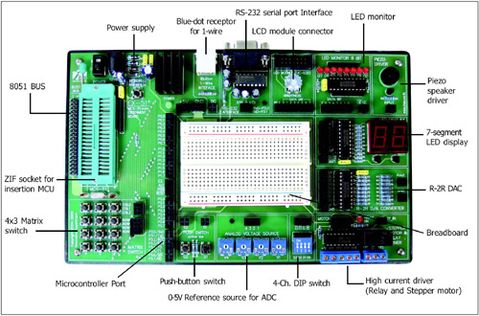 | Features of SKIT-51  1)PX-1000 V3 programmer  2) EX-51 plus experiment board  3) LCD module (16x2),  4)RS-232 cable (x2),  5)Small stepper motor  6) DC adaptor (x2)  7) Jumper wire in a box, Software and lab manual
2) ARM board: LPC2148  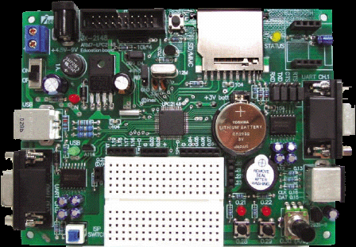 | JX-2148 Features :  1)LPC2148 ARM-7 Microcontroller  2) Standard JTAG connector, 3)USB connector  4)Two RS232  5) SD/MMC card connector  6) PS2 connector  7)Two buttons Potentiometer connected to ADC,  8)Two LEDs, Buzzer SPI connection  9)170 points mini-breadboard, RESET button  10) On board voltage regulator 3.3V,  11)12MHz main XTAL 32768Hz xtal and RTC backup battery,ESD-02 Bluetooth module socket (optional)
3) PIC Boards:
JX-877
- PIC16F87x/18F4xx Project Board
- On-Board PIC16F877 (A) 20MHz
- 3”x5” Prototype area with 1,303 pads and some libraries placement of popular components
- Selection of RUN/PROG mode by switch
- Requires the external +16Vdc 500mA
- Comes with CX-6 Parallel port Cable, CD-ROM and Documentation

PIC Board: NX-877 PLUS II
Specifications:
- Supports PIC16F87x & PIC18Fxxx
- On-Board PIC16F877 running at 20MHz
- In-system program with the PX-200 programmer, communication via USB port
(included)
- Selection of RUN/PROG mode by switch
- Supplies power of +5V 500mA
- Proto board measuring 2.5x7 Inches, 800 points
- RS-232 serial port interface circuit
- 1Hz- 1kHz pulse generator
- 4-Push switch (Low while active with a pull up resistor)
- 32-channel LED Monitor
- Piezo speaker
- LCD connector with brightness control
- 4 Channel 0-5Vdc voltage source for ADC experiments
- 4 by 3 Matrix switch with pull-up capabilities
- 3-digit multiplexed LED display
- 1-Wire and iButton jack (For use with DS1402 - included)

AVR controllers JX-MEGA128 COMPACT BOARD: Running speed of 16MHZ, Built in USB Serial Converter for uploading and serial communication, On board 10 pin Standard ISP Connector, On board +5v Low Dropout Vo9ltage Regulator with DC input terminal, Both pin name and WIRING's port numberings, Operating Voltage of 5v, Download via Bootloader, 16x2 LCD Module ,51 I/O ports free connection for interfacing

Wireless Boards: ZX-Bluetooth, ESD02 Bluetooth, XBEE-PRO, SKIT XBEE-PRO
Features: The XBee-PRO 802.15.4 (formerly Series 1) OEM RF module is an IEEE 802.15.4 compliant solution that satisfies the unique needs of low-cost, low-power wireless sensor networks. The module is easy-to-use, requires minimal power and provides reliable delivery of critical data between devices. Innovations stamped in the XBee-PRO design enable it to yield two- to three-times the range of standard ZigBee modules.
The XBee-PRO 802.15.4 module operates within the ISM 2.4 GHz frequency band and is pin-for-pin compatible with Digi's regular XBee (1 mW) 802.15.4 module.

Zoom Photo of the JX-MEGA128 AVR Board:

