Automatic Railway Gate Control & Track Switching( LATEST)
2009 August 3
by badmedia
Present project is designed using 8051 microcontroller to avoid railway accidents happening at unattended railway gates, if implemented in spirit. This project utilizes two powerful IR transmitters and two receivers; one pair of transmitter and receiver is fixed at up side (from where the train comes) at a level higher than a human being in exact alignment and similarly the other pair is fixed at down side of the train direction. Sensor activation time is so adjusted by calculating the time taken at a certain speed to cross at least one compartment of standard minimum size of the Indian railway. We have considered 5 seconds for this project. Sensors are fixed at 1km on both sides of the gate. We call the sensor along the train direction as ‘foreside sensor’ and the other as ‘aft side sensor’. When foreside receiver gets activated, the gate motor is turned on in one direction and the gate is closed and stays closed until the train crosses the gate and reaches aft side sensors. When aft side receiver gets activated motor turns in opposite direction and gate opens and motor stops. Buzzer will immediately sound at the fore side receiver activation and gate will close after 5 seconds, so giving time to drivers to clear gate area in order to avoid trapping between the gates and stop sound after the train has crossed.
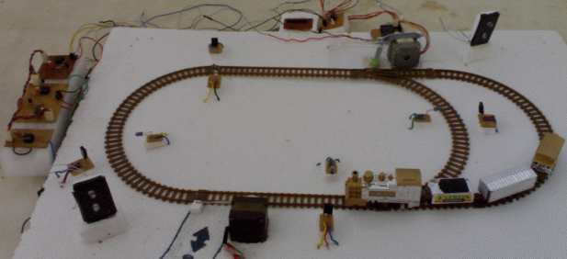
The same principle is applied for track switching. Considering a situation wherein an express train and a local train are traveling in opposite directions on the same track; the express train is allowed to travel on the same track and the local train has to switch on to the other track. Two sensors are placed at the either sides of the junction where the track switches. If there’s a train approaching from the other side, then another sensor placed along that direction gets activated and will send an interrupt to the controller. The interrupt service routine switches the track. Indicator lights have been provided to avoid collisions. Here the switching operation is performed using a stepper motor. Assuming that within a certain delay, the train has passed the track is switched back to its original position, allowing the first train to pass without any interruption. This concept of track switching can be applied at 1km distance from the stations.
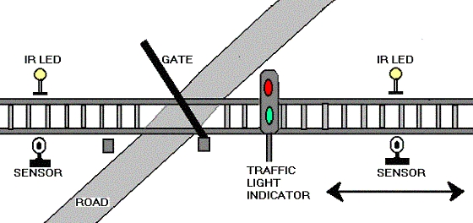
The project is simple to implement and subject to further improvement.
Model of Automatic Railway Gate Control & Track Switching
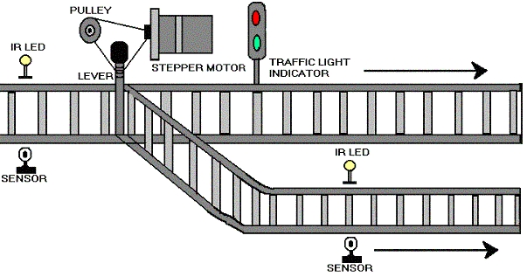
Gate Control:
Railways being the cheapest mode of transportation are preferred over all the other means .When we go through the daily newspapers we come across many railway accidents occurring at unmanned railway crossings. This is mainly due to the carelessness in manual operations or lack of workers. We, in this project has come up with a solution for the same. Using simple electronic components we have tried to automate the control of railway gates. As a train approaches the railway crossing from either side, the sensors placed at a certain distance from the gate detects the approaching train and accordingly controls the operation of the gate. Also an indicator light has been provided to alert the motorists about the approaching train.
Gate control
Hardware Description
The project consists of four main parts:
8051 microcontroller
IR Transmitter
IR Receiver
Stepper Motor Circuit
8051 Microcontroller
The I/O ports of the 8051 are expanded by connecting it to an 8255 chip. The 8255 is programmed as a simple I/O port for connection with devices such as LEDs, stepper motors and sensors. More details of the 8255 are given later.
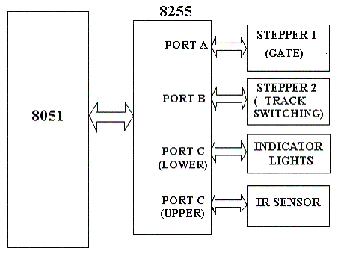The following block diagram shows the various devices connected to the different ports of an 8255. The ports are each 8-bit and are named A, B and C. The individual ports of the 8255 can be programmed to be input or output, and can be changed dynamically. The control register is programmed in simple I/O mode with port A, port B and port C (upper) as output ports and port C (lower) as an input port.
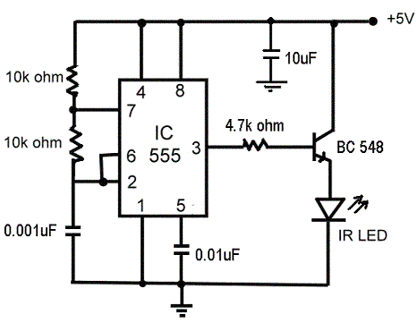
Block diagram of 8051 Microcontroller
IR Circuits
This circuit has two stages: a transmitter unit and a receiver unit. The transmitter unit consists of an infrared LED and its associated circuitry.
IR Transitter
The transmitter circuit consists of the following components:
IC 555
Resistors
Capacitors
IR LED
The IR LED emitting infrared light is put on in the transmitting unit. To generate IR signal, 555 IC based astable multivibrator is used. Infrared LED is driven through transistor BC 548.
IC 555 is used to construct an astable multivibrator which has two quasi-stable states. It generates a square wave of frequency 38kHz and amplitude 5Volts. It is required to switch ‘ON’ the IR LED.
IR Transmitter
IR Receiver
The receiver circuit consists of the following components:
TSOP1738 (sensor)
IC 555
Resistors
Capacitors
The receiver unit consists of a sensor and its associated circuitry. In receiver section, the first part is a sensor, which detects IR pulses transmitted by IR-LED. Whenever a train crosses the sensor, the output of IR sensor momentarily transits through a low state. As a result the monostable is triggered and a short pulse is applied to the port pin of the 8051 microcontroller. On receiving a pulse from the sensor circuit, the controller activates the circuitry required for closing and opening of the gates and for track switching. The IR receiver circuit is shown in the figure below.
IR Receiver
Stepper motor circuit
Stepper motor circuit
Here a stepper motor is used for controlling the gates. A stepper motor is a widely used device that translates electrical pulses into mechanical movement. They function as their name suggests – they “step” a little bit at a time. Steppers don’t simply respond to a clock signal. They have several windings which need to be energized in the correct sequence before the motor’s shaft will rotate. Reversing the order of the sequence will cause the motor to rotate the other way.
Track Switching
Using the same principle as that for gate control, we have developed a concept of automatic track switching. Considering a situation wherein an express train and a local train are travelling in opposite directions on the same track; the express train is allowed to travel on the same track and the local train has to switch on to the other track. Indicator lights have been provided to avoid collisions .Here the switching operation is performed using a stepper motor. In practical purposes this can be achieved using electromagnets.
Track Switching

