Answer all Questions
Part –A ( 2 X 10 = 20 )

- What is the use of snubber circuit?
Switching stresses are limited by 1) limiting trun-off transient voltage
2) limiting device current during trun-on transient 3) limiting di/dt through device during turn-on 4) limiting dv/dt across the device during turn-off 5) by shaping the switching trajectory. (Any 4 points – 2marks)
- Draw the circuit model of power BJT.

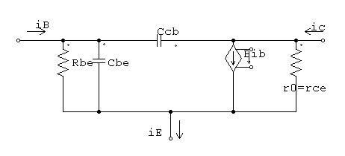
Terms explanation needed.

- Derive the expression for rms output voltage of 2-pulse converter with R-load.
V_{orms} = $√\frac{1}{π}\int_{α}^{π}{V_{m}^{2}\sin^{2}ωt dωt}$
After simplification
V_{orms} = V_{m} [$\frac{1}{2π}(π-α+\frac{sin2α}{2}$)]^{1/2}

- Mention the advantages of symmetric converter over asymmetric converter.
In a symmetric configuration of single phase semi converters, the cathodes of two SCRs are at the same potential so their gates can be connected and a single gate pulse can be used for triggering either SCR. In asymmetrical configuration, separate triggering circuits are to be used.

- A step up chopper is used to deliver load voltage of 660V from 220V dc source if non conduction time of chopper is 50µs, Compute the pulse width. If pulse width is halved find new output voltage.
E₀ = E_{dc} [1/(1-δ)] ( 1 mark)
660 = 220 X T/50X10⁻⁶
T = 150 micro second & T_{on} = 100 microseconds. ( 1 Mark)

- Explain current limit control
Current in load is maintained between two limits. When current exceeds upper limit chopper is switched off and vice versa.
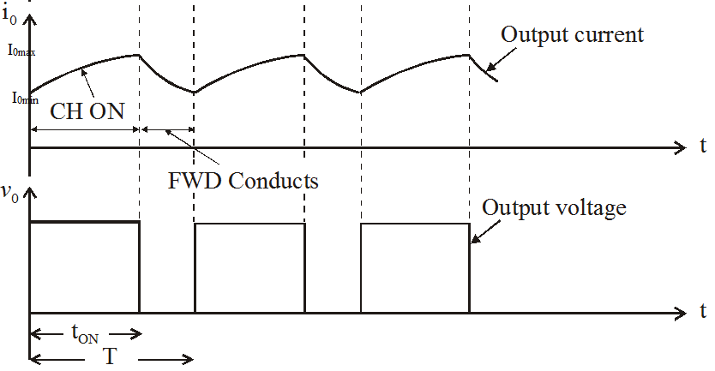
- Define SPWM.
In Sinusoidal Pulse Width Modulation , the width of each pulse is varied in proportion to the amplitude of a sine wave evaluated at the center of the same pulse.

- What are null vectors in space vector modulation?
The state vector V₇ (1 1 1) and V₈ (0 0 0) results in zero output line voltages of a three phase inverter under 180⁰ mode of operation. They are called as null vectors.

- Define duty cycle of AC voltage controller.
When Integral cycle control is used
Duty cycle k= $\frac{n}{n+m}$ where n= number of cycles for which regulator is ON and m= number of cycles for which regulator is OFF.

- What is cycloconverter?
A Cycloconverter is a direct-frequency changer that converts ac power at one frequency to ac power at another frequency by ac-ac conversion, without an intermediate conversion link.

PART-B

11.(a) Draw and explain the switching characteristics of SCR. (16)
(OR)
(b) What are the types of power IGBT? Explain the operation and
switching characteristics of IGBT. (16)

12.(a) A 3-pulse converter is operated from 3 Φ star connected 208V , 60Hz supply and the load resistance is R= 10Ω . If it is required to obtain an average output voltage of 50% of the maximum possible output voltage, calculate (i) delay angle. (ii)rms and average o/p current (iii) rms and average thyristor current (iv)rectification efficiency (V) input power factor. (16)

(OR)
(b) (i) Explain the inversion and rectification mode of operation
of 2- pulse converter. (10)
(ii) Discuss the role of freewheeling diode. (06)

13. (a)Explain the working of buck converter with neat waveform also
derive the expression of peak to peak voltage across the capacitor.(16)
(OR)
(b) (i)Explain the working of any one type of SMPS (8)
(ii) Compare ZCS with ZVS

14(a) A single phase half-bridge inverter has a resistive load of R=2.4 Ω and the dc input voltage is V_{s} = 48 V. Determine a) the rms output voltage at the fundamental frequency V₀₁, b) the output power P₀, c) the average and peak currents of each transistor, d) the peak reverse blocking voltage V_{BR} of each transistor, e) the THD, f)the DF, and g) the HF and DF of the LOH. (16)
- RMS value Fundamental of fundamental voltage =0.45 V_{s}= 21.6 V
- Output Power = V₀²/R = (0.5 x 48)²/2.4 = 240W
- Peak transistor current = 24/2.4 =10 A
Average transistor current = 0.5 x 10 =5A
- Peak reverse blocking voltage = V_{s} = 48 V (4x2 = 8 Marks)
- V_{h} = (V₀² – V₀₁²)^{1/2} = 0.2176 V_{s}
THD = V_{h}/V₀₁ = 48.34% (3 Marks)
- The Distortion factor =[ $\sum_{n=3,5,..}^{∝}{(\frac{V_{0n}}{n^{2}})}$²]^{1/2} / V₀₁= 5.382% (3 Marks)
- Harmonic factor of third harmonics = V₀₃/V₀₁ = 33.33% which is greater than 3%.
LOH = 3
DF₃ = (V₀₃/3²)/ V₀₁ = 3.704% (2 Marks)
(or)
(b) Explain the working of basic series resonant inverter.

15(a) Draw the circuit diagram of single phase A.C voltage controller with RL load. Explain with neat wave forms. (16)
(or)
(b)Describe the basic principle of working of single-phase to single-
phase step-down cycloconverter for both continuous and discontinuous conduction (16)

