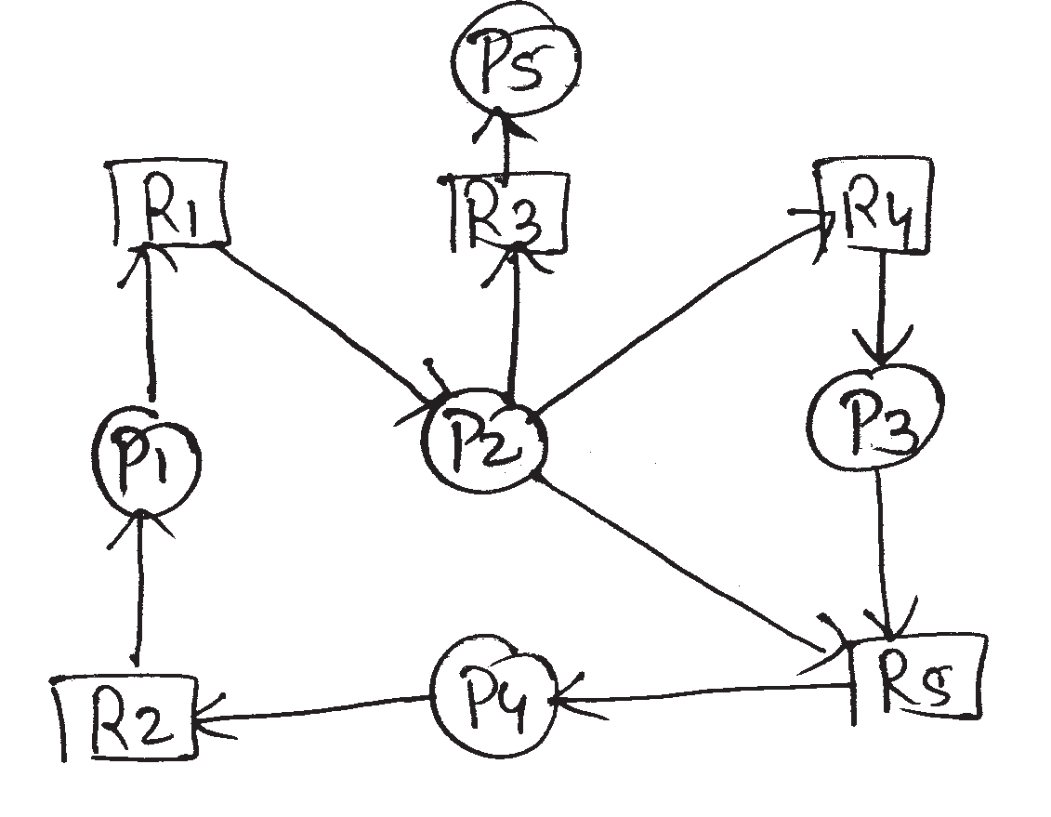
Q4) e)What is wait for graph? Convert following resource allocation graph into wait for graph.

Q5 )e) Consider the following snapshot of system which has 4 processes and four resources.
Allocation Max Available
A B C D A B C D A B C D 2 5 2 0
P0 | 0 | 0 | 2 | 2 | 0 | 0 | 2 2
P1 | 1 | 2 | 0 | 0 | 1 | 9 | 5 0
P2 | 2 | 4 | 5 | 4 | 3 | 4 | 5 6
P3 | 1 | 0 | 1 | 4 | 1 | 6 | 5 6

Answer the following questions using banker's Algorithm.
  - What are the content of matrix need. ii ) Is the system in a safe state?

